www.positiveeye.co.uk
gwyn@positiveeye.co.uk
Matching Bucket
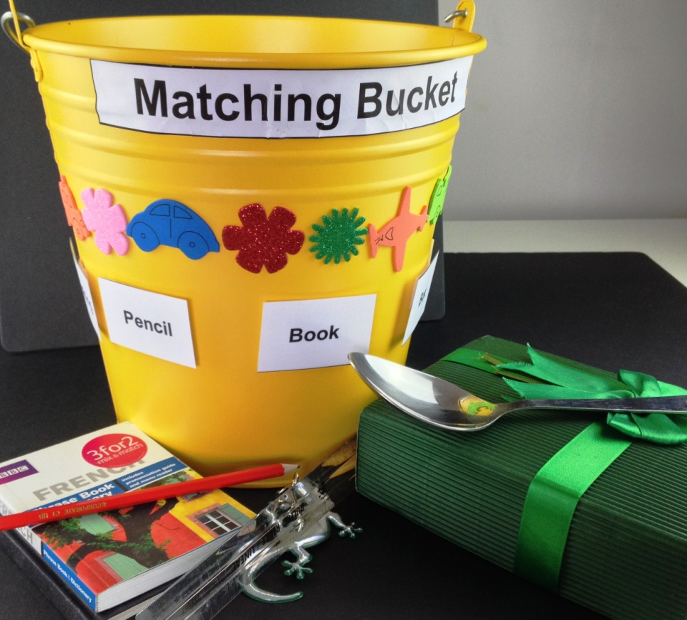
A simple resource which has a multitude of uses. Here are some ideas to inspire.
You will need:
- 1 bucket (preferably a bright coloured one, this is a metal one from IKEA)
- A selection of objects from around the environment
- A set of tickets naming the objects (laminated if preferred)
- Velcro to attach tickets to outside of bucket
- Shapes to decorate the bucket

The resource is quick to make and can involve the child
Step 1: Decorate the bucket
Step 2: Add your objects to the bucket
Step 3: Make your tickets and Velcro to the outside of the bucket

Learning and development suggestions
Match textures
Velcro textures to the outside and place matching texture in bucket for child to find and explore
Match shapes
Velcro textures to the outside and place matching shape in bucket for child to find and explore
Match objects
Velcro textures to the outside and place matching objects in bucket for child to find and explore
Match sounds
Velcro objects/textures with different sounds to the outside and place matching sound in bucket for child to find and recognise
Match initial letter sounds
Child to match initial letter sound on each ticket to correct object in bucket
Match words
Child to match word on each ticket to correct object in bucket
Collect objects
Collect objects beginning with particular letter
Collect objects with two attributes, three attributes
Collect natural objects (e.g. made of metal, wood, collect different shaped leaves)
Count objects
Place number tickets on Velcro spots around bucket. Choose a number and count correct amount of objects, perhaps with a particular initial letter sound into the bucket, from a selection placed on a tray.
Capacity
Fill the bucket with water, find out how heavy the bucket is when it is full
Place each object in the water find out which float and which sink
Make a chart on a magnetic board of those that sink and those that float
Fill the bucket with sand and make a massive sandcastle!
Make a castle using the bucket to make sandcastle turrets
Musical instrument
Turn the bucket upside down and play it is a drum with hands, with wooden spoons! Make different sounds from loud banging to quiet tapping
Make up a story or a poem about the bucket!
Include the child in thinking about the story, what happened one Saturday when Dad wanted his car washing and the bucket had a hole in it, what happened next......

