

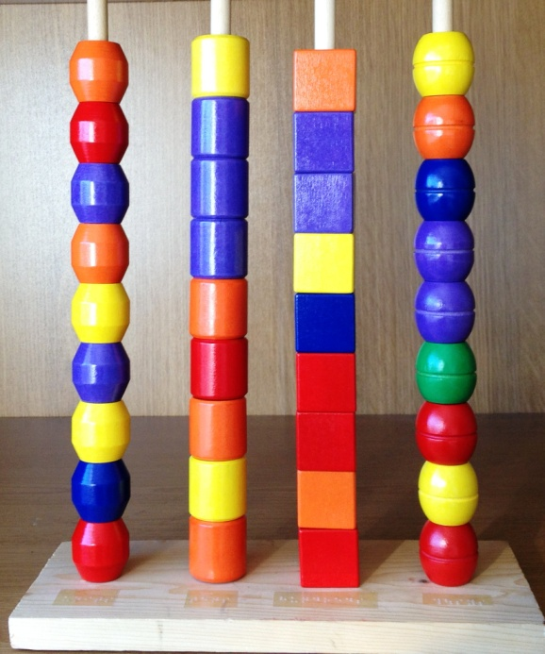**Making an abacus**

**You need:**

4 dowelling sticks cut to the same length and long enough to take your beads

36 beads divided into 4 sets, each set of beads to feel different.

A piece of wood long enough to take the four poles

Small amount of sticky back Braille

**What to do:**

* Cut the four poles to the same length each long enough to accommodate 9 beads (Tip take the beads to the store to check they fit over the dowelling!)
* Cut the base board to a size long enough to take your four poles
* Drill four holes to fit the width of each pole
* Braille labels: units, tens, hundreds and thousands and stick at the base of each pole in front of each hole
* Position your poles in the base board
* Add on your beads
* Your abacus is ready for use!