Low Vision Doctor’s Appointment Book

Front cover of book

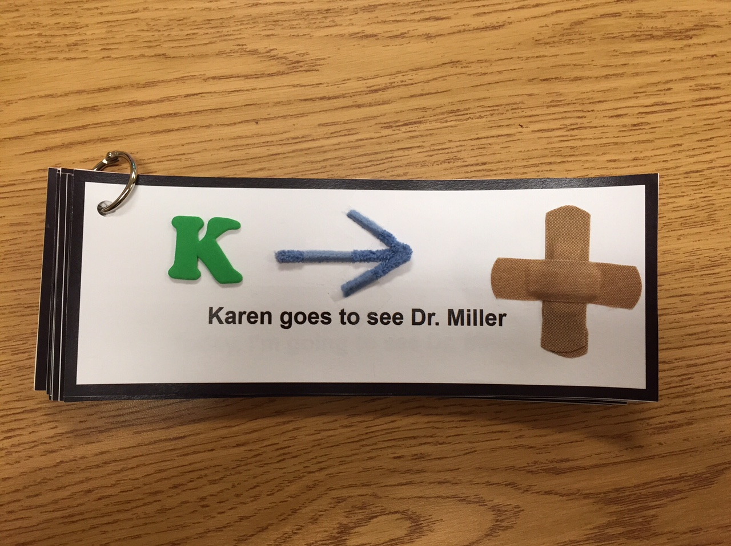

Page 1 of story  
  
  
  
  
  
  
  
  
  
  
  
  
Page 2 of story  
(move hands like you’re driving)

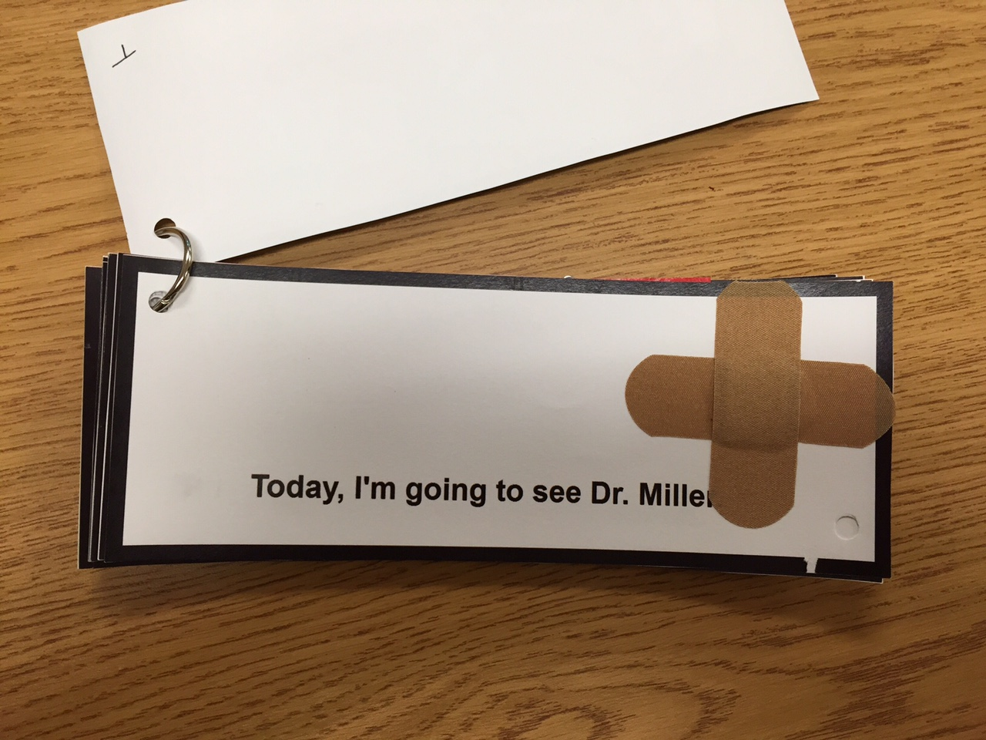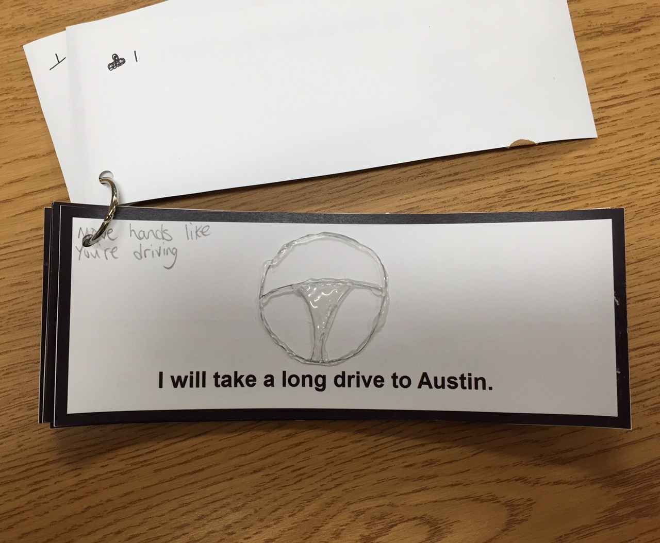

Page 3 of story  
(wave hand to say hello)  
  
  
  
  
  
  
  
Page 4 of story  
(blow air into her face)

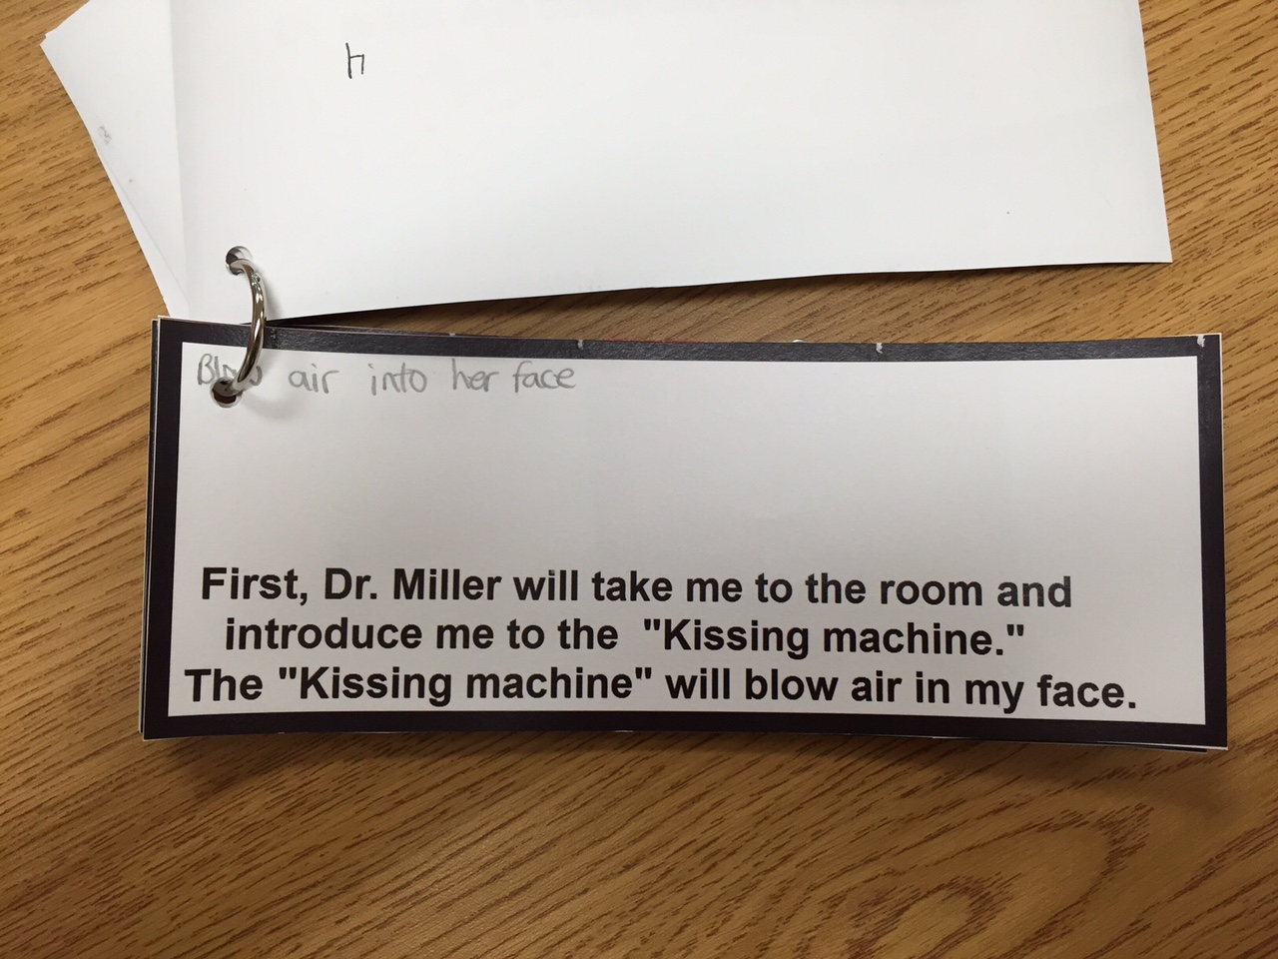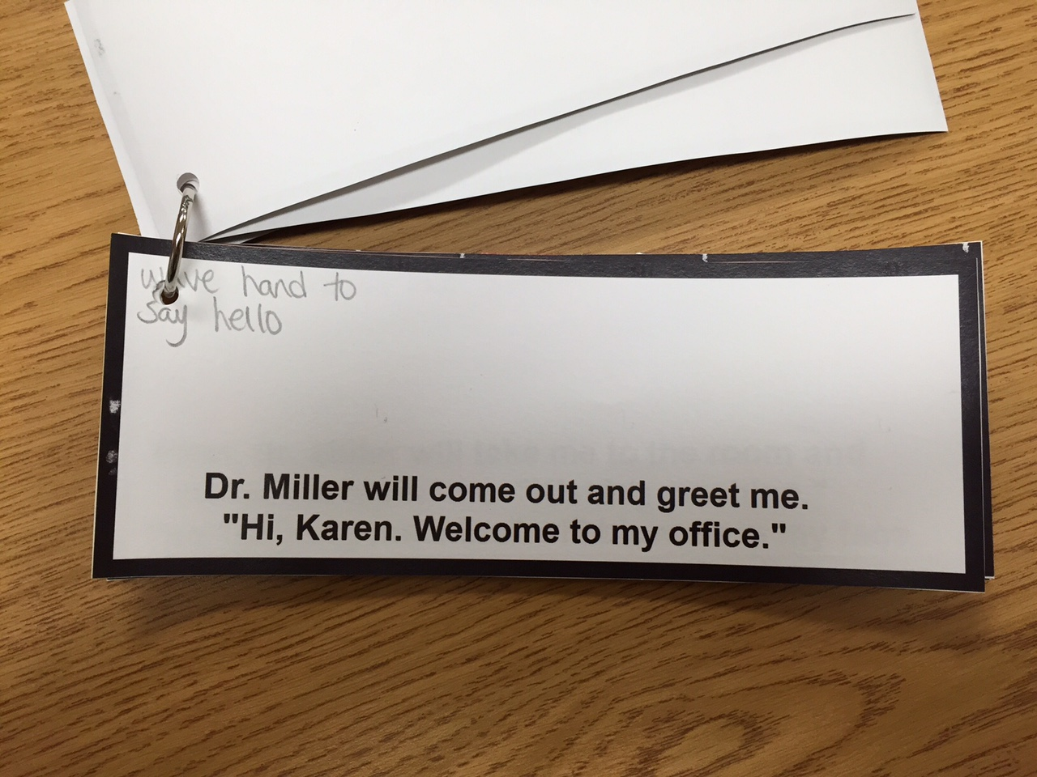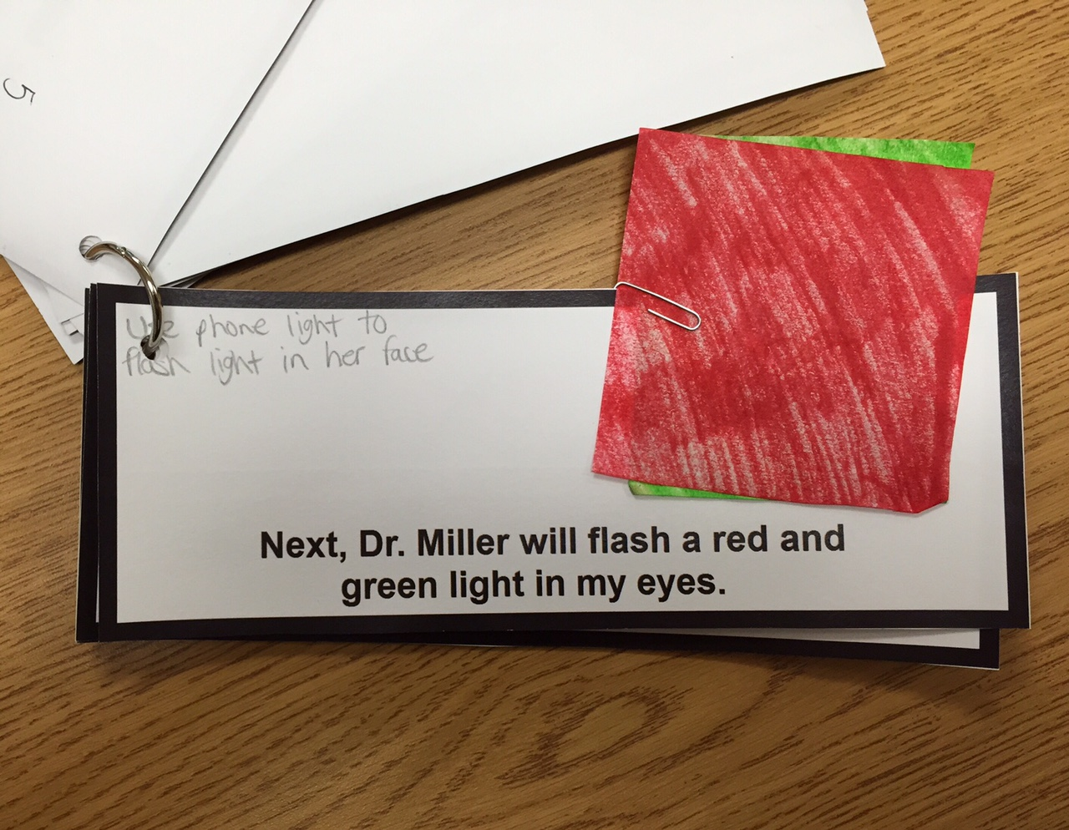

Page 5 of story  
( use phone light to flash light into her face using the red/green papers)

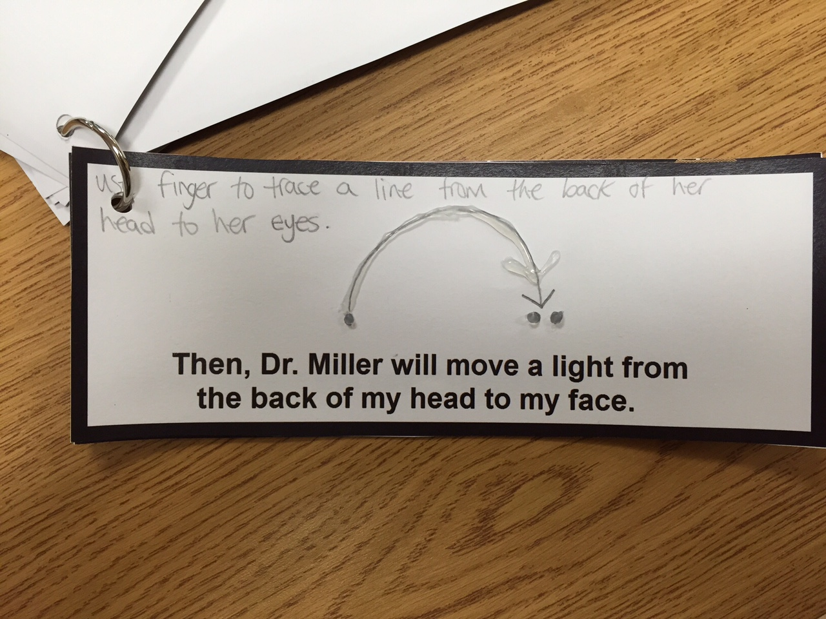

Page 6 of story  
(use a finger to trace a line from the back of her head to her eyes)  
  
  
  
  
  
  
Page 7 of story  
(sign language “finished” and “thank you”)  
  
  
  
  
  
  
  
Page 8 of story

