Early Learning

Access Technology Framework
for children who are blind or have significant vision impairment

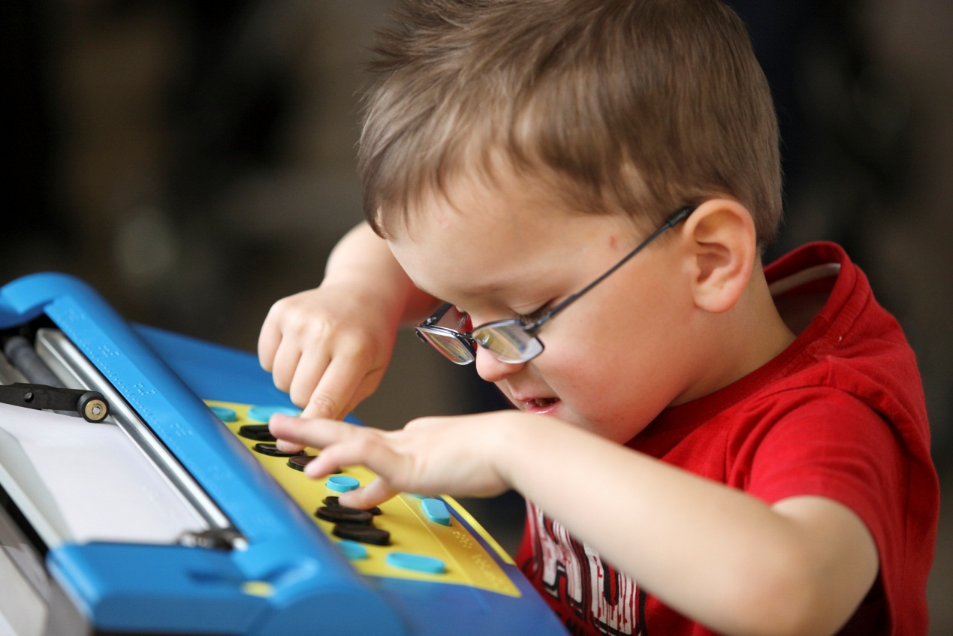

Michelle Knight, RIDBC Access Technology Consultant

A Note from the Author
Michelle Knight, December 2012
(michelle.knight@ridbc.org.au )
The Early Learning Access Technology Framework for children who are blind or have significant vision impairment (The Framework) is a guide for families and educators.
The Framework was created in recognition that children are regularly engaged with technology, even before they commence formal education. Children who are blind or have significant vision impairment require an environment that nurtures positive and meaningful technology experiences, and offers opportunities for life-long skill development, like their sighted peers.
The purpose of the Framework is to support a systematic approach to acquiring access and generic technology skills for children who are blind or have significant vision impairment. It is designed so that skills can be acquired simultaneously across seven themes. Underpinning each theme is a child-centred approach, that emphasises fun and introduces technology within the context of the child’s life. Learning how to use technology should be enjoyable, meaningful and motivating.
The Framework is a working document responding to the constant changes in technology. Activities are included to supplement skill development, however families and educators are encouraged to seek additional resources.
Lastly, thank you to the families and professionals for giving permission to use their photographs, and feedback to the Framework.

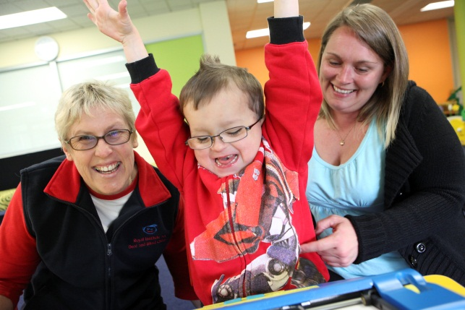
Copyright © 2013 by Royal Institute for Deaf and Blind Children

CONTENTS

A Note from the Author 2
TABLES 4
INTRODUCTION 5
THEME DESCRIPTORS 8
THEME 1: EXPLORE AND COMMUNICATE 9
THEME 2: LISTEN, UNDERSTAND AND RESPOND 15
THEME 3: KEYBOARD AWARENESS AND NAVIGATION 23
THEME 4: TABLET DEVICES 33
THEME 5: BRAILLE EXPERIENCES 42
THEME 6: NAVIGATION BY MOUSE 45
THEME 7: I CAN SEE IT! – CUSTOMISATION FOR LOW VISION 51
Glossary 57
References 60
Bibliography 61
Appendix 1: Useful Websites (Access Technology - Vision Impairment) 63
Appendix 2 – Access Technology Skills Summary Sheet 66

TABLES

Table 1: Framework of Themes 6
Table 2: Examples of Questions 11
Table 3: Orientation to Hardware Checklist 12
Table 4: Equipment Care and Safety Checklist. 13
Table 5: Terminology Checklist. 14
Table 6: Orientation to External Speakers Skills Checklist. 18
Table 7: Orientation to Headphones Skills Checklist. 19
Table 8: Communication Skills Checklist. 20
Table 9: Speech Output Preferences 20
Table 10: Speech Output Skills Checklist. 21
Table 11: Suggested Activities - Listen, Understand and Respond 22
Figure 1: 'Homemade" Tactile and Visual Markers 24
Table 12: Stages of Keyboard Awareness 26
Table 13: Keyboard Skills Checklist. 27
Table 14: Keyboard Awareness Activities 29
Table 15: Introductory iPad Skills Checklist 38
Table 16: Zoom Skills Checklist. 38
Table 17: VoiceOver Skills Checklist. 39
Table 18: Apps for Early Learners who are Blind or have Significant Vision Impairment. 40
Table 19: Refreshable Braille Skills Checklist. 44
Table 20: Mouse Skills Checklist. 48
Table 21: Mouse Skills Checklist. 49
Table 22: Magnifier Mouse Skills 54
Table 23: Checklist for Built-In Options Skills 55
Table 24: Screen Magnification Early Learning Skills Checklist. 56
Table 25: Access Technology Skills Summary Sheet 67

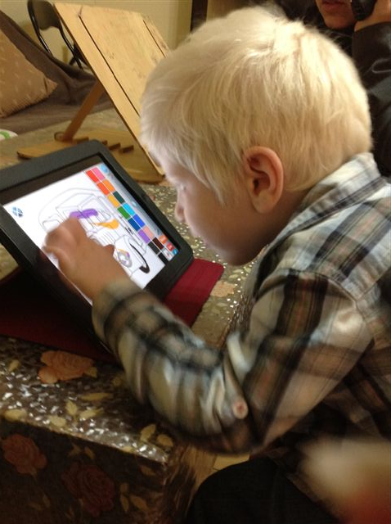
INTRODUCTION

The Early Years Access Technology Framework (The Framework) has been designed in recognition of the importance of technology in the lives of children who are blind or have significant vision impairment. Technology is essential for these children ”to access the environment around them, learn about the world, and function in their daily lives” (Presley & D’Andrea, 2009).
Children experience technology from an early age, whether it is in their home, school or general community. For children who are blind or have significant vision impairment experiences of a range of technology are usually limited due to reduced opportunities for incidental learning, as well as the lack of access technology and restricted opportunities for technology training. Children must have hands-on opportunities, demonstrations by peers and adults, and direct instruction by a teacher (Hutinger, 1998).Through a systematic approach utilising this Framework parents and educators of children who are blind or have significant vision impairment can assist these children in developing key concepts and skills.

Who should use the framework?
This Framework is designed to be used by families and professionals working with children who are blind or vision impaired. In particular, it was devised to be used in the preschools and Early Learning Programs at the Royal Institute for Deaf and Blind Children (RIDBC).
This Framework is a guide for educators involved in the introduction and use of technology for children who are blind or vision impaired. Aspects of the Framework may be useful for children who have no disabilities, or additional disabilities. It is aimed primarily at children between the ages of two and six years, or as a guide for older children who are in the “early years” of their engagement with technology.

What will children learn?
Children who are blind or have significant vision impairment are introduced to a range of generic and access technology. Technology skills and knowledge are divided into seven themes. Children learn to confidently explore their technology and communicate their needs using appropriate language and terminology. By experiencing a range of audio output, children develop skills in using recorded and synthetic speech. Through introductory keyboard awareness children will develop foundation skills to accessing technology, and pre-requisite skills to touch typing. For those children who are blind, they are introduced to braille reading and production technology. Children with low vision gain mouse skills, and are introduced to early customisation and magnification skills. The unique approach to accessing tablet devices will be investigated.

Overview of Framework Structure
Skills and activities can be selected across the seven themes, and developed concurrently. Each lesson can utilise multiple themes, varying the emphasis depending on the concepts being developed.
The preschool, home, or early learning setting provides many opportunities for children to develop technology skills and knowledge. These less-structured environment offer flexibility to draw on activities occurring within the educational setting and to develop activities based on a child’s individual experiences. Older children, in more formal learning environments, may develop technology skills based around the school curriculum.
This document is divided into the following; Introduction, Theme Descriptors, Themes, Glossary, References, Bibliography and Useful Websites.
The desired technology skills and knowledge for children who are blind or have significant vision impairment presented in the Framework are divided into seven themes:
- Explore and Communicate
- Listen, Understand and Respond
- Keyboard Awareness and Use
- Tablet Devices
- Braille Experiences
- Navigation by Mouse
- I Can See It – Customisation for Low Vision
For a summary of the themes see Theme Descriptors, page 7.
Long-term goals should be determined, and then lessons devised drawing on each of the themes, with varying degrees of emphasis. Technology opportunities for learning can be short, informal activities or more structured lessons over a longer timeframe.
Refer to the themes to determine the general concepts and skills you wish to develop with a child. Each theme is divided into 5 sections, as shown in the table below.
Table 1: Framework of Themes
Section | Description
Outcomes | Lists what the child will be able to do on completion.
Considerations | Identifies skills and knowledge that may be required before developing skills in this theme.
Setting up the environment | Considers the physical environment, setting up of equipment, layout etc
Teaching strategies | Suggests strategies for teaching, provides helpful tips and considerations.
Resources: Information, Skill Development and Assessment Tools | Provides checklists, websites, links, handouts and other useful tools
Activities | Suggested activities to promote skill development, including games utilising websites, and with freeware or purchased software.

The checklists in Resources: Information, Skill Development and Assessment Tools can be used as a teaching guide, progress notes and as an assessment tool.
To develop the skills and knowledge you will need a range of resources. Some of the themes have an additional list of suggested activities that develop specific skills. These are intended to be supplementary activities to your existing collection. Some of the activities listed develop a range of skills and are based on multiple themes.
The glossary provides definitions of the most commonly used access technology terms, and those used within the Early Years Access Technology Framework.
Appendix 1 contains useful websites has additional websites related to access technology (vision impairment) and educational resources.
Appendix 2 contains an Access Technology Skills Summary Sheet. Use this to provide an overview of skill development.

A final word of introduction
It is the intention of this framework to provide positive experiences with technology for children who are blind or vision impaired. It is essential that those working with children model competent use of technology and provide meaningful examples of others who use similar technology. Short sessions focussing on the development of one or two skills can prove more successful than longer sessions focussing on the development of many skills.
You are introducing children to the life-long development of technology skills. This is only the beginning. Developing technology concepts, skills and knowledge will enable children who are blind or vision impaired to become confident, independent learners within their educational environment and wider community.
Lastly, be enthusiastic and have fun!

THEME DESCRIPTORS
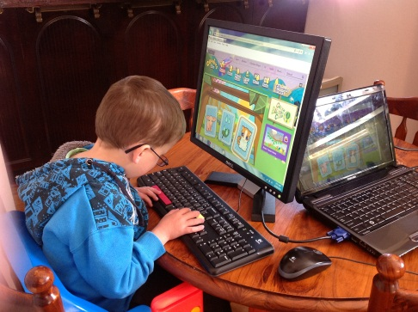
This section provides a brief description of each of the seven themes.

Explore and Communicate
The Exploration theme encourages children to explore the technology hardware. Children learn the terminology and develop language that is relevant to the technology they are using. They develop broad concepts of the hardware and software they are using.

Listen, understand and respond
The Listen, understand and respond theme develops children’s skills in utilising recorded and synthetic speech. Children learn how to communicate their basic speech output needs. They develop skills enabling them to make simple adjustments.

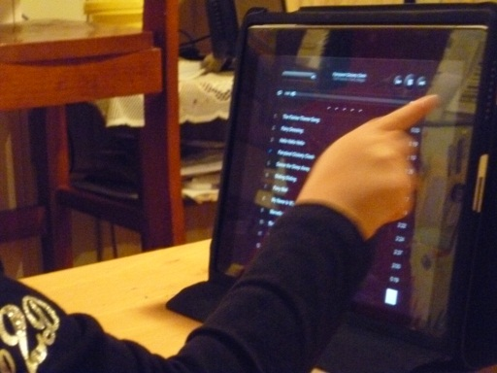
Keyboard Awareness and Navigation
The Keyboard Awareness and Navigation theme starts with introductory keyboard awareness and progresses to developing touch typing skills. An example of progression is listed below:

Tablet Devices
The Tablet theme introduces children to using tablet computers such as the iPad, iPhone and iPod. It focuses on navigation within the touch screen environment and an introduction to accessibility features.

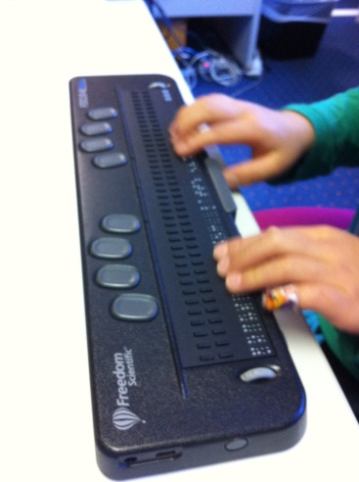
Braille Experiences
The Braille Experiences theme gives children who use braille the opportunity to discover braille technology. Children interact with a range of braille production and reading tools.

Navigation by Mouse
The Navigation by Mouse theme develops children’s mouse skills. It introduces basic concepts of mouse use and navigation.

I Can See It! – Customisation for Low Vision
The I Can See It theme introduces early customisation and magnification concepts to children with low vision. It allows children to explore a range of options that can enhance their access to computers. This theme encourages children to develop an understanding of their vision-related needs when accessing computers.

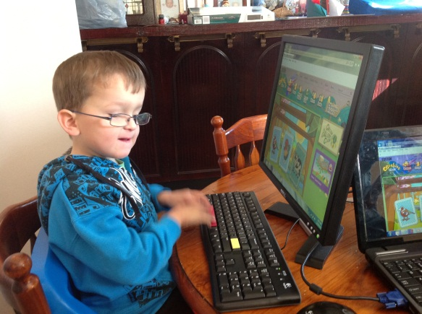
THEME 1: EXPLORE AND COMMUNICATE

The Explore and Communicate theme encourages children to explore technology. Children learn terminology and develop language that is relevant to the technology they are using. They develop broad concepts of their hardware and software.
Children are encouraged to explore and ask questions. Hands-on and visual exploration, gives children an opportunity to understand what technology they are using, why they are using it, how it works and, when and where they use particular hardware and software.
Technology is also an effective tool in facilitating communication. Children can use technology to access information, investigate ideas and represent their thinking (Council of Australian Governments, 2009). Theme 1 will encourage children to understand technology in the context of their environment.

Outcomes
The child develops skills in three broad areas: technology orientation, use of correct terminology and language, and the care of equipment

Orientation to Technology
The child will be able to:
- locate and identify hardware
- describe hardware use
- describe software use.

Equipment Care and Safety
The child will be able to:
- understand that equipment should be used with care
- identify ways to look after equipment, for example, have clean hands
- identify dangers in the use of the equipment
- pack away equipment at the end of an activity.

1.1.3 Terminology and Language
The child will be able to:
- describe hardware and software using correct terminology.

Pre-requisite skills and Knowledge
The child has:
- age appropriate language.
- ability to discriminate and name shapes.
- interest and ability to explore tactually.

Setting up the Environment
- Position equipment so that a child can easily explore, for example, a large desk, and suitable lighting conditions.
- Consider safety, for example power points, moving parts and positioning of the child and equipment.
- Initially always set up the equipment in a familiar position
- Select equipment that is robust and will not be damaged easily
- Ensure that by exploring the child will not activate or de-activate software or equipment (unless required)
- Select contrast and colour of equipment to suit the needs of the child with significant vision impairment

Teaching Strategies
The teaching strategies for the Explore and Communicate theme are grouped according to the identified Outcomes.

Orientation to Technology
- Set clear guidelines for the use of equipment
- Ensure adequate timeframe to explore
- Label equipment (links to literacy) with text, tactile or visual markers
- Gradually allow children to determine the set up and layout of equipment
- Encourage children to explore and ask questions.

Equipment Care and Safety
- Encourage the child to unpack and pack away equipment
- Discuss hazards and ask child to identify potential safety issues.

Terminology and Language
- Use the correct terminology from the introduction of equipment.
- Label equipment in print or braille
- Encourage children to ask questions.

Table 2: Examples of Questions
What | How? | Why? | Where? | When?
What is this?  What is it called?  What does it do?  What is it connected to?  What will happen if? | How do I …. (make it louder, bigger etc)?  How do I find …?  How does this work? | Why do I use this?  Why would I …?  Why does this ..? | Where do I …?  Where does this go? | When will I …?  When will it start/stop?

Resources: Information, Skill Development and Assessment Tools
Each checklist in the Explore and Communicate theme is based on the three broad Outcomes.

Orientation to Technology
Table 3 is a list of common hardware and software. Customise the table to accommodate the child and their technology.
Table 3: Orientation to Hardware Checklist
Hardware | Introduced | Practicing  (with assistance) | Achieved  (independent)
1 Computer
2 Keyboard
3 QWERTY keyboard
4 Mouse
5 Screen
6 Speakers
7 Braille
8 Refreshable braille
9 Brailler (mechanical)
10 Brailler (electronic)

Equipment Care and Safety

Table 4 is a checklist for equipment care and safety.
Table 4: Equipment Care and Safety Checklist.
Equipment Care and Safety Skill | Introduced | Practicing  (with assistance) | Achieved  (independent)
1 Demonstrates care when using technology
2 Always has clean hands when using technology
3 Ensures surface has adequate space and is clean
4 Places technology in a safe position
5 Identifies potential dangers when using technology e.g. cables
6 Turns technology off
7 Packs away technology at the end of the session

Terminology Checklist

Table 5 is a checklist of common access and generic technology terms that can be used with early learners who are blind or have significant vision impairment. Customise the checklist to correspond with the unique learning experience of the child.
Table 5: Terminology Checklist.
Terms Used | Introduced | Practicing  (with assistance) | Achieved  (independent)
1 Computer
2 Keyboard
3 QWERTY keyboard
4 Mouse
5 Screen
6 Speakers
7 Volume
8 Magnification
9 Bigger/Increase
10 Smaller/Decrease
11 Magnified
12 Screen Reader
13 Braille
14 Refreshable braille
15 Access/adaptive/assistive technology
16 Brailler (mechanical)
17 Brailler (electronic)
18 Windows

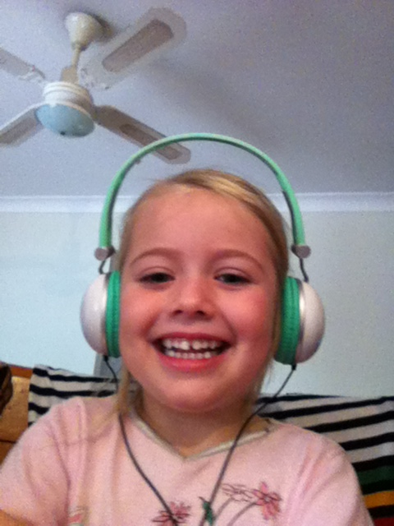

THEME 2: LISTEN, UNDERSTAND AND RESPOND
The Listen, Understand and Respond theme develops children’s skills in utilising recorded and synthetic speech. Children learn how to communicate their basic speech output needs. They develop skills enabling them to make simple adjustments to the hardware and software.
RIDBC uses the JAWS screen reader to provide access to PC using synthetic speech. Additional information can be found at Freedom Scientific: www.freedomscientific.com . Other screen readers used are:
- NVDA. Additional information can be found at NVDA: www.nvda-project.org/
- WindowEyes. Additional information can be found at GW Micro: www.gwmicro.com/window-eyes/
- VoiceOver. Additional information can be found at www.apple.com/accessibility/voiceover/

2.1 Outcomes
Listed below are the key introductory skills when utilising audio output. They are divided into four sections.

Orientation to audio equipment
The child will be able to:
- locate speakers and identify major features
- locate headphones and identify major features
- position headphones independently.

Communication
The child will be able to:
- identify their personal requirements (likes, dislikes, volume, rate, type)
- use appropriate terminology and language.

Adjusting the volume
The child will be able to:
- request volume to be adjusted
- adjust volume independently.

Listening to and understanding speech output
The child will be able to:
- enjoy listening to recorded speech and music
- enjoy listening to synthetic speech
- describe the difference between recorded and synthetic speech
- understand recorded speech
- understand synthetic speech

Pre-requisite Skills and Knowledge
- No pre requisite skills or knowledge required.

Setting up the Environment
The environment should be designed so that it enables a child to comfortably listen to audio output. Consideration should be given to the environment in which the child is playing. For example, is the setting where other children will be playing? Is the environment noisy or difficult to hear in? Alternatively, will audio output interfere with others in the surrounding environment?
There are a range of devices that provide audio output, including the following:

Internal Speakers
Computers and other devices often include internal speakers. Some children may require an additional device to enhance the audio output, either external speakers or earphones.

External Speakers
Good quality speakers will enhance the learning experience of the child. Position the speakers so that the child is able to easily adjust the volume control. If the speakers have a short power cable, attach an extension cable to enable easy access to the controls.

Headphones and Earphones
Determine if the child prefers headphones or earphones.
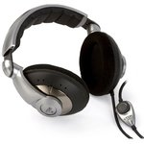
There are a range of headphone styles available. Consider the following:
- size
- weight
- cushioning
- Volume control

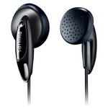
Earphones are lightweight and can be placed in one or both ears.
If headphones are preferred remember to select headphones that can be adjusted and accommodate a child’s head size.

Adaptors can be connected so that 2 headphones can be attached to one audio port.

Teaching Strategies
There are many opportunities for children to gain experience in listening to a range of audio output and develop listening strategies. Listed below are simple strategies that encourage early learners to engage with audio output and start to customise their experience.
Check the volume before allowing children to use headphones.

- Adjust volume, rate and pitch to suit the child’s requirements. This may take a while to determine.
- Start with recorded speech. This allows children to work with a voice that is familiar and easier to understand. For example, when designing activities use the child’s voice and other familiar voices. This can be fun for the child and provides an easy transition into using synthetic speech.
- Use questioning strategies and observation to determine whether the child comprehends the speech output.
- Children enjoy listening to other children talking and singing. There are many games that use children for narration, or to give instruction and direction.
- Discuss likes and dislikes with children of the different voices and speech output.
- Examples or listening and understanding activities include listening to books, writing stories and playing games.
- Use a range of software and hardware that gives children the opportunity to listen to a range of voice output.
- Encourage the child to determine their speech output preferences.

No sound?
Check the volume control on speakers, headphones or operating system

Skills: Resources and Assessment Tools

Orientation to Audio Equipment: External Speakers
Table 6 provides a checklist to orientate a child who is blind or has significant vision impairment to external speakers attached to a computer or other device. It includes skills to identify hardware features and control audio output.
Table 6: Orientation to External Speakers Skills Checklist.
Skills using External Speakers | Introduced | Practicing  (with assistance) | Achieved  (independent)
1 Locate on/off button

2 Turn speakers on/off
3 Locate volume control
4 Adjust volume randomly
5 Adjust volume to required setting
6 Locate connection between speakers
7 Locate connection to computer or other device
8 Locate connection to power supply

Orientation to audio equipment: Headphones/Earphones
Table 7 identifies introductory skills in using headphones attached to a computer or other device. The skills are sequential, from lower to higher order, identifying hardware and controlling audio output.
Table 7: Orientation to Headphones Skills Checklist.
Headphones Skill | Introduced | Practicing  (with assistance) | Achieved  (independent)
1 Position headphones/earphones on ears.
2 Connect headphones/earphones to computer or device.
3 Locate volume control.
4 Adjust volume randomly.
5 Adjust volume independently.

Communication
Table 8 is a checklist of introductory communication skills when using audio output.
Table 8: Communication Skills Checklist.
Communication Skill | Introduced | Practicing  (with assistance) | Achieved  (independent)
1 Identifies volume is too loud or soft
2 Requests volume to be adjusted.
3 Requests modification of speech output, with prompting
4 Requests modification of speech output, independently
5 Uses appropriate vocabulary to express likes and dislikes

Speech Output Preferences
Table 9 provides an area to list speech output preferences. This will enable you to set up equipment according to the child’s preferences, and record any changes.
Table 9: Speech Output Preferences
Type of Speech Output | Description
Recorded
Synthetic

Speech Output
Table 10 is a checklist of introductory recorded and synthetic speech skills. Skills are listed from lower to higher-order skill level.
Table 10: Speech Output Skills Checklist.
Speech Output Skill | Introduced | Practicing  (with assistance) | Achieved  (independent)
1 Recognises there is a difference between recorded and synthetic speech
2 Identifies recorded speech
3 Identifies synthetic speech
4 Listens to, and understands recorded speech
5 Listens to, and understands synthetic speech

Activities

Table 11 outlines suggested activities to facilitate the outcomes of (i) orientation to audio equipment, (ii) communication, (iii) adjusting the volume and (iv) listening to and understanding speech output. The activities are software-based and web-based activities.
These are suggestions only. You are encouraged to find additional resources to support skill development for this theme.
Table 11: Suggested Activities - Listen, Understand and Respond
Activity | Skills | Resources
Create your own PowerPoint book | Listens to, and understands recorded speech | Powerpoint
StoryLine Online Website | Listens to, and understands recorded speech | www.storylineonline.net
ABC for Kids playroom (playlist) | Listens to, and understands recorded speech | www.abc.net.au/abcforkids/playroom/
CD used with Real Player | Listens to, and understands recorded and synthetic speech | Real Player
AlphaPlay | Listens to, and understands synthetic speech | JAWS and MSWord
Create a story | Listens to, and understands synthetic speech | JAWS and MSWord

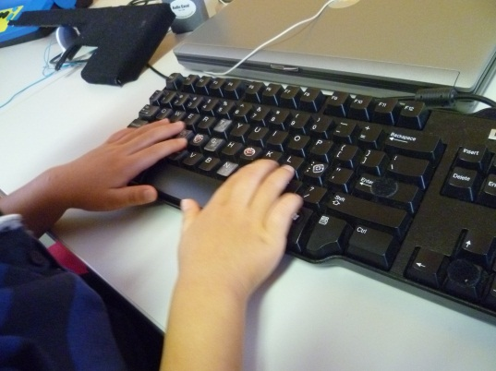

THEME 3: KEYBOARD AWARENESS AND NAVIGATION

The Keyboard Awareness and Navigation theme for children aged two to six years starts with introductory keyboard awareness and, if possible, progresses to the early stages of touch typing.
A keyboard provides one method of computer access for a child who is blind or has significant vision impairment. Foundation keyboard awareness activities can be incorporated into computer play before more formal touch typing training is undertaken.

Outcomes

The child will be able to:
- explore the keyboard, with assistance
- complete “Stages of Keyboard Awareness” as listed in the table below
- develop early stages of touch typing.

Pre-requisite Skills and Knowledge
The following pre-requisite skills are required before a child who is blind or has significant vision impairment commences using a keyboard.
The child has the ability to:
- isolate fingers
- match or recognise letter shape
- locate keyboard markers tactually and/or visually.
The resources below provide additional information regarding fine motor skills:
- Cerebral Palsy Alliance: http://www.cerebralpalsy.org.au/about-cerebral-palsy/basic-guide-to-cerebral-palsy/types-of-cerebral-palsy/fine-motor-skills
- Sheridan, M., D. (1998). From Birth to Five Years. Children’s Developmental Progress. Melbourne: ACER Press
- Skillbuilders Pediatric Occupational Therapy: www.skillbuildersonline.com
For pre-requisite skills for touch typing see the “Touch Typing Resource Sheet for Teachers” in the Resources and Assessment Tools section, page .

Setting up the Environment
It is essential that the environment meets the needs of the child who is blind or has significant vision impairment. Consideration should be given to the keyboard and physical layout of the environment, including seating and positioning.

Keyboards
There are a range of keyboards that are suitable for young children with vision impairment. Finding the optimum keyboard will give the child the best possible access to a computer. Children with significant vision impairment may require a keyboard that has large lettering, high contrast and less clutter than a regular QWERTY keyboard.
Factors that influence the type of keyboard that a child with significant vision impairment include:
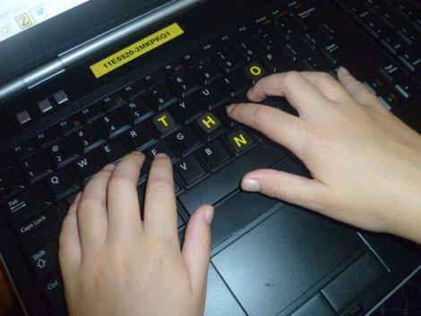
- style of keyboard
- size of keyboard, keys and lettering
- colour of letters and background
- contrast of letters and background
- lowercase and/or uppercase lettering
- durability of keyboard
- connectivity to required devices
- operating system on computer or tablet
- cost
Alternative keyboards to the regular QWERTY keyboards are available. A good starting point to investigate the options is Spectronics, www.spectronics.com.au .
Multiple keyboards can be connected to the one computer. Always check connections!

Visual and Tactile Keyboard Markers
Tactile and visual markers can assist the child in locating keys on the keyboard or assist in finger placement. Markers can be either purchased commercially, or custom-made. You can make your own tactile and visual markers.
Figure 1 shows an example of tactile markers made by a teacher. She calls them sticky dots. They are made from sticker dots and a glue gun.

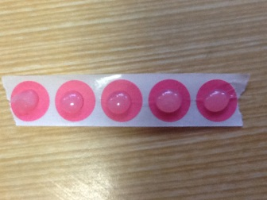
Figure 1: 'Homemade" Tactile and Visual Markers
For example use Velcro, stick-on children’s ear-rings or high contrast stickers to locate specific keys on a keyboard. Listed below are examples of commercial tactile and visual markers:
- Braille Keyboard Overlay labels
http://www.spectronics.com.au/product/braille-keyboard-overlay-labels
- KeySticks, Lowercase Keyboard Stickers
http://www.englishsoftware.com.au/adult%20literacy/keystick.htm
- Keyboard Stickers by Inclusive Technology
http://spectronics.com.au/product/keyboard-stickers

Ergonomics
It is essential that you consider ergonomics when setting up the environment for keyboard use. Consideration should also be given to the child’s vision impairment and other requirements.
The following resources provide information regarding ergonomics using a computer:
- Ergonomics for Children and Educational Environments: http://www.iea.cc/ECEE/guidelines.html
- Manual Handling, Ergonomics and Computer Work, Deakin University, Australia: http://www.deakin.edu.au/hr/ohs/manual-handling.php
The following suppliers have a range of tables and chairs suitable for children:
- Cap educational furniture and equipment: http://www.capedu.com.au/
- Modern Teaching Aids: http://www.teaching.com.au/
- Office Furniture Direct: http://www.officefurnituredirect.com.au/Postura-Chair-Sebel-Postura-Chair.htm http://www.teaching.com.au/catalogue?catalogue=MTA&category=MTA-SEBEL-POSTURA-CHAIRS
You can also order cut out attachments for children with poor trunk stability
- Rifton Multidesk: http://www.fasequipment.com/cp.html http://www.specialneedssolutions.com.au/products/rifton-multidesk/
- http://www.fasequipment.com/downloads/instructions/multidesks.pdf

Teaching Strategies
Keyboard awareness and navigation skills can be taught through a variety of games, focusing on broad groupings (e.g. letters or numbers) and then progressing to specific keys. The following strategies will aid in developing these skills:
- Introduce keyboard awareness and navigation in stages, depending on the child’s needs. Table 12 lists the four stages.
Table 12: Stages of Keyboard Awareness
Stage 1: Exploration
- random exploration of the keyboard
- structured exploration of the keyboard
Stage 2: Locate the following keys:
- spacebar
- enter/return
- arrow keys (up, down, left, right)
Stage 3: Locate the following keys:
- escape
- numbers row ( 0 – 9)
- letters (A-Z)
- backspace
Stage 4: Locate the following keys:
- “left-hand letters” and “right-hand letters”
- control, shift, ALT
- using both hands on the keyboard
- using multiple keys

- Tactile or visual markers can be removed as the child becomes more skilled in the use of the keyboard.
- Customise a keyboard cover to block out keys if the child finds the keyboard overwhelming.
- Some children with low vision initially require an enlarged keyboard. They then move to a regular QWERTY keyboard once they have developed an awareness of the layout and additional skills.
- When possible, encourage children to explore different types of keyboards (e.g. laptop keyboards, QWERTY keyboards with and without NumPad). Discuss similarities and differences.

Resources: Information, Skills Development and Assessment Tools

Keyboard Skills Checklist
Table 13 identifies introductory keyboard skills. The skills are listed sequentially, building on level of difficulty and suggested order of teaching.

Table 13: Keyboard Skills Checklist.
Keyboard Skills | Introduced | Practicing  (with assistance) | Achieved  (independent)
1 Describe the purpose of a keyboard
2 Explore the keyboard, with direction
3 Explore the keyboard, independently
4 Explain elements of keyboard are grouped (e.g. NumPad, arrow keys, letters)
5 Press keys randomly
6 Look for key/s with intent
7 Press specified key with intent – multiple or sustained press
8 Press specified key with intent – single key press
9 Use index finger in isolation to depress key
10 Locate and use space bar
11 Locate and use up and down arrow keys
12 Locate and use left and right arrow keys
13 Locate and use enter/return key
14 Find general location of alphabetic keys
15 Locate and use escape key
16 Locate and use number keys
17 Locate and use full stop
18 Recognise letters on the keyboard as capital or uppercase letters
19 Match lowercase letter with uppercase letter
20 Produce an uppercase letter using the Shift key
21 Use both hands simultaneously on the keyboard
22 Explain the concept of touch typing
23Position fingers correctly on home row
24 Use 2 keys simultaneously.
25 Use 3 keys simultaneously.

Activities
Table 14 provides a range of activities that develop keyboard skills. The activities are based on either online or freeware or purchased software.
- Ballyland by Sonokids is a soon-to-be released game that supports keyboard development for children who are blind or have significant vision impairment: www.ballyland.com .
- Priory Woods software can be downloaded from the Priory Woods website: http://www.priorywoods.middlesbrough.sch.uk/ .
- cBeebies games can be located at the cBeebies games website: http://www.bbc.co.uk/cbeebies/games/
- HelpKidzLearn requires registration for a fee: http://www.helpkidzlearn.com/
Table 14: Keyboard Awareness Activities
Activity | Skill | Resources
Orientation techniques | Locate and use spacebar | Keyboard, stickers
HelpKidzLearn | Locate and use spacebar | www.helpkidzlearn.com/early.html
All Abilities eplayground | Locate and use spacebar | www.allabilitiesplayground.net.au
Here Comes the Duck | Locate and use spacebar | Pizza Games
10 Fat Sausages | Locate and use spacebar | Priory Woods software
Five Little Ducks | Locate and use spacebar | Priory Woods software
Five Little Speckled Frogs | Locate and use spacebar | Priory Woods software
Read PowerPoint book | Locate and use spacebar | PowerPoint that you have created.
Orange Sounds | Locate and use spacebar | http://www.zefrank.com/snm/index.htm l
Fimbles music maker | Locate and use alphabetic keys (z x c v b n m) | cBeebies
What’s that noise? | Locate and use spacebar  Locate and use enter key | cBeebies
CD used with RealPlayer | Locate and use enter key | RealPlayer
Big Bang software | Locate and use enter key | Big Bang software
Read PowerPoint book | Locate and use spacebar  Locate and use enter key | PowerPoint book that you have created.
Map in AllAbilities ePlayground | Locate and use enter key | www.allabilitiesplayground.net.au
Hark the Sound | Locate and use up and down arrow key  Locate and use left and right arrow key | http://www.cs.unc.edu/~gb/research/hark-the-sound/
LetterPop | Press specified key with intent  Recognise letters on the keyboard as capital or uppercase letters  General location of alphabetic keys | http://helpkidzlearn.com/findout/letterpop,htm
AlphaPlay – playing with letters of the alphabet | Press keys randomly  General location of alphabetic keys | MSWord  JAWS  Magnifier or change font size and other settings.
TrixMix | Locate and use number keys | www.allabilitiesplayground.net.au

Touch Typing resource sheet for teachers
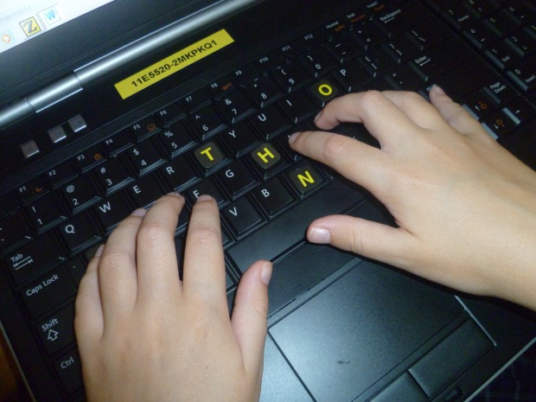
Touch typing is a life skill and is essential for children who are blind or vision impaired. It is important to provide effective instruction, and that children maintain their typing skills. Touch typing allows a child to concentrate on the task they are undertaking, rather than the mechanics of production.

To provide effective teaching of touch typing the teachers require the following skills:
- ability to touch type
- identify observable keyboarding behaviours
- have the ability to use appropriate hardware, software and other teaching materials suited to children who are blind or vision impaired
- understand how students will use their touch typing.

Teaching strategies
- Identify when a child is ready to learn to touch type (see prerequisite skills).
- Provide a program where there is a REASON for the child to acquire the skill, an OUTLET for the student to use their skills, and a METHOD to reinforce and refine.
- Model good touch typing technique.
- Encourage the child to use touch typing techniques whenever they use a keyboard.
- Commit time to regular accomplish proficiency in touch typing, i.e. practice.

Prerequisite Skills
Prerequisite skills for touch typing include:
- good finger strength
- good wrist strength
- eye hand coordination (for children with low vision)
- ability to maintain good posture
- finger dexterity - the ability to isolate fingers
- ability to concentrate for short periods of time
- stages 1 -3 keyboard awareness skills
- low level literacy skills.
(http://www.setbc.org/setbc/vision/virg/p2_10.html)

Software
Touch typing software that is particularly useful for children or are blind or vision impaired are listed below:

Large Print
- TTAPS: Touch Typing a Program for Schools
http://www.east-west.com.au
- TypeQuick (Kewala)
http://www.typequick.com.au/ , including an online test, http://www.typequick.com.au/ttest/testyourskills.html
- TypeQuick
- RapidTyper

Speech Output
- Talking Typer for Windows
http://www.aph.org/
- TypeAbility
http://www.yesaccessible.com/typeability.html

THEME 4: TABLET DEVICES

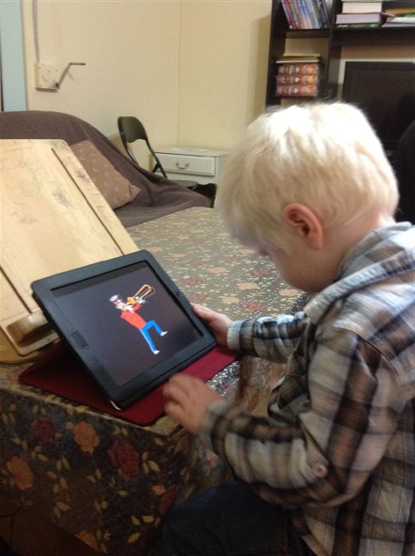
The Tablet Devices theme introduces children who are blind or have significant vision impairment to using accessible tablet devices such as the iPod, iPhone and iPad. This theme focuses on navigation within the touch screen environment and an introduction to accessibility features.
The focus of the Tablet Devices theme is on the iPad. The theme will be modified as technology changes.

Outcomes
Outcomes in the Tablet and Devices theme focus on generic and access introductory skills for early learners using the iPad.
The child will be able to:
- open/close the iPad cover
- locate the Home button, ON/OFF button, volume control
- use simple navigational techniques
- perform simple commands to access apps on the tablet
- identify and use accessibility features.

Pre-requisite Skills and Knowledge
Pre-requisite skills consider the child’s cognitive and physical access to the tablet device.
The child can:
- attends to tablet device
- has a method to access the tablet device
- can be positioned (supported/unsupported) to allows access to the tablet device
- understands appropriate spatial concepts language (e.g. top, bottom)
- understands cause and effect.

Setting up the Environment
Consideration should be given to the positioning of equipment and modifications that can made utilising built-in options of both the operating environment and specific apps.

Positioning
The following list provides suggestions to
- Place the device in an easily accessible position. Consider sensory and physical impairments.
- Slope boards, mounts and portable table tops may assist with viewing position and physical access to the device.

Connectivity
- iPads can either be WiFi, or WiFi and 3G enabled. This will determine your connectivity to the Internet and network. Both can be temporarily disabled if they are distracting to the child.
- Ensure that password protection is set up for access to the iPad and to iTunes.

Screen adjustments
Simple measures can be taken to accommodate the needs of a child with low vision using the Apple iPad. Modifying built-in options within the iPad and utilising iPad peripherals may assist. Adjustments include:
- positioning the iPad to reduce reflection from light sources
- use a screen overlay to protect from scratches and reduce screen brightness
- adjust screen brightness to suit the needs of the child (Settings – Brightness and Wallpaper)
- modify the screen background to accommodate a child with low vision (Settings – Brightness and Wallpaper).

Apps
Built-in features within an app can assist a child who is blind or has significant vision impairment to access the content. This includes:
- individual apps may provide control over font sizes and styles, e.g. Notes. Check in Settings.
- app content may be enlarged using the ‘pinch-to-zoom’ gesture. Check before introducing the app to the child.
Other suggestions include placing frequently used apps on the Home screen, or store in folders to reduce on-screen clutter.

4.2.3 Covers
- Robust iPad covers can be purchased. Some have soft surrounds, padding, can block little fingers and include a stand.

Zoom
The Zoom accessibility feature offers built-in magnification on the iPad for children with significant vision impairment. This option is useful when the app does not respond to ‘pinch-to-zoom’ or additional magnification is required. The quality of the screen content can be reduced when using this feature.
- Set Zoom as the Triple Home click option (Settings – General – Accessibility – Triple-click)

VoiceOver
VoiceOver is a built-in screen reader, offering built-in speech output. VoiceOver also offers braille output if a refreshable braille display is attached to the device.
- Set VoiceOver as the Triple Home click option (Settings – General – Accessibility – Triple-click)
- Customise VoiceOver settings to suit the needs of the child (Settings – General – Accessibility – VoiceOver)

Teaching Strategies
- The iPad/iPhone is very responsive to touch. Set clear guidelines in its use and that the child can follow simple instructions.
- There are a myriad of Apps available for portable touch devices – choose carefully. Many are free, others charge a nominal amount. When determining suitable apps consider the following for a child with significant vision impairment:
  - Clear, simple layout
  - Does the app use colour only to convey information (if child has difficulties with colours)
  - Audio output can be engaging and can also assist with prompts and providing additional information
  - Is it compatible with VoiceOver?
- The iPad is extremely portable and can therefore be used in a variety of settings.
- Provide a detailed orientation to the iPad. Allow the child to explore. If you are using your own personal equipment then make sure that the child cannot access material that is for your own use only.
- Encourage clean hands and other strategies to care for the equipment.
- Sweaty hands can make it difficult to swipe and touch the screen.

Zoom
Utilising the following strategies will assist with developing magnification skills:
- demonstrate and model magnification skills
- provide regular practice, particularly when working within a magnified screen
- encourage movement and exploration within the screen
- encourage the child to determine when, and the level of magnification required
- compare and contrast ‘pinch-to-zoom’ utility with zoom feature
- when using three fingers young children may find it easier to use the three fingers used for writing, i.e. pincer grip.
For specific teaching resources see the section Resources: Information, Skill Development and Assessment Tools on page 35.

VoiceOver
VoiceOver can be introduced with early learners who utilise speech and/or braille output.
- Modify the VoiceOver settings to suit the child. Allow the child to determine the voice settings they prefer.
- Demonstrate and model VoiceOver.
- Select simple apps to introduce the screen reader. Apps are limited for early learners who require VoiceOver as their access to the iPad/iPhone.
- Some apps that contain buttons may be customised.
- Refer to Listening, Understanding and Responding theme.

For specific teaching resources see the section Resources: Information, Skill Development and Assessment Tools on page 37.

Resources: Information, Skill Development and Assessment Tools

Tablet Resources: Blind or Significant Vision Impairment
The following list of resources may be useful in developing skills and knowledge in the use of iPad/iPhone and other tablet devices for those who are blind or have significant vision impairment.
- AppAdvice: http://appadvice.com/applists/show/apps-for-the-visually-impaired
- Apple in Education: http://www.apple.com/au/education/apps/
- AppleVis Empowering blind and low-vision users of Apple products and related applications: http://www.applevis.com/
- Oklahoma School for the Bind, Resources: http://osb.k12.ok.us/education/assistive-technology/assistive-technology-resources/
- Royal National Institute for the Blind, Technology Information: http://www.rnib.org.uk/livingwithsightloss/computersphones/pc/tablets/Pages/tablet_devices.aspx
- Statewide Vision Resource Centre: http://svrc.vic.edu.au/ATipad.shtml
- TechVision: http://blindgeteducated.blogspot.com.au/
- VisionAustralia Resources Adaptive Technology Guide: http://www.visionaustralia.org/

Tablet Resources: Additional Disabilities
The following links provide additional information regarding using tablet devices with children who have additional disabilities :
- CommuinicATe - Assistive Technology for Independence:
http://www.communicateat.com.au/mounting-positioning/38-ipads-and-tablets/72-a-few-ways-to-secure-your-idevices-to-tables
http://www.communicateat.com.au/products/browse/37-desk-mounts?sef=hc
- Spectronics – Inclusive Learning Technologies: http://www.spectronicsinoz.com/product/inclusive-ipad-mounts#toggle
- Novitatech: http://www.novitatech.org.au

General Skills to Access an iPad
Table 15 is a checklist of basic, introductory skills for early learners using the iPad. Skills are listed in a suggested learning sequence.
Table 15: Introductory iPad Skills Checklist
Introductory iPad Skills | Introduced | Practicing  (with assistance) | Achieved  (independent)
1 Single tap to open app
2 Single tap within an app
3 Locate and use Home Button
4 Locate and use volume control
5 Increase/decrease volume
6 Close App by pressing Home Button
7 Single finger swipe (left)
8 Single finger swipe (right)
9 Single finger swipe (up)
10 Single finger swipe (down)
11 Continuous finger drag (straight line)
12 Continuous finger drag (curved line)
13 Two finger pinch

Zoom (Magnification) Checklist
Table 16 lists the introductory skills for early learners required to use the built-in magnification, Zoom.
Table 16: Zoom Skills Checklist.
Zoom Skills | Introduced | Practicing  (with assistance) | Achieved  (independent)
1 Start Zoom (Triple finger, double tap)
2 Close Zoom temporarily (Triple finger, double tap)
3 Increase magnification (Triple finger swipe up)
4 Decrease magnification (Triple finger swipe down)
5 Move within a magnified screen.
6 Brings off-screen items into view.

Voice Over (Screen Reader) Checklist
Table 17 lists introductory VoiceOver screen reader skills for early learners.
Table 17: VoiceOver Skills Checklist.
VoiceOver Skills | Introduced | Practicing  (with assistance) | Achieved  (independent)
1 Start VoiceOver
2 Close VoiceOver
3 Move through items (e.g. apps, buttons) using single swipe
4 Select item using double tap

Activities
Table 18 suggests apps for early learners who are blind or have significant vision impairment. The apps, suggested by RIDBC Early Learning Program Consultants (Vision Impairment), focus on developing a range of vision-specific or more general developmental skills. Apps marked with an asterisk (*) can be accessed by children who are blind.
Table 18: Apps for Early Learners who are Blind or have Significant Vision Impairment.
App Name | Developer
Baby Finger | DJ International
Baby’s Musical Hands | Streaming colour Studios
* Barney the dog | Kids Place
Build it up | MyFirstApp.com
Dear Zoo | Pan Macmillan
*I Hear Ewe | Claireware Software
Interactive Alphabet – ABC Flash Cards | Piikea St. LLC
Kapu Forest | Kapu Toys
Peekaboo Barn for iPad | Night & Day Studios Inc
Peekaboo: Ladybird Baby Touch | Penguin Books
Peeping Musicians | Inclusive Technology
Play School Art Maker | Australian Broadcasting Corporation
Shape Puzzles | JP Game LLC
Touch and Say | Interbots
Slide and Spin | MyFirstApp.com
Starfall Learn to Read | Starfall Education
Squiggles | Lazoo Worldwide Inc.
Tap-N-See Zoo | Little Bear Sees

Additional apps useful for children who are blind or have significant vision impairment can be found at the following websites:
- Spectronics:
  - http://www.spectronicsinoz.com/iphoneipad-apps-for-aac/
  - http://www.spectronicsinoz.com/article/iphone-ipad-apps-for-magnification-and-vision-support
- http://www.optometrystudents.com/8-apps-for-visually-impaired-patients/

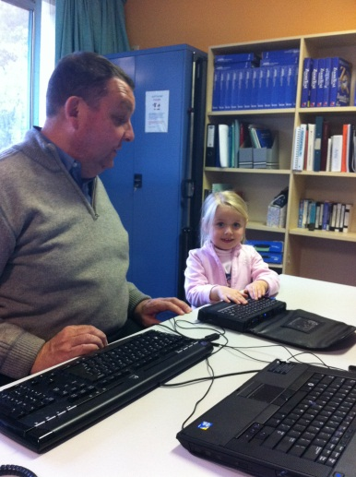
THEME 5: BRAILLE EXPERIENCES

The Braille Experiences theme introduces children who use, or may use braille, to braille technology. Children interact with a range of braille production and reading tools.
Children generally gain their initial experiences in writing and reading braille using the Perkins Brailler and/or the Mountbatten Brailler. The use of this technology is integrated into their early literacy experiences.
There are excellent teaching and learning resources for the Perkins Brailler and Mountbatten Brailler.
Teaching resources for the Perkins Brailler can be found at www.perkins.org/PerkinsBrailler .
Teaching resources for the Mountbatten Brailler can be found at the Mountbatten website: http://www.mountbattenbrailler.com/user-guides-and-downloads.html.
The Braille Experiences theme focuses on refreshable braille with Windows computers and the Apple range, including tablet devices. Children are introduced to braille embossers, and develop an understanding of higher volume production of braille.
RIDBC uses the following refreshable displays:
- Brailliant BI 40. For additional information go to the HumanWare website: www.humanware.com
- BrailleNote Apex. For additional information go to the HumanWare website: www.humanware.com
- Focus 40 Blue. For additional information go to the Freedom Scientific website: www.freedomscientific.com

Outcomes
The outcomes for the Braille Experiences theme are based on introductory concepts for early learners who use, or may use braille.
The child will be able to:
- define, simply, refreshable braille.
- identify what drives the refreshable braille display, e.g. screen reader software.
- describe how the refreshable braille display is connected to the computer or other device.
- determine when braille is refreshed or changes
- locate patterns, characters and words on a refreshable braille display.
- locate beginning and end of refreshable braille display.

Pre-requisite Skills and Knowledge
Prior to introducing refreshable braille and other braille technology children need to have had previous early braille experiences.

Setting up The Environment
Setting up refreshable braille displays requires particular consideration. This includes the choice of displays, connectivity options (e.g. cable, Bluetooth) and features enabled. The following should be considered:
- Design the environment so that it enables a child to comfortably experience refreshable braille.
- Ensure that there is sufficient space for a range of technology.
- Refreshable braille displays have many features. Some features may be distracting for a child. Choose carefully. Teach the child which keys can be used and/or determine if some features can be disabled.
- Ensure that connectivity between the refreshable braille display and screen reader has been enabled before undertaking the activity.

Teaching Strategies
Introducing refreshable braille displays is to highlight to children the connection between braille and technology. The following strategies may assist in introducing the concept of braille technology.
- Ensure that the child is comfortable using the refreshable braille display.
- Refreshable braille feels different from the paper-based braille children may have experienced. Encourage discussions on braille, why it feels different, utilise a range of language.
- Introduce the refreshable braille display very gradually.
- Base lessons on literacy experiences in other aspects of the child’s life. For example, learning to write and recognise their name and reading stories.
- Demonstrate connectivity to a range of devices.
- Demonstrate reading and writing using the refreshable braille display.
- Provide experiences where the child interacts with others using refreshable braille.

Resources: Skill Development and Assessment Tools
Table 19 introduces basic refreshable braille skills to early learners who use, or may use braille.
Table 19: Refreshable Braille Skills Checklist.
Refreshable Braille Skills | Introduced | Practicing  (with assistance) | Achieved  (independent)
1 Define (simply) refreshable braille.
2 Describe (simply) how a refreshable braille display is connected to the PC or other device.
3 Locate patterns, characters and words on a refreshable braille display.
4 Locate beginning and end of refreshable braille display.
5 Identify what drives the refreshable braille display, e.g. JAWS software.
6 Locate cursor on refreshable braille display
7 Understand the function of the cursor.
8 Track braille as writing appears on refreshable braille display.
9 Recognises spoken text is appearing on refreshable braille display simultaneously.

THEME 6: NAVIGATION BY MOUSE
The Navigation by Mouse theme develops children’s mouse skills. The theme is aimed at children with low vision who will use a mouse as one method of access to computers. It introduces basic concepts of mouse use and navigation.

6.1 Outcomes
Outcomes for the Navigation by Mouse theme are based on the operation and manipulation of a mouse connected to a computer.
The child with low vision will be able to:
- recognise that screen arrow movement corresponds with mouse movement
- move mouse, with purpose, independently
- select and manipulate screen items using a mouse.

Pre-requisite Skills and Knowledge
The child with significant vision impairment requires sufficient vision to be a visual user of a computer. They require the ability to:
- attend to the computer screen
- locate mouse pointer on the computer screen.

Setting up the Environment

The Mouse
The mouse is one method of access to a computer for a child who has significant vision impairment. It is preferable to use a mouse that is small and fits in a child’s hands comfortably. Ensure that there is adequate space for movement of the mouse. There are a range of mouse options that are designed specifically for children. Some are brightly coloured, allowing for easy discrimination of the left and right button. Others have a single button (usually set to a left click), so that it is easier for a child to manipulate the clicking action. Wireless options are ideal for those children who are distracted by the cable connection. Remember that a wireless mouse requires batteries and the computer requires an available USB port or BlueTooth connectivity. Also, the connection may not be as reliable or consistent as a cable-connected mouse.
When selecting a mouse consideration should be given to:
- size of the mouse
- colour and contrast (particularly of the buttons)
- markers (visual and tactile) to assist with discrimination between buttons
- built-in magnifier, as a simple option to magnify screen content
- scroll wheel, to assist with screen navigation
- connectivity (cable or wireless)
- operating system
- cost.
Utilising the most suitable mouse enables the child to access the computer quickly and with greater ease.
Below are examples of a mouse specifically designed for children. Other types are also available. For example,
- Chester Mouse
- Little Mouse
- Tiny Mouse.
The following websites may provide additional information on mouse options:
- Spectronics: www.spectronics.com.au
- Novitatech: www.novitatech.org
- Computer and/or electronic stores.
Remember that some mice come with software that will need to be installed on the computer. This may require administrative rights to the computer.

Mouse Pointers
One of the most common challenges that a child with vision impairment experiences when viewing the computer screen is finding the location of the mouse pointer. The default setting for a mouse pointer tends to be a small, white arrow with a black outline. This can be difficult to identify against a busy or poor contrasting background. By using a large, good contrasting mouse pointer the child is able to quickly and easily locate the mouse pointer and concentrate on the task at hand.

Built-In Options
Windows and Apple operating systems allow the mouse pointer size and colour to be adjusted. Refer to the Windows and Apple websites to determine the specific features of the operating system version being used.
Other useful features that can be customised are:
- slowing mouse pointer speed: easier to track
- setting mouse pointer locator: utilising keyboard command making it easier and quicker to locate the mouse pointer
For further information on changing the mouse pointer settings refer to the following websites:
- Windows: www.microsoft.com/enable
- Apple: www.apple.com/accessibility

Add-Ons
Additional mouse pointers, either freeware or purchased, can be found on the Internet. Examples include:
- BigCursor
- BigBold Cursors
- ACE cursors
- CHNGCURS.

Within Third Party Software
Some software contains its own large mouse pointers. For example, ZoomText Magnifier/Reader software, gives a choice of large mouse pointers and cursors. Children’s software may come with mouse pointers that are large and appealing to younger users.

Teaching Strategies
There is a range of training materials to teach mouse skills available online. Additional considerations are required for early learners with significant vision impairment.
- Demonstrate correct usage of the mouse, encouraging to children to observe and copy positioning.
- Encourage children to use the mouse correctly every time.
- Always determine the most suitable mouse pointer for the child during the initial activity or assessment.
- Allow children to determine their preferred mouse pointer. Sometimes this is based not only on visual suitability, but also on colour “likes and dislikes”.
- When determining appropriate mouse pointer, test the mouse pointer against a variety of backgrounds.
- Use a variety of software to build on mouse skills.

Resources: Skill Development and Assessment Tools

Mouse Skills by the developer Inclusive Technology, is software that provides simple activities that introduce mouse skills incrementally. This software can be customised to suit the needs of a child with vision impairment. It includes enlarged mouse pointers, a variety of colour contrasts, and motivational audio feedback.

Mouse Skills Checklist

Table 20 sequentially lists mouse skills to be developed by early learners.
Table 20: Mouse Skills Checklist.
Mouse Skills | Introduced | Practicing  (with assistance) | Achieved  (independent)
1 Position hand on mouse correctly
2 Understand that moving the mouse moves the mouse pointer on the computer screen
3 Move mouse (randomly) with assistance
4 Move mouse (randomly) independently
5 Move mouse to specific locations on computer screen
6 Single click (left)
7 Single click (right)
8 Single click (in set time)
9 Double click
10 Click and Drag
12 Click and Drag (specific location or path)

Activities
Table 21 lists a range of activities to develop specific mouse skills. The activities are web-based games, freeware or purchased software.
Table 21: Mouse Skills Checklist.
Activity | Skills | Resources
HelpKidzLearn  Early Mouse Movements | Move mouse randomly (with assistance)  Move mouse randomly (independently) | www.helpkidzlearn.com
Aven’s Corner  - Fan  - Switch | Move mouse (randomly) with assistance  Move mouse (randomly) independently | http://avenscorner.com/default.aspx
HelpKidzLearn  Big Bang Bugs | Single click (left) | www.helpkidzlearn.com
HelpKidzLearn  - Pop the Bubbles,  - Five Little Monkeys  - Aunt Maggie’s Recipe  - Destructive Digger | Single click (left) | www.helpkidzlearn.com
StarFall - All About Me | Single Click (left) | www.starfall.com/n/level-b/index/load.htm?f
Priory Woods  - Five Ducks  - Five Snowmen  - Animal Sounds  - Bugz  - Frog  - Monkey  - Penalty  - Sausages | Single Click (left)
Avens Corner  - Blue/Green Train  - Red Train  - Pop Bubbles  - Red Helicopter | Single Click (left) | http://avenscorner.com/default.aspx
Eric the Engine Story Book | Single Click (left) | http://www.britishcouncil.org/kids-stories-eric-engine-popup.htm
HelpKidzLearn  - Drag and Drive  - Train Tracker  - Farm Jigsaws  - Colouring Book  - Shape Pictures - Transport | Click and Drag | www.helpkidzlearn.com
iboard player  - A Day at the Beach  - A Day at the Park  - A Day in the Country  - Escaped Animals  - Classroom Museum | Click and Drag | http://iboardplayer.com/player/
iBoard Player  - Cheese Sniffer  - Fix up the Park |  | http://iboardplayer.com/player/

Listed below are additional useful resources to develop mouse skills:
- KidsAbility: http://www.kidsability.ca/uploads/Common/pdfs/ACS/Developing%20Early%20Mouse%20Skills.pdf

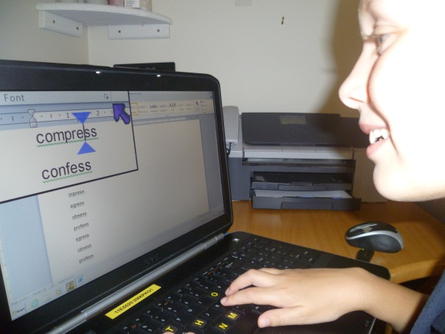

THEME 7: I CAN SEE IT! – CUSTOMISATION FOR LOW VISION

The I Can See It! theme introduces early customisation and magnification concepts to children with significant vision impairment. It allows children to explore a range of options that can enhance their computer access. This theme encourages children to develop an understanding of their vision-related needs when accessing computers.
Using a large monitor (20 inch or greater) is a simple solution to enlarge text and images on the computer screen. Before using more sophisticated screen magnification options to access computers, consideration should be given to built-in, freeware or low cost applications. There is a myriad of freeware and open-source material on the Internet. Use these programs with caution. Consider running them from a USB, if possible, rather than installing on the hard drive.
At RIDBC we use ZoomText Magnifier/Reader as a screen magnification option. Additional information on ZoomText Magnifier/Reader can be found at the AiSquared website: www.aisquared.com .

Outcomes
The Outcomes for the I Can See It theme are based on skills to use within built-in options and third party solutions to enable children with low vision to access technology.
The child will be able to:
- determine when magnification or enlargement is required
- use language to request that on-screen text and images are enlarged
- turn magnification mouse on/off
- increase/decrease magnification
- navigate with a mouse and/or keyboard within a magnified screen

Pre-requisite Skills and Knowledge
The child will require some experience with technology including:
- well-developed mouse skills.
- basic keyboard awareness
- good spatial skills.

Setting up the Environment

Large Monitor
Consider the following:
- Ensure that there is adequate desk space to accommodate a large monitor.
- Check that the seating and desk height allow for correct seating position for the child when using a large monitor.

Magnifier Mouse
Consider the following:
- A USB port for a mouse with built-in magnifier is required.
- There are several options for a magnifier mouse which have different button layouts.
- Button options can be modified to accommodate a child’s needs
- The child’s hand size needs to match the size of the mouse.

Built-In Options
Consider the following:
- Investigate applications to determine if they have features that may be useful for a child with vision impairment.
- Ensure you have administrative rights to change features within the Control Panel and can be saved?
- Check that the monitor supports any required change in resolution.

Screen Magnification
Consider the following:
- Ensure you have administrative rights to install or change software attributes?
- Ensure that the software is compatible with the operating system. Check the system requirements of magnification software you wish to use.
- A young child requires simple software
- Default magnification can be adjusted and saved to suit the child.

Teaching Strategies
Children with low vision use a range of strategies to enable technology access. Consider alternative software options that include features suitable for a child with low vision. For example, TuxPaint can be substituted for Microsoft Paint. Encourage children to communicate their needs and preferences. Support children to learn to independently determine when they require modifications to the on-screen content.

Built-in Options
Built-in options are a good starting point for young children. The following strategies will assist with the introduction of built-in options:
- Determine appropriate settings together with the child. The most common features that need to be enlarged for young children are the mouse pointer, caption buttons, scroll bars, menu and title bars.
- To develop the concept of enlarged items and other concepts start with basic items such as caption buttons, scroll bars and the mouse pointer.
- Introduce font size in word processors, for example Microsoft Word.

Screen Magnification
- Determine whether the child has the skills and vision required for using screen magnification.
- Provide brief, simple explanations and demonstrations of screen magnification. Use visuals to support descriptions.
- Provide opportunity for lots of practice in moving within a magnified screen.
- Keyboard shortcuts are often easier for children to increase/decrease magnification.
- Select activities which require the use of screen magnification.

Resources: Information, Skill Development and Assessment Tools

The following websites provide more detailed information on built-in options within the Windows and Apple operating systems:
Windows: www.microsoft.com/enable
Apple: www.apple.com/accessibility

Magnifier Mouse
Table 22 lists basic skills utilising a magnifier mouse.
Table 22: Magnifier Mouse Skills
Magnifier Mouse Skills | Introduced | Practicing  (with assistance) | Achieved  (independent)
1 Uses simple language to advise that screen content is too small/too large
2 Requests screen content be enlarged/reduced
3 Enables magnifier using magnifier button
4 Disables magnifier using magnifier button
5 Enlarges magnifier window
6 Reduces magnifier window size
7 Increases magnification
8 Decreases magnification

Built-In Options
Table 23: Checklist for Built-In Options Skills
Built-In Options Skills | Introduced | Practicing  (with assistance) | Achieved  (independent)
1 Uses simple language to advise that screen content is too small/too large
2 Requests screen content be enlarged/reduced
3 Selects settings with assistance
4 Increases font size in word processor
5 Decreases font size in word processor

Screen Magnification Checklist

Additional information can be found at the following websites:
- AiSquared: www.aisquared.com (ZoomText Magnifier/Reader)
- American Foundation for the Blind (AFB): www.afb.org
- Freedom Scientific: www.freedomscientific.com (MAGic Screen Magnification software)
- The Screen Magnifiers Home: www.magnifiers.org
Table 24 lists introductory screen magnification skills for early learners. It includes language and magnification skills to customise the screen.
Table 24: Screen Magnification Early Learning Skills Checklist.
Screen Magnification Skills | Introduced | Practicing  (with assistance) | Achieved  (independent)
1 Uses simple language to advise that screen content is too small/too large
2 Requests screen content be enlarged/reduced
3 Recognises when magnified screen content may be off-screen
4 Uses magnifier to find and view images on screen
5 Brings magnified screen content into view
6 Turns magnifier on
7 Turns magnifier off
8 Increases magnification (by mouse)
9 Increases magnification (by keyboard)
10 Decreases magnification (by mouse)
11 Decreases magnification (by keyboard)

Glossary

Access Technology (Vision Impairment)
Access Technology (Vision Impairment) refers to hardware or software that is either,
- mainstream technology that is modified or has built-in options that can be utilised, or
- specialised technology, designed specifically for a person who is blind or vision impaired.
Access technology is also referred to as “assistive”, “adaptive” or “inclusive” technology.

Alternative Keyboard
A keyboard that offers an alternative to the conventional QWERTY keyboard design. Alternative keyboards range in design, size, layout and connectivity.

Alternative Format
Text and images reproduced in a format that is accessible by a person who is blind or has vision impairment. Examples of alternate format are braille, large print, electronic text and audio.

Brailler
A mechanical or electronic device that requires input via a braille keyboard to produce a paper copy of braille. Examples include the Perkins brailler, TatraPoint and Mountbatten brailler.

Braille Embosser
A brailler that embosses computer-generated text and images as braille on paper. Braille can be embossed on either one or both sides (known as interpoint) of the braille paper.

Braille Notetaker
A portable, electronic device that has refreshable braille and speech output. It typically has a range of utilities including a word processor, calendar, calculator, communication tools and access to the Internet. The notetaker uses either a braille or QWERTY keyboard layout to enter information or navigate the system. Files may be sent to a printer or braille embosser, or transferred to a computer.

Braille Translation Software
Software that translates text and formatting into braille.

Closed Circuit Television (CCTV)
CCTV’s use a camera to project a magnified image onto a video monitor, television or computer monitor. CCTV’s range in size, portability, connectivity and offer an array of options to change magnification level, contrast, clarity and control of the magnified image.

DAISY
DAISY is an acronym for Digital Accessible Information System. DAISY is a standard format for digital talking books. DAISY books can be accessed in a range of formats, including recorded voice, synthetic speech and braille.

Digitised Speech
Digitised speech is speech that has been digitally recorded. Unlike synthesised speech, digitised speech has a finite, predetermined vocabulary. Examples of digitised speech include speech in the Mountbatten Brailler learning mode, some electronic books and computer games.

eBook
A book containing electronic text and/or images that is accessed through a computer or portable reading device. eBooks can be free, borrowed or purchased.

E-Text
E-text is electronic text. Also known as digital text.

iPad
The iPad is the first tablet computer from Apple with a 9.7-inch touchscreen It comes with a choice of memory capacity, with or without 3G connectivity. All models offer Wi-Fi. Third party applications (Apps) can be purchased from the iTunes App Store to run on the iPad. Accessibility for those who are blind or have low vision include a magnification tool called Zoom, and speech and braille output through VoiceOver. Some refreshable braille displays can be connected. The iPad 2 includes a camera which offers limited use for near and distance viewing.

iPhone
The iPhone is Apple's first Internet-enabled smartphone. It combines the features of a mobile phone, wireless Internet device, and iPod. The 3.5-inch screen provides an interface based on touch. Third party applications (Apps) can be purchased from the iTunes App Store to run on the iPad. Accessibility for those who are blind or have low vision include a magnification tool called Zoom, and speech and braille output through VoiceOver. Some refreshable braille displays can be connected.

Optical Character Recognition (OCR) software
Computer software that converts digital images of printed text into a form that can be recognised and manipulated by a word processor, or other editing tool. It can then be read, edited or translated into a format required by a person who is blind or has vision impairment.

Refreshable Braille Display
A device that provides braille output of information presented by a screen reader on a computer screen. Pins represent the 6 dots to make up a braille cell. Dots 7 and 8 may be included to represent text formatting. The displays generally range in size from 12 to 80 braille cells. Refreshable braille displays may include navigational and input keys such as thumb wheels and buttons.

Scanner
A device that converts an image from a printed page to a computer image file.

Screen Magnification Software
Screen magnification software magnifies content on the screen. It allows the user to customise the display presentation, modify tracking of screen content and customise the appearance of screen attributes. Some screen magnification software includes optional speech output that can be used when typing or reading text.

Screen Reader
A screen reader is software that reads information from a computer screen, both automatically and on request. It speaks the information, using synthesised speech and/or produces it on a refreshable braille display.

Synthesised Speech
Computer-generated speech.

Talking Book and DAISY Player
A portable device that plays MP3 and DAISY books. They range in size, functionality, keypad layout, memory capacity and cost. Some DAISY players are available as software that can be used on a PC.

References

Council of Australian Governments. (2009). Belonging, Being & Becoming. The Early Years Learning Framework for Australia. Retrieved July 23, 2012, from
http://www.deewr.gov.au/Earlychildhood/Policy_Agenda/Quality/Documents/Final%20EYLF%20Framework%20Report%20-%20WEB.pdf
Hutinger, P., Johanson. J., & Robinson. L. (1998). Building inlerACTTive futures. Macomh, IL: Macomh Projects. Western Illinois University.
Presley, I., & D’Andrea, F., M. (2009). Assistive Technology for students who are blind or visually impaired: A guide to assessment. New York: AFB Press.

Bibliography

Aubrey, C. & Dahl, S, (2008). A review of the evidence on the use of ICT in the Early Years Foundation Stage. Retrieved August 1, 2012, from http://www.e-learningcentre.co.uk/Resource/CMS/Assets/5c10130e-6a9f-102c-a0be-003005bbceb4/form_uploads/review_early_years_foundation.pdf
Cause, L., & Chen D. (2010). A tablet computer for young children? Exploring its viability for early childhood education. Journal of Research on Technology in Education, 4 (1), 75-98, Retrieved August 1, 2012, from ProQuest database.
Kelly, S. M. (2011). The use of assistive technology by high school students with visual impairments: A second look at the current problem. Journal of Visual Impairment & Blindness, 105 ( 4), 235-239. Retrieved May 4, 2011, from ProQuest database.
Morgan, A. & Siraj-Blatchford, J. (2010). Using ICT in the early years. Parents and educators in partnership. Albert Park State: Teaching Solutions.
Parette, H.P., Hourcade, J.J. and Heiple, G.S., (2000). The importance of structured computer experiences for young children with and without disabilities. Early Childhood Education Journal, 27, 4, 243-250. Retrieved September 11, 2012, from ProQuest Database.
Parette, H., Quesenberry, A., & Blum, C. (2009). Missing the boat with technology usage in early childhood settings: A 21st century view of developmentally appropriate practice. Early Childhood Education Journal, 37, 335-343. Retrieved September 1, 2012, from ProQuest.
Smith, D. W., Kelly, S. M., & Kapperman, G. (2011). Assistive technology for students with visual impairments. Position paper of the Division on Visual Impairments, Council for Exceptional Children. Retrieved April 9, 2012, from http://www.cecdvi.org/positionpapers.html
Turja, L., Endepohls-Ulpe, M., & Chatoney, M. (2009). A conceptual framework for developing the curriculum and delivery of technology education in early childhood. International Journal of Technology and Design Education, 19, 353-365, Retrieved August 11, 2012, from SpringerLink.
Wood, E., Specht, J., Willoughby, T., & Mueller, J. (2008). Integrating computer technology in early childhood education environments: Issues raised by early childhood educators. Alberta Journal of Educational Research, 54(2), 210-226. Retrieved from PyscINFO.

Appendix 1: Useful Websites (Access Technology - Vision Impairment)

Important Notes

Links often change, this list will almost certainly be out of date in a reasonably short time. When you find a link has changed, update it in this list and update your Favourites.

Before listening to audio or watching videos

When you listen to audio or watch video on the Internet, you may be downloading at a significant rate. When listening or watching material on the Internet from home, make sure you don’t exceed the usage your plan allows.
DO NOT watch or listen from work unless you have checked that your network has the capacity to accommodate the download you need without adversely affecting others.

Important note about the following resources

The following list of products and resources is not an exhaustive list.
No approval or endorsement is given or implied by RIDBC to any product, manufacturer or supplier whose name appears on the following list. Due care and consideration should be given to the selection of equipment.
SUGGESTION: If you add or change information in this list, change the date in the heading and in the file name so you can easily identify your latest copy.

Australian Software and Equipment Suppliers

HumanWare
- BrailleNote family of products
- ZoomText screen magnification system
- Trekker Breeze GPS system
- Victor Reader Stream for reading a wide range of audio formats
- A range of CCTVs.
http://www.humanware.com

Quantum Reading Learning Vision Pty Ltd
- Master distributor for Freedom Scientific Products including JAWS, MAGic, Wynn and Pac Mate
- Distributers of the Mountbatten Brailler
- Producers of Jot-A-Dot
- a wide range of CCTVs
- ClearNote.
http://www.quantumrlv.com.au

Spectronics – inclusive learning technology:
http://www.spectronics.com/

Vision Australia
Supplies a wide range of access technology
http://www.visionaustralia.org.au

Early Learning

- ABCya! Kindergarten Kids Computer Games & Activities: http://www.abcya.com/kindergarten_computers.htm

- Aven’s Corner – Preschool Online Games and Educational Online Games: http://avenscorner.com/
- Ballyland by Sonokids: www.ballyland.com
- BBC – cBeebies: http://www.bbc.co.uk/cbeebies/games/
- Color Mixing Song Learning Games for Kids: http://www.learninggamesforkids.com/educational_videos/color-mixing-song.html
- HelpKidzLearn: http://www.helpkidzlearn.com/
- Hiyah.net – Free Educational Software for Children: http://hiyah.net/
- Mouse Skill Resources for Pre-K at Internet 4 Classrooms: http://internet4classrooms.com/early_childhood/mouse_skills_pre-k.htm
- Northumberland Grid for Learning ICT Resources: http://ngfl.northumberland.gov.uk/ict/default.htm
- Priory Woods: http://priorywoods.web4.devwebsite.co.uk/
- Shiny Learning: http://www.shinylearning.co.uk/freegames/index.shtml
- SonoKids: http://www.sonokids.com
- Special Education Apps Best iPad Apps for Kids: http://a4cwsn.com/
- Starfall’s Learn to Read with phonics: http://www.starfall.com/
- Tots ‘n Tech: http://tnt.asu.edu/

Education

- American Foundation for the Blind – includes research and JVIB: http://www.afb.org/
- American Printing House for the Blind – games and other products: http://www.aph.org/
- Royal Institute for Deaf and Blind Children (RIDBC): http://www.ridbc.org.au
- Royal National Institute of Blind People – products, research, information and links to other vision-related organizations around the world: http://www.rnib.org.uk
- South Pacific Educators in Vision Impairment (SPEVI) - information and resources for South Pacific educators including a mailing list: http://www.e-bility.com/spevi
- Special Education Technology British Columbia: www.setbc.org
- StateWide Vision Resource Centre: http://svrc.vic.edu.au/
- Texas School for the Blind and Vision Impaired: http://www.tsbvi.org/

Glossaries
- Colorado State University Access Project: http://accessproject.colostate.edu/disability/modules/at_glossary/at_glossary.cfm
- Texas School for the Blind and Visually Impaired: www.tsbvi.edu
- The Family Center on Technology and Disability: http://www.fctd.info/show/glossary

Appendix 2 – Access Technology Skills Summary Sheet

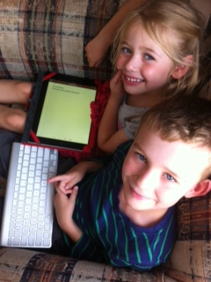
The Access Technology Skills Summary Sheet (Table 12, paged 65) gives you the option to summarise the child’s skills. It is intended to be used ‘at-a-glance’. This will allow you to easily determine area of skill level achieved, and where further development is required.
The numbers in Table 12 correspnd to the skills in each table located within the themes. To show that the skill has been achieved mark an ‘X’, or similar in the skill box.

Table 25: Access Technology Skills Summary Sheet
Skills | Theme 1: Explore and Communicate |  |  | Theme 2: Listen, Understand and Respond |  |  |  | Theme 3: Keyboard Awareness and Navigation | Theme 4: Tablet Devices |  |  | Theme 5: Braille Experiences | Theme 6: Navigation by Mouse | Theme 7: I Can See It! - Customisation for Low Vision
 | Orientation to technology | Equipment Care and Safety | Terms | External Speakers | Headphones | Communication | Speech Output |  | Introductory Generic iPad Skills | Zoom Magnification Skills | VoiceOver Screen Reader Skills |  |  | Magnifier Mouse Skills | Built-In Options | Screen Magnification
1
2
3
4
5
6
7
8
9
10
11
12
13
14
15
16
17
18
19
20
21
22
23
24

