www.positiveeye.co.uk
Dinosaurs and all that rubbish
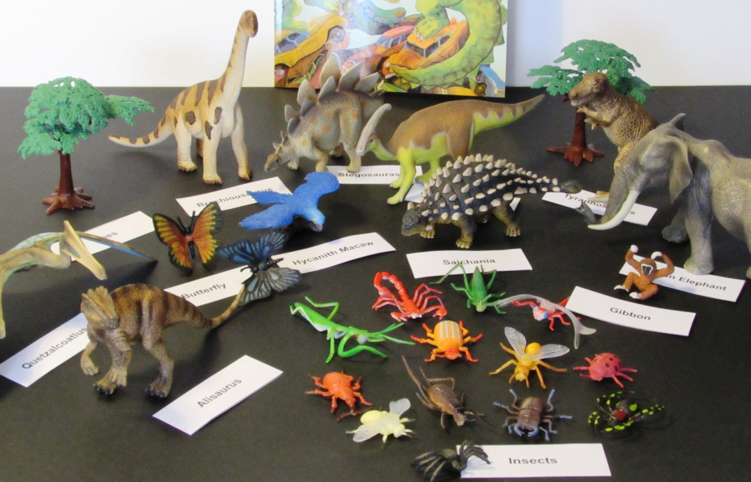
Literacy
- Imagine that you went in a journey in a rocket. Where would you go? Could you write a story about it?
- Can you rewrite the story from the man's point of view?
- Imagine a world that is full of rubbish and pollution. Can you think of words / phrases to describe it?
- Write a poem using each letter of one of the dinosaurs

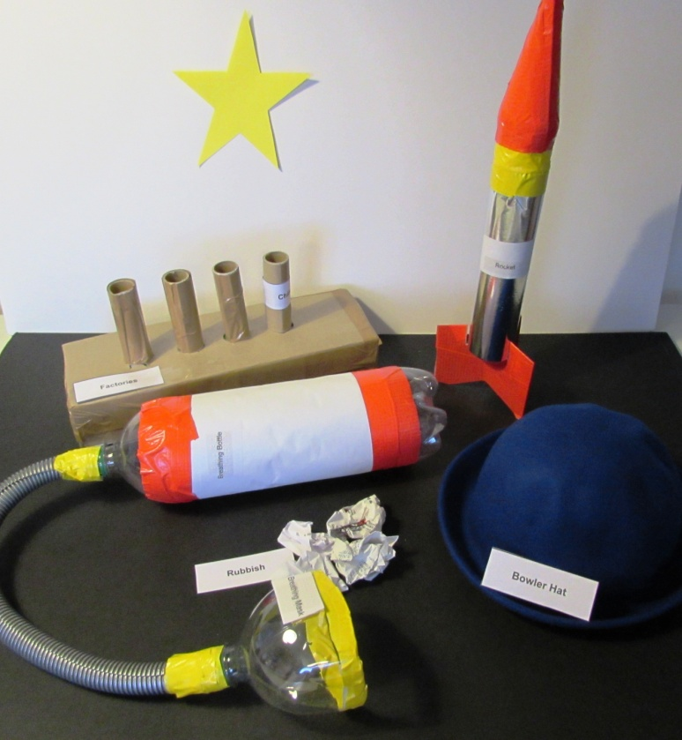

Numeracy
- Count the number of insects / dinosaurs that are in the book

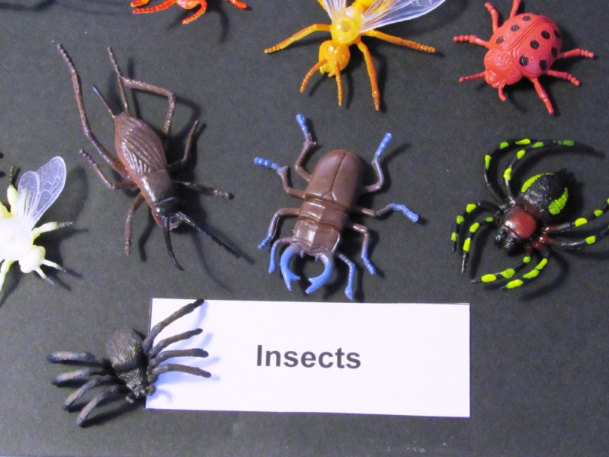
Science
- Lots of plants and trees grow throughout the story. Find out what plants need to grow healthily
- Can you write some instructions to teach someone how to care for a plant?
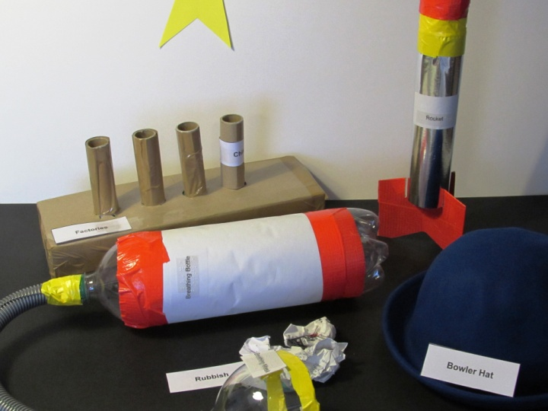
- Research the topic of dinosaurs. What different types if dinosaurs were there? How were they similar / different?
Design Technology
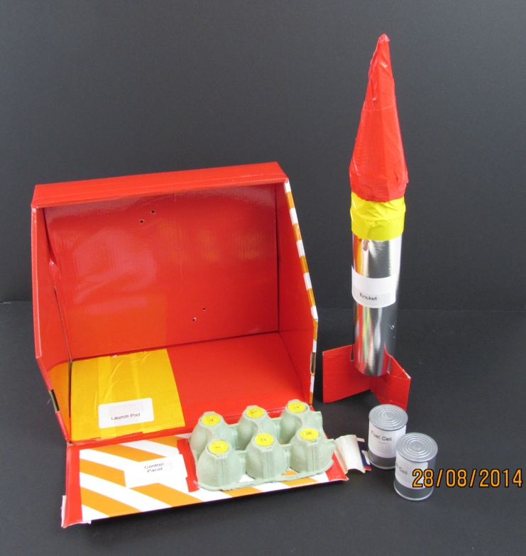
- Design a model rocket to help the man reach the star

Geography
- Find out about different types of pollution and how they affect the environment
- Make a list of things that people can do to help the environment
- Find out what happens to waste that isn't recycled
- The dinosaur explains that the earth belongs to everyone. Could you use this message on a poster / banner?
History
- Make a timeline showing when dinosaurs and humans have been alive
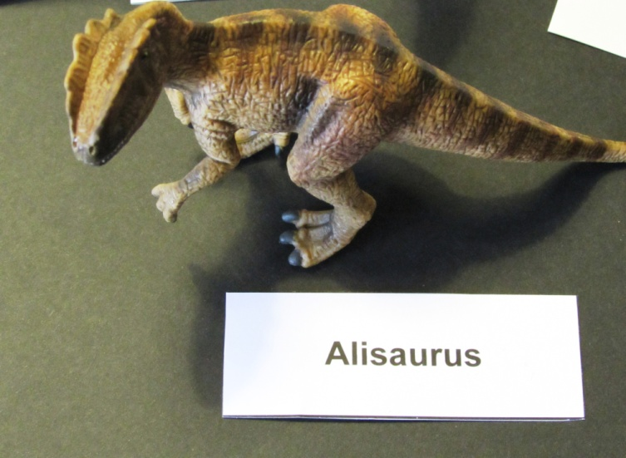
PSHE
- At the start of the story, the man dreams about the star. What are your hopes and dreams?
- The dinosaur says that the man should have been rules by his heart and not his head. What does this mean?

