

Accessibility
A Guide for Educators
Empower students with accessible technology
that enables personalized learning
Published by Microsoft Corporation
Trustworthy Computing
One Microsoft Way
Redmond, Washington 98052-6399
Managing editors: LaDeana Huyler and Gary Moulton, Trustworthy Computing, Accessibility Outreach
Edition 3.1. Published in 2011.
Copyright © 2011 Microsoft Corporation. All rights reserved.
Terms of use: www.microsoft.com/info/cpyright.mspx
Trademarks: www.microsoft.com/library/toolbar/3.0/trademarks/en-us.mspx
To download a copy of this guide, visit www.microsoft.com/enable/education
Microsoft, Windows, Internet Explorer, Natural, Outlook, and Intellimouse are either registered trademarks or trademarks of Microsoft Corporation in the United States and/or other countries. All other trademarks are property of their respective owners.
Permission for Reuse: This guide may be used for non-profit educational and training purposes only. These materials may be printed and duplicated when used for educational or training purposes and not for resale. If you or your organization wants to use these materials for any other purpose, you may submit a request to and obtain written permission from Microsoft (www.microsoft.com/about/legal/permissions/default.mspx) Requests will be considered on a case-by-case basis.

Table of Contents
About This Guide 3
Chapter 1: Personalized Learning & Accessibility 3
What is Accessibility and Accessible Technology? 4
The Need for Accessible Technology in Schools 5
The Challenge: Inclusive Classrooms with Equal Access for All Students 6
Chapter 2: Impairment Types & Technology Solutions 7
Defining “Disability” and Impairments 7
Vision Impairments 8
Learning Impairments 13
Mobility and Dexterity Impairments 14
Hearing Impairments and Deafness 21
Language Impairments 24
Chapter 3: Selecting Accessible Technology 27
Identifying the Right Mix of Accessibility Solutions 27
Accessibility in Microsoft Products 29
Assistive Technology Product Starter Guide 37
Assistive Technology Decision Tree 40
Resources 44
Resources from Microsoft 44
Additional Resources and Annual Conferences 44

About This Guide
Purpose of This Guide
In the era of personalized learning where we shift the focus from what is being taught, to what is being learned, the student’s needs and style become more central. Personalized learning requires attention to the unique needs of all students—particularly students with learning difficulties or physical disabilities. As students are encouraged to take greater responsibility for their learning, and for using technology to acquire new skills, schools have a responsibility to provide accessible technology that can be personalized for each student’s needs.
This guide from Microsoft provides information about accessibility and accessible technology to help educators worldwide ensure that all students have equal access to learning with technology. For educators new to accessibility and working with students with disabilities, accessibility can seem overwhelming. To help educators teach students with all types of abilities, you will find specific information about each type of impairment and accessible technology solutions.
How to Use This Guide
Chapter 1 provides an overview of accessibility, defines accessible technology, and discusses the importance of providing students with accessible technology in the era of personalized learning.
Chapter 2 is organized by the types of disabilities and the accessibility solutions available to help students who have such a disability. Each type of impairment is defined, and examples of accessibility features and assistive technology products helpful for those impairments are addressed. In many cases, specific product names are provided as examples.
Chapter 3 provides more in-depth information including an overview of accessibility features in the most recent versions of Microsoft® Windows®, Internet Explorer®, and Microsoft® Office. Chapter 3 also includes more details about assistive technology products and resources for selecting and finding assistive technology products for your students.
Download
This guide is available for download on the Microsoft Accessibility website www.microsoft.com/enable/education/

Chapter 1:
Personalized Learning & Accessibility
Education leaders around the world are focused on preparing students in primary and secondary schools for tomorrow’s world, with the objective of helping each one meet his or her maximum potential. This focus, combined with the realization that every child learns in a unique way, is at the heart of “personalized learning.” As educators have endeavored to reach this goal, technology has emerged as a key component in making personalized learning a reality.
As personalized learning shifts the focus from what is being taught to what is being learned, the student’s needs and style become more central. Personalized learning requires attention to the unique needs of all students—particularly students with learning difficulties or physical disabilities.
As students are encouraged to take greater responsibility for their learning and for using technology to acquire new skills, schools have a responsibility to provide accessible technology that can be personalized for each student’s needs.
Microsoft supports the personalized learning vision by providing technology that is accessible to every student—regardless of ability. Microsoft leads the industry in accessibility innovation and in building products that are safe and easy to use.
Providing accessible technology in the classroom to students with disabilities enables all students to have the same educational opportunities. For example, students with vision impairments who cannot read the small text on their screens can adjust the font and text to make it easier to read, providing them with the same content and learning opportunities as their peers.
This chapter introduces accessibility, defines exactly what accessible technology is, and why it is important to ensure all students have accessible technology in schools.

What is Accessibility and Accessible Technology?
In the context of this guide, accessible technology is defined as computer technology that enables individuals to adjust a computer to meet their vision, hearing, dexterity, cognitive, and speech needs. Accessibility makes it easier for all students to see, hear, and use a computer, and to personalize their computers to meet their own needs and preferences. For many, accessibility is what makes computer use possible. If technology is “accessible,” it can be adjusted to meet the needs and preferences of a diverse set of individuals.
Although many people believe that accessibility is just for computer users with disabilities, in reality, the majority of individuals benefit from accessibility features in their products. For example, we all enjoy the option to personalize our computers and learning environments by changing colors, font style and size, background images, and computer sounds.
Accessible technology encompasses three elements:
- Accessibility features or settings that are built into software programs and allow adjustment and customization of product settings to meet vision, hearing, mobility, language, and learning needs. For example, in Windows, changing the font size and color, and changing mouse pointer options are accessibility settings. Microsoft® Windows®, Microsoft® Office, and Microsoft® Internet Explorer® include many accessibility features and settings that make the computer easier to see, hear, and use.
- Assistive technology products (specialty hardware and software products) that are carefully chosen specifically to accommodate an individual’s disability or multiple disabilities. Examples include a screen magnification program for a computer user who has low vision or an ergonomic keyboard for a computer user with wrist pain.
- Compatibility between assistive technology products, the operating system, and software applications. This is critical for assistive technology products to function properly.
This guide presents accessibility features and assistive technology products that are compatible with Microsoft Windows. Many of the accessibility features found in Windows 7 and Windows Vista can be found through the Ease of Access Center (in Control Panel). The Ease of Access Center, Figure 1-1, provides a convenient, centralized place to find accessibility settings and programs to make your computer easier to use.
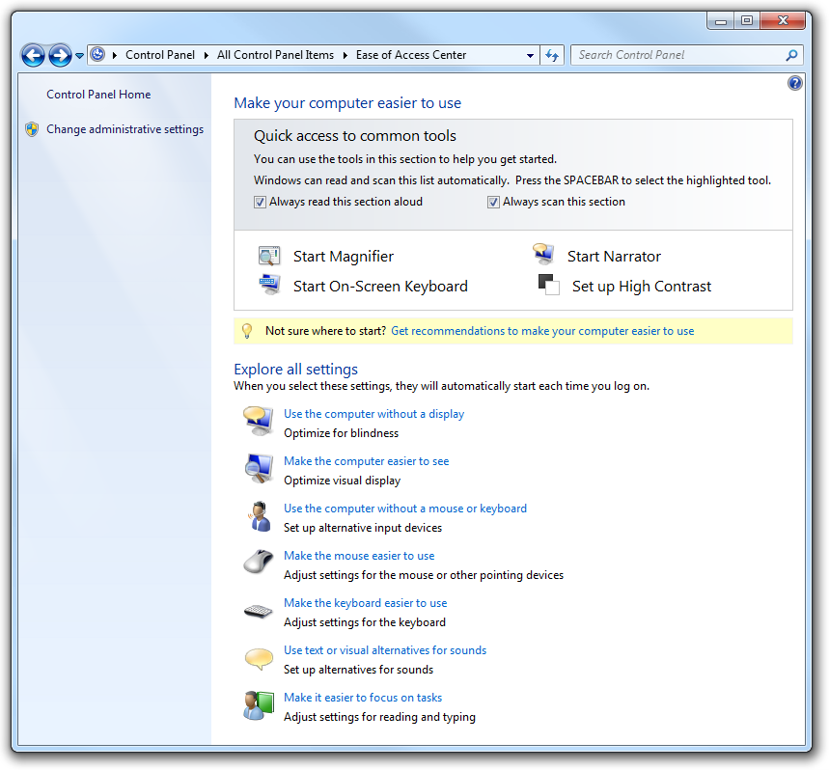
Figure 1-1. Ease of Access Center is found in Windows 7 and Windows Vista
The Need for Accessible Technology in Schools
Accessible technology in schools is important for several reasons. First and foremost, many countries--including the United States--require schools by law to provide equal access to technologies for students with disabilities, which means accommodating those students’ disabilities. Among the myriad reasons for legislating equal access is the inclusion of students with disabilities in mainstream classrooms.
In many developing countries, students with special needs are being integrated into mainstream classrooms rather than schools that focus solely on students with disabilities. This trend created a greater need for schools and educators to understand how accessible technology can benefit the diverse needs
of students.
Prevalence of Adults and Students with Disabilities Across the Globe
Although definitions of disability and statistics collected by various organizations vary widely; by any estimate, the number of people living with disabilities worldwide is very large.
The number of children with special education needs has grown the past 20 years due to increased diversity in communities and better diagnostic tools. According to Organisation of Economic Co-operation and Development, as many as 35% of school-age students need some kind of special support or have been diagnosed as having special needs.
According to the U.S. Census Bureau, 15% (15.4 million) of U.S. children aged 6 to 14 are considered to have disabilities. Numbers for ages 15 and above are slightly higher. The definition of disabilities ranges from mental retardation or some other developmental delay to limitations in seeing, hearing, speaking, and walking, to the need for personal assistance in daily living. About half of the studied age group had more than one of the selected developmental conditions. Needless to say, these individuals need educational aids such as accessible and assistive technology during their learning years.
Meanwhile, student use of computers is ever increasing, creating a need to provide accessibility accommodations to those with disabilities. In fact, 2003 data for primary and secondary students showed that nearly 64 percent use computers at both home and school, indicating the need for accessible technology outside of the classroom as well.
Educational Technology in Schools and the Workforce of the Future
As the numbers of students with disabilities integrated into general education classrooms has increased, so has the use of computers in classrooms. In many countries, nearly all students have access to a computer at school.
Students with and without disabilities are our future workforce. Computer technology is an important and powerful tool, and is known to increase employment opportunities for people with disabilities. Integrating accessible technology into schools, and introducing it to students with disabilities early in their educational lives, will not only enhance their learning, but also their future employment options.
The Challenge: Inclusive Classrooms with Equal Access
for All Students
With the increased use of computers in schools, and the increased number of students with disabilities placed in inclusive general education classrooms, it is even more vital to ensure that all students have equal access to computer technology and the educational opportunities it provides.
Often, computerized instructional materials are not available in formats that are accessible to students with disabilities. And, inaccessible materials can stigmatize children with disabilities by preventing them from learning along with their peers, thereby limiting their educational opportunities. Therefore, as technology becomes more prevalent in classrooms, students with disabilities face even more challenges in keeping pace with their classmates if they can’t use that technology.
Fortunately, personal productivity software publishers and educational software developers are beginning to include children with disabilities in their target audiences. As an educator, you can help ensure that students with disabilities have the same access to technology as general education students by seeking out solutions that are accessible for students you know to have disabilities. In the process, you will notice other students with various learning styles who will also benefit. Accessibility benefits everyone.

Chapter 2:
Impairment Types & Technology Solutions
In this chapter, the term “disability” is discussed, and the different types of impairments are outlined including vision, mobility and dexterity, hearing, language, learning, and age-related impairments. Specific examples of accessible technology solutions are provided for each type of impairment.
Defining “Disability” and Impairments
A quick Internet search on the question “What is the definition of disability?” is likely to net thousands of matches. Each person who tackles the question does so from a particular perspective and bias. In fact, most of us already have formed our own definition of what disability means to us based on our own frame of reference. In many cases, the definition is all about legal contracts and insurance benefits.
The definition of a disability or impairment, however it is defined, is relevant in this discussion only because we discuss accessible technology solutions for different types of impairments. Before determining how accessible technology can benefit your students, it is beneficial to understand the types of impairments and how those impairments impact computer use.
More Info
Find resources published by the National Association of Special Education Teachers at www.naset.org
Below, find descriptions of impairment types and suggested accessibility features and assistive technology products for:
- Vision impairments
- Learning impairments
- Mobility and dexterity impairments
- Hearing impairments and deafness, and
- Language impairments.
Vision Impairments
Among computer users in the United States, approximately 1 in 4 (27%) has a vision impairment that impacts computer use. There are many options for individuals with vision difficulties to modify their computer displays and appearance to make them easier to see, or, alternatively, to receive information through sound or touch.
Did You Know?
Visual acuity is expressed as a fraction. The top number refers to the distance you stand from the vision chart, which is usually 20 feet. So, 20/200 vision indicates that the line you correctly read at 20 feet could be read by a person with normal vision at 200 feet.
Vision impairments include:
- Low vision. Students with low vision do not have clear vision even with the use of eyeglasses, contact lenses, or intraocular lens implants. There are many ways to adjust and personalize the appearance of Windows to make it easier to see for an individual with vision impairment. For students with vision impairments and low vision, the computer monitor, appearance, text and icon size, and resolution should all be modified to make text and images more legible and easier to see. For students who still have difficulty seeing things on the screen, sound and touch options are available through Windows and compatible assistive technology products to make computing possible. Below you’ll find options in Windows to increase clarity and legibility on the screen to make the computer easier to see.
- Colorblindness. Students who are colorblind have difficulty seeing particular colors or distinguishing between certain color combinations. Computer programs that allow users to choose the display’s color combinations and adjust screen contrast are helpful for people who are colorblind. Individuals with a variety of vision impairments often find it easier to read white text on a black background instead of black on white. Windows lets you use High Contrast schemes, or select your own color schemes so you can find colors that are easiest for you to read.
- Blindness. Blindness occurs in a variety of degrees, and many people who are considered blind do have some measure of sight. For example, a person whose level of sight is equal to or less than 20/200—even with corrective glasses or lenses—is considered “legally blind” in the United States. A person who is completely sightless is considered “blind.” Many diseases and conditions contribute to, or cause, blindness, including cataracts, cerebral palsy, diabetes, glaucoma, and multiple sclerosis. Accidents, diabetes, and macular degeneration account for most blindness in the United States. Worldwide, according to the World Health Organization, the number of people blinded by infectious diseases has been greatly reduced, but age-related impairment is increasing. Cataract remains the leading cause of blindness globally.
Students who are blind can interact with a computer through screen readers, keyboards, Braille devices, and audio/voice rather than a traditional monitor and mouse. The use of sophisticated assistive technology provides for both computer input and output, and is critical for people who
are blind.
Students who are both deaf and blind can also use computers through assistive technology products. To someone who is both deaf and blind, captioning and other sound options are of no use, but Braille assistive technology products are critical. People who are both deaf and blind can use computers by using refreshable Braille displays and Braille embossers, discussed below.
Accessibility Features in Windows
Windows makes it easy to find options helpful for students who have difficulty seeing the screen, or for students who are blind and need to use the computer without a display. Below you will find accessibility features in Windows 7 and Windows Vista organized by how to make the computer easier to see, how to use the computer without a display (or monitor), and by keyboard shortcuts.
Make the computer easier to see
For students who have vision impairments and low vision, start by using the Make the computer easier to see page in the Ease of Access Center found in Windows 7 and Windows Vista.
Tip
To go to the Ease of Access Center, press Windows logo key + U.
- In Windows 7 or Windows Vista, open the Make the computer easier to see page by clicking the Start button, clicking Control Panel, clicking Ease of Access, clicking Ease of Access Center, and then clicking Make the computer easier to see.
- On the Make the computer easier to see page, you can select the options that you want to use:
  - Choose a High Contrast theme. This option allows you to set a high-contrast color scheme that heightens the color contrast of some text and images on your computer screen, making those items more distinct and easier to identify.
  - Turn on or off High Contrast when Left ALT+LEFT SHIFT+PRINT SCREEN is pressed. This option allows you to toggle a high-contrast theme on or off by pressing the LEFT ALT+LEFT SHIFT+PRTSCN (Print Screen) keys.
  - Turn on Narrator. This option sets Narrator to run when you log on to your computer. Narrator reads aloud on-screen text and describes some on-screen events (such as error messages appearing) while you're using the computer. For more information about using Narrator, see
Hear text read aloud with Narrator.
  - Turn on Audio Description. This option sets Audio Descriptions to run when you log on to your computer. Audio Descriptions describe what's happening in videos.
  - Change the size of text and icons. This option allows you to make text and other items on your screen appear larger, so they're easier to see. For more information, see Make the text on your screen larger or smaller.
  - Turn on Magnifier. One of the most common accessibility solutions for a computer user with low vision is a screen magnifier. Microsoft Windows includes a screen magnifier program called Magnifier which enlarges portions of the screen making it easier to view text and images and to see the whole screen more easily. Magnifier in Windows 7 now includes full-screen mode, lens mode, and docked mode. The magnification quality is improved and you can set the magnification level up to 16 times the original size, and choose to track what you magnify by movement of your mouse, the keyboard, or text editing. For more information about using Magnifier, see Make items on the screen appear bigger (Magnifier).
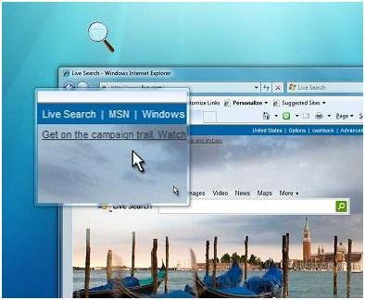
Figure 2-1. Magnifier in lens mode
  - Adjust the color and transparency of the window borders. This option allows you to change the appearance of window borders to make them easier to see.
  - Fine tune display effects. This option allows you to customize how certain items appear on your desktop.
  - Make the focus rectangle thicker. This option makes the rectangle around the currently selected item in dialog boxes thicker, which makes it easier to see.
  - Set the thickness of the blinking cursor. This option allows you to make the blinking cursor in dialog boxes and programs thicker and easier to see.
  - Turn off all unnecessary animations. This option turns off animation effects, such as fading effects, when you close windows and other elements.
  - Remove background images. This option turns off all unimportant, overlapped content and background images to help make the screen easier to see.
For additional information about how to use accessibility features in Windows and other Microsoft products, see the Microsoft Accessibility Tutorials available online at www.microsoft.com/enable/training/.
Use the computer without a display
For students who are blind, or partially blind, assistive technology products will be critical for productive computer use. To get started, Windows has many features that enable students to use the computer without a display. For example, you can have screen text read aloud by using Narrator or you can have Windows describe screen activity to you.
For students who are blind and cannot use a monitor you can turn on or adjust settings to Use the computer without a display in the Ease of Access Center. Below, you’ll find assistive technology products that will be needed for students who are blind or partially blind.
Tip
To go to the Ease of Access Center, press Windows logo key + U.
- In Windows 7 or Windows Vista, open the Use the computer without a display page by clicking the Start button , clicking Control Panel, clicking Ease of Access, clicking Ease of Access Center, and then clicking Use the computer without a display.
- On the Use the computer without a display page, select the options that you want to use:
  - Turn on Narrator. Windows comes with a basic screen reader called Narrator, which reads text on the screen aloud and describes some events (such as an error message appearing) that happen while you're using the computer. This option sets Narrator to run when you log on to Windows. Narrator reads aloud on-screen text and describes some on-screen events (such as error messages appearing) while you're using the computer. For more information about Narrator, see Hear text read aloud with Narrator.
  - Turn on Audio Description. This option sets Audio Description to run when you log on to Windows. Audio descriptions describe what's happening in videos.
  - Turn off all unnecessary animations. This option turns off animation effects, such as fading effects, when windows and other elements are closed.
  - How long should Windows notification dialog boxes stay open? This option sets how long notifications are displayed on the screen before they are closed.
Keyboard shortcuts
Keyboard shortcuts are combinations of two or more keys that, when pressed, can be used to perform a task that would typically require a mouse or other pointing device. Keyboard shortcuts can make it easier for students with all kinds of impairments, particularly vision impairments, to interact with their computers. Memorizing a few keyboard shortcuts makes it easier for some students who have difficulty seeing the monitor or keyboard to quickly accomplish tasks.
A list of keyboard shortcuts for Windows is available at http://windows.microsoft.com/en-US/Windows7/
Keyboard-shortcuts
Assistive Technology Products for Students with Vision Impairments
For the operating system or an application to be accessible to someone who is blind, it must provide information about its interactions with the user so that assistive technology can then present it in an alternative format. For example, if the computer provides a list box containing several selections to choose from, the assistive technology product must inform a computer user who is blind that he or she needs to choose from a list of selections. The list of selections might be spoken or presented in a tactile fashion with a Braille display. A common assistive technology product used by people who are blind is a screen reader. Screen readers are software programs that present graphics and text as speech. Computer users who are blind also may use Braille displays and Braille printers—in fact, a combination of assistive technology products is quite common.
Assistive Technology Product Guide
Chapter 3 includes a table with details about specific assistive technology products.
Assistive technology products with different capabilities are available to help people with vision impairments. Some assistive technology products provide a combination of capabilities that help specific individuals. Assistive technology products that are helpful to students and adults with vision impairments are described in the following list.
- Screen magnifiers work like a magnifying glass. They enlarge a portion of the screen as the user moves the focus—increasing legibility for some users. Some screen enlargers (software or hardware) allow a user to zoom in and out on a particular area of the screen. Learn about Magnifier in Windows 7 and Windows Vista, and the built-in zoom and magnify features in Microsoft’s mouse and keyboard products. Another example of a screen magnifier program is ZoomText by AiSquared.
- Screen readers are software programs that present graphics and text as speech. A screen reader is used to verbalize, or "speak," everything on the screen including names and descriptions of control buttons, menus, text, and punctuation. An example of a screen reader is Window-Eyes.
- Braille printers (or embossers) transfer computer generated text into embossed Braille output. Braille translation programs convert text scanned in or generated via standard word processing programs into Braille, which can be printed into raised Braille. The Tiger Cub Jr. is an example of a Braille printer.
- Braille displays, as shown in Figure 2-2, provide tactile output of information represented on the computer screen. The user reads the Braille letters with his or her fingers, and then, after a line is read, refreshes the display to read the next line. The Seika Braille Display is an example.
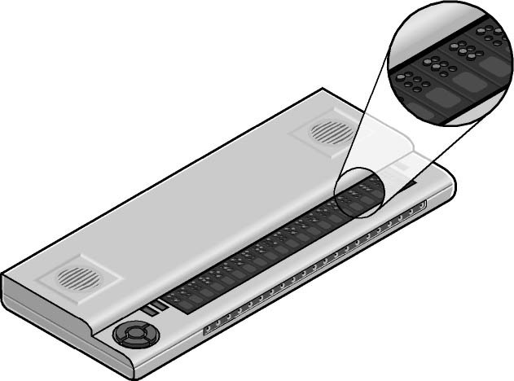
Figure 2-2. Braille display
- Braille notetakers enable a student who is blind to capture notes and then transfer them to a PC. Braille notetakers take advantage of refreshable Braille technology. In some cases, Braille notetakers replace or supplement a standard keyboard. An example of such a notetaker is the Eurobraille Esys.
- Book readers. Students with low vision need book reading assistance. Magnification devices are available as a desktop magnification aid (such as Desktop SenseView DSV) or as a portable magnification aid (such as SmartView Nano Magnifier). A student may also use a PC configuration for book reading assistance (for example, Cicero Text Reader). Some students may also use a dedicated reading device (such as the Victor Reader Wave). A student’s ability to read classroom materials and the accommodations they will use is dependent upon the format in which the material is available. For example, printed materials and books can be read by students with low vision with the assistance of a desktop or portable magnification aid. A student who is blind would need to have printed material scanned and read aloud through a text-to-speech software program on the PC. Books are available in digital formats through organizations such as Bookshare (www.benetech.org) and Recording for the Blind and Dyslexic (www.rfbd.org). The most common digital format is called DAISY. There is an add-in for Microsoft Word to convert documents to DAISY format. The Word to DAISY translator lets you take a document in Microsoft Word 2010, 2007, 2003 and XP and easily convert the Word document to the talking DAISY book format. This makes it easier for teachers and students to share Word documents with students who need to use book readers to read documents. Learn more and download the DAISY/Word add-in at http://office.microsoft.com/en-us/help/HA102786941033.aspx.
Learning Impairments
Learning impairments can range from conditions such as dyslexia and attention deficit disorder to retardation. Processing problems are the most common and have the most impact on a person’s ability to use a computer. These conditions interfere with the learning process.
Many students with these impairments are perfectly capable of learning if information is presented to them in a form and at a pace that is appropriate to them individually. Information that is presented in short, discrete units is often easier to understand. In addition, many individuals with learning disabilities learn more efficiently using their visual abilities rather than their auditory skills. Many are primarily visual or auditory learners, whereas other learners are “ambidextrous.” Control over the individual learner’s single- or multisensory experience is critical.
Did You Know?
According to the International Dyslexia Association and the Learning Disabilities Association of America, about 15% of the population (close to 1 in 7) has a learning disability.
Accessibility Features in Windows
The simplified interface in Windows 7 and Windows Vista benefits people with learning impairments, as well as people with language impairments, because it helps reduce the number of competing elements on the screen. Complicated user interfaces can interfere with learning. User interface engineers found that an emphasis on a consistent user experience had the greatest positive impact on individuals with processing problems. Consider the student who can’t read his own handwriting but can edit for others by using a computer. Additional computer settings such as adjustable text and screen element sizes, speech capabilities, choice of visual or sound warnings for system events, and Internet display options can benefit those with learning impairments.
Features in Windows and Office that might be useful for students with learning impairments include:
- Making it easier to focus on reading and typing tasks
- Checking spelling and grammar in Office programs
- Using AutoComplete in Office
Making it easier to focus on reading and typing tasks
You can use the settings on the Make it easier to focus on tasks page in the Ease of Access Center in Windows 7 and Windows Vista to reduce the amount of information on the screen and to help students focus on reading and typing tasks.
In Windows 7 or Windows Vista, open the Make it easier to focus on tasks page by clicking the Start button , clicking Control Panel, clicking Ease of Access, clicking Ease of Access Center, and then clicking Make it easier to focus on tasks.
Checking spelling and grammar in Office programs
In Microsoft Office 2010, the Spelling & Grammar command is on the Review tab. Also on the Review tab, are the Research, Thesaurus, and Translate commands which also may be helpful for students.
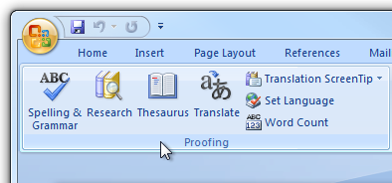
Figure 2-3. Office 2010 Spelling & Grammar button on the Review tab
Assistive Technology Products for Students with Learning Impairments
Assistive technology products used with computers by people with learning impairments are described in the following list.
- Word prediction programs allow the user to select a desired word from an on-screen list located in the prediction window. The program predicts words from the first one or two letters typed by the user. The word can then be selected from the list and inserted into the text by typing a number, clicking the mouse, or scanning with a switch. These programs help support literacy, increase written productivity and accuracy, and increase vocabulary skills through word prompting. ClaroRead Standard and TextHelp’s Read & Write Standard are just two examples of such programs.
- Reading tools and learning disabilities programs include software designed to make text-based materials more accessible for people who struggle with reading. Options can include scanning, reformatting, navigating, or speaking text out loud. These programs help people who have difficulty seeing or manipulating conventional print materials; people who are developing new literacy skills, or who are learning English as a foreign language; and people who comprehend better when they hear and see text highlighted simultaneously. The Universal Reader is an example of assistive technology that can make reading easier.
- Speech synthesizers (also known as text-to-speech) speak information aloud in a computerized voice. Speech synthesizers can be helpful for students with learning, language, or vision impairments. Products such as Scan and Read Pro produce natural sounding speech synthesis that can support reading skills development.
- Speech recognition programs allow computer navigation by voice rather than entering data by keyboard or mouse. You can still use a mouse and keyboard as well as voice, to enter data, write text, and navigate applications. Students who have difficulty typing or reading text because of a learning, language, or mobility impairment can often successfully work on a computer with the use of speech recognition. Speech Recognition is available in Windows 7 and Windows Vista. Some may prefer or require a more robust speech recognition program, such as Dragon NaturallySpeaking.
Mobility and Dexterity Impairments
Mobility and dexterity impairments can be caused by a wide range of common illnesses and accidents such as cerebral palsy, multiple sclerosis, loss of limbs or digits, spinal cord injuries, and repetitive stress injury, among others. As a result of accidents or conditions, students might be unable to use (or be without) arms or fingers to interact with their computers using a standard keyboard or mouse.
Others who have dexterity impairments or pain in their hands, arms, and wrist might need to adjust settings to make it more comfortable to use a keyboard or mouse. For example, some people cannot press multiple keys simultaneously (like CTRL+ALT+DELETE). Still others might strike multiple keys or repeat keys unintentionally. Some students might have use of their hands and arms but have a limited range of motion. All of these conditions can make using a standard mouse or keyboard difficult, if not impossible.
Mobility and dexterity impairments need to be individually addressed to choose the right mix of accessibility features in Windows and assistive technology hardware and software solutions.
There are many types of products available to allow students to use a computer, even if the students can move only their eyes. Outlined below are accessibility features in Windows to make the mouse and keyboard more comfortable. In addition, you can set up a computer for a student who needs to use an on-screen keyboard and other alternative input options rather than a standard keyboard or mouse. Following are examples of assistive technology hardware and software products.
Accessibility Features in Windows
Accessibility features built into Windows that are useful to people with mobility impairments include keyboard filters that compensate somewhat for erratic motion, tremors, slow response time, and similar conditions. For example, Sticky Keys (a feature in Windows) allows the user to enter key combinations without having to hold one key down while depressing a second. Other options allow users to adjust how quickly a letter appears on the screen when they hold down a key. In addition, Windows allows users to adjust mouse options such as button configuration, double-click speed, pointer size, and how quickly the mouse pointer responds to movements of the mouse. Users can also increase the size of screen elements to provide a larger target, which can benefit people who have disabilities related to fine motor skills.
Make the mouse easier to use
For students who have pain or discomfort when using the mouse, or other dexterity impairments, consider a different style of mouse (options discussed below), and try changing the size of the mouse cursor and the mouse button options to make the mouse easier to use. Start by exploring the mouse options available on the Make the mouse easier to use page in the Ease of Access Center.
Tip
To go to the Ease of Access Center, press Windows logo key + U.
- In Windows 7 or Windows Vista, open the Make the mouse easier to use page by clicking the Start button , clicking Control Panel, clicking Ease of Access, clicking Ease of Access Center, and then clicking Make the mouse easier to use.
- On the Make the mouse easier to use page, select the options that you want to use:
  - Change the color and size of mouse pointers. You can use these options to make the mouse pointer larger, or change the color to make it easier to see.
  - Turn on Mouse Keys. You can use this option to control the movement of the mouse pointer by using the numeric keypad.
  - Activate a window by hovering over it with the mouse. This option makes it easier to select and activate a window by pointing at it with the mouse rather than by clicking it.
  - Prevent windows from being automatically arranged when moved to the edge of the screen. This option prevents windows from automatically resizing and docking along the sides of your screen when you move them there.
  - You can also change mouse settings including customizing the mouse in a variety of ways, such as reversing the functions of your mouse buttons, making the mouse pointer more visible, and altering the scroll wheel speed. In Windows 7 and Windows Vista, open the Mouse Control Panel by clicking the Start button , clicking Control Panel, clicking Hardware, and then clicking Mouse.
Make the keyboard easier to use
For a student who has pain or discomfort when using the keyboard, consider a different style of keyboard (options discussed below) and also make sure to adjust the keyboard controls. You can adjust these settings on the Make the keyboard easier to use page in the Ease of Access Center.
- In Windows 7 or Windows Vista, open the Make the keyboard easier to use page by clicking the Start button , clicking Control Panel, clicking Ease of Access, clicking Ease of Access Center, and then clicking Make the keyboard easier to use.
- On the Make the keyboard easier to use page, select the options that you want to use:
  - Turn on Mouse Keys. This option sets Mouse Keys to run when you log on to Windows. Instead of using the mouse, you can use the arrow keys on your keyboard or the numeric keypad to move
the pointer.
  - Turn on Sticky Keys. This option sets Sticky Keys to run when you log on to Windows. Instead of having to press three keys at once (such as when you must press the CTRL, ALT, and DELETE keys together to log on to Windows), you can use one key at a time by turning on Sticky Keys and adjusting the settings. Then, you can press a modifier key and have it remain active until another key is pressed.
  - Turn on Toggle Keys. This option sets Toggle Keys to run when you log on to Windows. Toggle Keys can play an alert each time you press the CAPS LOCK, NUM LOCK, or SCROLL LOCK keys. These alerts can help prevent the frustration of inadvertently pressing a key and not realizing it.
  - Turn on Filter Keys. This option sets Filter Keys to run when you log on to Windows. You can set Windows to ignore keystrokes that occur in rapid succession, or keystrokes that are held down for several seconds unintentionally.
  - Underline keyboard shortcuts and access keys. This option makes keyboard access in dialog boxes easier by highlighting access keys for the controls in them. (For more information about keyboard shortcuts, see below).
  - Prevent windows from being automatically arranged when moved to the edge of the screen. This option prevents windows from automatically resizing and docking along the sides of your screen when you move them there.
Keyboard shortcuts
Keyboard shortcuts are combinations of two or more keys that, when pressed, can be used to perform a task that would typically require a mouse or other pointing device. Keyboard shortcuts can make it easier for students with all kinds of impairments, particularly dexterity impairments who might find using the mouse tiresome. Memorizing a few keyboard shortcuts makes it faster for students to get to where they need to go.
A list of keyboard shortcuts for Windows is available at http://windows.microsoft.com/en-US/Windows7/
Keyboard-shortcuts
Here are a few keyboard shortcuts for the features mentioned in this section:
Press this key | To do this
RIGHT SHIFT for eight seconds | Turn Filter Keys on and off
LEFT ALT+LEFT SHIFT+PRTSCN (or PRTSC) | Turn High Contrast on or off
LEFT ALT+LEFT SHIFT+NUM LOCK | Turn Mouse Keys on or off
SHIFT five times | Turn Sticky Keys on or off
NUM LOCK for five seconds | Turn Toggle Keys on or off
Windows logo key +U | Open the Ease of Access Center
Use the computer without the mouse or keyboard
Windows has two features that make it possible to use the computer without using a mouse or keyboard: Speech Recognition, which lets you use voice commands to navigate Windows 7 or Windows Vista, and On-Screen Keyboard, which lets you enter text by selecting keys on a visual keyboard on the screen.
You can turn on or adjust settings for these features on the Use the computer without a mouse or keyboard page in the Ease of Access Center.
Tip
To go to the Ease of Access Center, press Windows logo key + U.
- In Windows 7 or Windows Vista, open the Use the computer without a mouse or keyboard page by clicking the Start button , clicking Control Panel, clicking Ease of Access, clicking Ease of Access Center, and then clicking Use the computer without a mouse or keyboard.
- Select the options that you want to use:
  - Use On-Screen Keyboard. On-Screen Keyboard displays a visual keyboard with all the standard keys. Instead of relying on the physical keyboard to type and enter data, you can use On-Screen Keyboard to select keys using the mouse or another pointing device. On-Screen Keyboard in Windows 7 can be resized and customized to make it easier to see and use. On-Screen Keyboard now also includes text prediction in eight languages. When text prediction is enabled, as you type, On-Screen Keyboard displays a list of words that you might be typing. For more information, see Type without using the keyboard (On-Screen Keyboard).
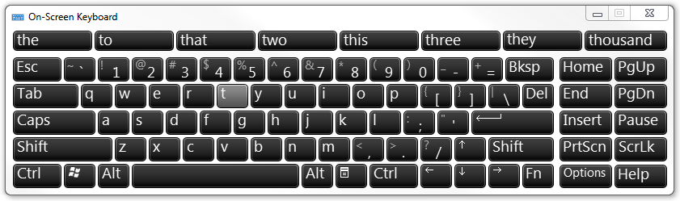
Figure 2-4. On-Screen Keyboard in Windows 7 with text prediction
- Use Speech Recognition. Use this option to control the computer with your voice. With a microphone, you can speak commands that the computer will understand and respond to, as well as dictate text. For more information about setting up Speech Recognition, see Set up Speech Recognition.
Assistive Technology Products for Students with Mobility and Dexterity Impairments
The following list describes assistive technology products used with computers by people with mobility and dexterity impairments.
- Ergonomic keyboards and mice. Ergonomic keyboards and mice are designed to be more comfortable than a standard keyboard and mouse. To improve the quality and health of your PC experience, Microsoft designers and ergonomists created industry-leading keyboard and mouse products to encourage healthier hand and wrist positions. Microsoft® Natural® keyboards and mice have set the industry standard for comfort, and can significantly reduce carpal tunnel syndrome symptoms. Microsoft keyboards and mice also have built-in zoom and magnifier options.
- Joysticks can be plugged into the computer’s mouse port and used to control the cursor on the screen. Joysticks benefit users who need to operate a computer with or without the use of their hands. For example, some people might operate the joystick with their feet or with the use of a cup on top of the joystick that can be manipulated with their chin. An example of a joystick is the SAM-Joystick.
- Trackballs look like an upside down mouse with a movable ball on top of a stationary base. An example of a trackball is shown in Figure 2-5. The ball can be rotated with a pointing device or a hand. People who have fine motor skills but lack gross motor skills can use these devices more easily and comfortably than a traditional mouse. BigTrack is an example of a trackball style mouse that is more comfortable for many people with dexterity issues.

Figure 2-5. Trackball
- On-screen keyboard programs provide an image of a standard or modified keyboard on the computer screen. The user selects the keys with a mouse, touch screen, trackball, joystick, switch, or electronic pointing device. On-screen keyboards often have a scanning option. With the scanning capability turned on, the individual keys on the on-screen keyboard are highlighted. When a desired key is highlighted, the user is able to select it by using a switch positioned near a body part that he or she has under voluntary control. On-Screen Keyboard is found in Windows 7 and Windows Vista. Another example is ScreenDoors 2000 which is another on-screen keyboard product that can be helpful for some students.
- Keyboard filters include typing aids such as word prediction utilities and add-on spelling checkers. These products can often be used to reduce the number of keystrokes. As an example, imagine you have to type the letter “g.” However, in order to type the letter, you first have to move your finger over the entire first row of your keyboard and halfway across the second row. Along the way, you might accidentally depress “R,” “P,” or “D” keys, but you only want the letter “g.” Keyboard filters enable users to quickly access the letters they need and to avoid inadvertently selecting keys they don’t want. SoothSayer Word Prediction is an example of a keyboard filter.
- Touch screens are devices placed on the computer monitor (or built into it) that allow direct selection or activation of the computer by touching the screen. These devices can benefit some users with mobility impairments because they present a more accessible target. It is easier for some people to select an option directly rather than through a mouse movement or keyboard. Moving the mouse or using the keyboard for some might require greater fine motor skills than simply touching the screen to make a selection. Other users might make their selections with assistive technology such as mouth sticks. With Windows 7 and a touch-screen monitor, you can just touch your computer screen for a more direct and natural way to work. Use your fingers to scroll, resize windows, play media, and pan and zoom. Additional touch screen technologies are available for Windows.
- Alternative PC hardware and all-access workstations. In some cases, alternative PC hardware is needed. Some individuals with mobility impairments find it challenging to open the monitor of a laptop because the laptop latch isn’t accessible for them. Or, some students might need a laptop to be mounted to a wheelchair. Such assistive technology solutions are referred to as “all-access workstations.” The Desktop SenseView DSV is an alternative PC workstation that is easy to control with dexterity impairments and enlarges text for students with vision impairments.
- Alternative input devices allow users to control their computers through means other than a standard keyboard or pointing device.
Alternative input devices include:
  - Alternative keyboards available in different sizes with different keypad arrangements and angles. Larger keyboards (one example is BigKeys LX) are available with enlarged keys (see the example shown in Figure 2-6, following page), which are easier to access by people with limited motor skills. Smaller keyboards are available with smaller keys (or keys placed closer together) to allow someone with a limited range of motion to reach all the keys. Many other keyboards are also available⎯one hand keyboards, keyboards with keypads located at various angles, and split keyboards where the keypad is split into sections.
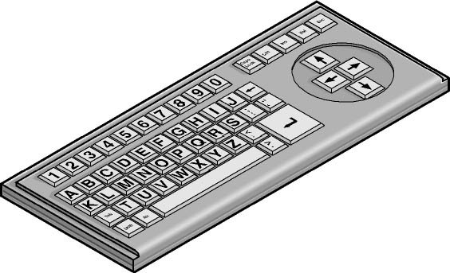
Figure 2-6. Alternative keyboard with large keys and ABC layout
  - Electronic pointing devices allow the user to control the cursor on the screen using ultrasound, an infrared beam, eye movements, nerve signals, or brain waves. When used with an on-screen keyboard, electronic pointing devices also allow the user to enter text or data. The assistive technology product HeadMouse Extreme is an example of a pointing device.
  - Sip-and-puff device, shown in Figure 2-7, refers to just one of many different types of switch access. In typical configurations, a dental saliva extractor is attached to a switch. An individual uses his or her breath to activate the switch. For example, a puff generates the equivalent of a keystroke, the pressing of a key, a mouse click, and so on. Maintaining constant “pressure” on the switch (more like sucking than sipping) is the equivalent of holding a key down. With an on-screen keyboard, the user “puffs” out the letters. Moving the cursor over a document’s title bar and “sipping” enables the user to drag items around on the screen just as you would with a mouse. This technology is often used with on-screen keyboards. The Jouse 2 is an example of a sip-and-puff device.
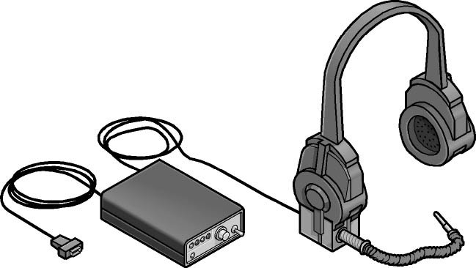
Figure 2-7. Sip-and-puff device
  - Wands and sticks are typing aids used to strike keys on the keyboard. They are most commonly worn on the head, held in the mouth, strapped to the chin, or held in the hand. They are useful for people who need to operate their computers without the use of their hands or who have difficulty generating fine movements. The majority of these devices are customized for a user by adapting a pencil, or wooden dowel which can be purchased in any hardware store.
Hearing Impairments and Deafness
Hearing impairments encompass a range of conditions—from slight hearing loss to deafness. It is estimated that 1 in 5 computer users has some form of hearing loss.
Hearing impairments include:
- Hearing loss and hard-of-hearing. Students who have hearing loss or are hard-of-hearing may be able to hear some sound, but might not be able to distinguish words. People with this type of hearing impairment can use an amplifying device to provide functional hearing. On the computer, adjusting sounds, using alternatives for sounds such as visual indicators and captions, and headphones to eliminate background noise can be helpful options.
- Deafness. Students who are deaf may not be able to hear any sounds or words spoken. It is helpful to adjust the computer to use visual alternatives for sounds.
Computer Use among People Who Are both Deaf and Blind
Although it’s not well known, people who are both deaf and blind can use computers with the aid of assistive technology. To someone who is both deaf and blind, captioning and other sound options are of no use, but Braille assistive technology products are critical. People who are both deaf and blind can use computers with assistive technology such as refreshable Braille displays and Braille embossers.
Accessibility Features in Windows
Accessibility features for those with hearing impairments include changing notifications from sound to visual notifications, volume control, and captioning. These features are available in Windows 7 and Windows Vista. Visual notifications (Sound Sentry) and captions (Show Sounds) allow users to choose to receive visual warnings and text captions, rather than sound messages, for system events such as a new e-mail message arriving.
Accessibility features helpful for students who have hearing impairments include:
- Adjusting volume
- Changing computer sounds
- Using text or visual alternatives for sounds
Adjusting volume
Although most speakers have a volume control, you can also control speaker volume using Windows. The quickest way to change the speaker volume for your computer is to click the Speakers button in the notification area of the taskbar, and then move the slider up or down to increase or decrease the
speaker volume.
To adjust overall sound volume in Windows 7 or Windows Vista:
- Open Volume Control by clicking the Start button , clicking Control Panel, clicking Hardware and Sound, and then, under Audio Devices and Sound, clicking Adjust system volume.
- Under Main Volume, move the slider up or down to raise or lower the volume.
Change computer sounds
You can select the sounds that play when certain events occur on screen. This is helpful for students who have trouble hearing some sounds—high or low-pitched sounds, for example, or sounds associated with other devices. To change sounds in Windows 7 or Windows Vista:
- Open Sound by clicking the Start button , and then clicking Control Panel. In the search box, type sound, and then click Sound.
- Click the Sounds tab.
- In the Sound Scheme list, click the sound scheme that you want to use, and then click OK.
To change an individual sound, select an event (under Program Events) to which you want to assign a new sound. You can click Test to hear each sound.
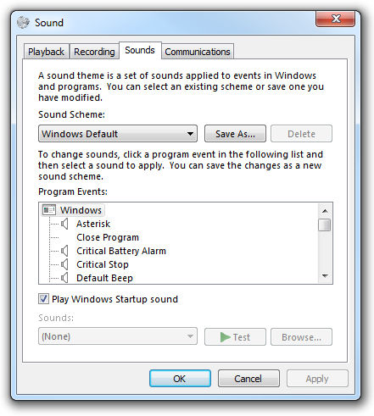
Figure 2-8. Sound options
Use text or visual alternatives to sounds
Windows provides settings for using visual cues to replace sounds in many programs. You can adjust these settings on the Use text or visual alternatives for sounds page in the Ease of Access Center.
- In Windows 7 or Windows Vista, open the Use text or visual alternatives for sounds page by clicking the Start button , clicking Control Panel, clicking Ease of Access, clicking Ease of Access Center, and then clicking Use text or visual alternatives for sounds.
- On the Use text or visual alternatives for sounds page, select the options that you want to use:
  - Turn on visual notifications for sounds. This option sets sound notifications to run when you log on to Windows. Sound notifications replace system sounds with visual cues, such as a flash on the screen, so that system alerts are noticeable even when they're not heard. You can also choose how you want sound notifications to warn you.
  - Turn on text captions for spoken dialog. This option causes Windows to display text captions in place of sounds to indicate that activity is happening on your computer (for example, when a document starts or finishes printing).
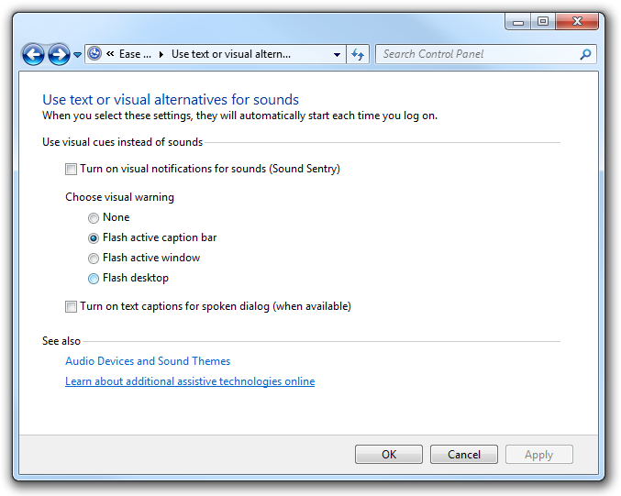
Figure 2-9. Use text or visual alternatives for sounds page in the Ease of Access Center
Assistive Technology Products for Students with Hearing Impairments
Individuals with hearing impairments may need a classroom sign language interpreter or other accessibility solutions to be able to communicate actively in their classroom.
Personal listening devices and personal amplifying products can also be helpful for students with
some hearing.
One product that may be useful for schools is iCommunicator which is a graphical sign language translator that converts speech to sign language in real time to enable people who are deaf to communicate more easily with hearing people. For more information, see: http://www.icommunicator.com.
Depending on the learning environment, students may be able to use Microsoft Outlook, Microsoft Office Communicator and other instant messaging services, and Office Live Meeting solutions for receiving text rather than spoken dialogue to communicate between fellow classmates. A combination of speech recognition (available in Windows 7 and Windows Vista) paired with Outlook and instant messaging could be effective in helping students with hearing impairments communicate in real-time.
Language Impairments
Language impairments include conditions such as aphasia (loss or impairment of the power to use or comprehend words, often as a result of brain damage), delayed speech (a symptom of cognitive impairment), and other conditions resulting in difficulties remembering, solving problems, or perceiving sensory information. For students who have these impairments, complex or inconsistent visual displays or word choices can make using computers more difficult. For most computer users, in fact, software that is designed to minimize clutter and competing objects on the screen is easier to use, more inviting, and
more useful.
Some individuals with language impairments do not have the ability to communicate orally. These individuals can use augmentative and assistive communication devices to “speak” for them. To communicate, these individuals either type out words and phrases they wish to “say” or select from a series of images that, when arranged in a particular way, generate a phrase. For example, an individual could use the combination of a picture of an apple and a representation of McDonalds’ golden arches to order a hot apple pie. Pairing the picture of the arches with a picture of a car could say, “Let’s take a ride to McDonalds.”
Accessibility Features in Windows
When Windows 7 and Windows Vista were developed, there was a focus on reducing screen clutter to help individuals focus on only the things important to them on their computer screens. Windows 7 and Windows Vista let you choose to eliminate shortcuts and icons from the desktop if they are not helpful. Reducing unnecessary options on screen benefits people with language and learning impairments, in particular, because it reduces visual clutter on screen, which can be confusing.
Other options that allow for abbreviated menus and customized toolbars, for example, also help reduce the number of competing elements on the screen. Spelling and grammar checkers are also helpful for those who commonly reverse the order of letters because of dyslexia and other learning impairments.
Make it easier to focus on reading and typing tasks
You can use the settings on the Make it easier to focus on tasks page in the Ease of Access Center in Windows 7 and Windows Vista to reduce the amount of information on the screen and to help students focus on tasks.
- In Windows 7 or Windows Vista, open the Make it easier to focus on tasks page by clicking the Start button , clicking Control Panel, clicking Ease of Access, clicking Ease of Access Center, and then clicking Make it easier to focus on tasks.
- Then, select the options that are most helpful:
  - Turn on Narrator. This option sets Narrator to run when you log on to Windows. Narrator reads aloud on-screen text and describes some events (such as error messages appearing) while you're using the computer. For more information about using Narrator, see Hear text read aloud with Narrator.
  - Remove background images. This option turns off all unimportant, overlapped content and background images to help make the screen easier to see.
  - Turn on Sticky Keys. This option sets Sticky Keys to run when you log on to Windows. Instead of having to press three keys at once (such as when you must press the CTRL, ALT, and DELETE keys together to log on to Windows), you can press one key at a time by turning on Sticky Keys and adjusting the settings. Then, you can press a modifier key and have it remain active until another key is pressed.
  - Turn on Toggle Keys. This option sets Toggle Keys to run when you log on to Windows. Toggle Keys can play an alert each time you press the CAPS LOCK, NUM LOCK, or SCROLL LOCK keys. These alerts can help prevent the frustration of inadvertently pressing a key.
  - Turn on Filter Keys. This option sets Filter Keys to run when you log on to Windows. You can set Windows to ignore keystrokes that occur in rapid succession, or keystrokes that are held down for several seconds unintentionally.
  - Turn off all unnecessary animations. This option turns off animation effects, such as fading, when windows and other elements are closed.
  - Choose how long Windows notification dialog boxes stay open. With this option, you can choose how long notifications are displayed on the screen before they close.
  - Prevent windows from being automatically arranged when moved to the edge of the screen. This option prevents windows from automatically resizing and docking along the sides of your screen when you move them there.
Replacement for Serial Keys
Windows 7 does not include Serial Keys. In previous versions of Windows, Serial Keys provided support so that alternative input devices, such as augmentative communication devices, could be plugged into the computer's serial port. For individuals who use these devices, it is important to install an alternative solution prior to upgrading to Windows 7. Recommended solutions: AAC Keys from AAC Institute (www.aacinstitute.org/) and SKEYS from Eyegaze (www.eyegaze.com/).
Assistive Technology Products for Students with Language Impairments
Assistive technology products used with computers by people with language impairments are described in the following list.
- Augmentative and assistive communication (AAC) devices are used by individuals who cannot speak or who find speaking difficult. The user types in a word, phrase, or sentence to communicate—or selects a series of symbols or pictures on the device—and the device “speaks” aloud for the user. Often these devices are used to replace a PC keyboard. In these cases the user is able to use one device for both communicating and computer input. One example of an augmentative communication device is QualiSPEAK Pro.
- Touch screens are devices placed on the computer monitor (or built into it) that allow direct selection or activation of the computer by touching the screen. Earlier we discussed how touch screens benefit people with mobility impairments, but they also benefit users with language disabilities. The ability to touch the computer screen to make a selection is advantageous for people with language and learning disabilities because it is a more simple, direct, and intuitive process than making a selection using a mouse or keyboard. With Windows 7 and a touch-screen monitor, you can just touch your computer screen for a more direct and natural way to work. Use your fingers to scroll, resize windows, play media, and pan and zoom. Additional touch screen technologies are available for Windows. The Gus Communicator PC10 Touch Screen Tablet PC is an example of an assistive technology product that can be used via touch to communicate.
- Speech synthesizers, defined earlier, provide the user with information through a computer voice. Also known as text-to-speech (TTS), the speech synthesizer receives information in the form of letters, numbers, and punctuation marks, and then “speaks” it out loud to the user in a computer voice. Scan and Read Pro is an example of an assistive technology product that produces more natural sounding speech synthesis.

Chapter 3: Selecting Accessible Technology
When selecting technology for your school or classroom, it is important to consider accessibility features and assistive technology products that will be helpful to individuals with specific disabilities. It is also important to plan for the onset of temporary disabilities that will inevitably occur.
This chapter includes guidance on how to go about identifying accessibility solutions for students, details about accessibility settings in Microsoft products, a starter guide to assistive technology hardware and software, and a needs assessment tool.
Identifying the Right Mix of Accessibility Solutions
Improving the learning experience can mean different things to different individuals: having a multisensory experience of audio paired with a visual representation may benefit one student, while reducing visual and auditory distractions may be better for another. There are hundreds of types of accessibility solutions available⎯both built-in features and assistive technology hardware and software products ⎯ so it is important to take the time to identify the right mix of accessibility solutions for each student.
Needs Assessments
Identifying the best assistive technology solution often requires an in-depth needs assessment to understand how a difficulty or impairment impacts computer use. It is important to take the time to evaluate a student’s needs through an assessment tool or provide assistive technology consultation with an AT expert before purchasing products.
Many schools and districts have accessibility and special education staff for student assessment. If your school doesn’t have those resources available, an assistive technology decision tree tool is provided later in this guide to help you. In addition, many accessibility consultants are available through various organizations including those listed below.
Accessibility Consultants
Many assistive technology centers and occupational therapists have accessibility consultants to help individuals identify the right mix of accessibility features and products. Some centers offer computer training and many organizations have lending libraries, so you can try a product before committing to purchase it.
In the United States
- Microsoft Accessibility Resource Centers (www.microsoft.com/enable/centers) are available in the United States. These centers provide expert consultation on assistive technology and accessibility features built into Microsoft products.
- The Alliance for Technology Access (www.ataccess.org) and the Assistive Technology Act Programs (www.ataporg.org/) are other U.S. national networks dedicated to providing information and technology support services to children and adults with disabilities.
- The Rehabilitation Engineering and Assistive Technology Society of North America, known as RESNA, (www.resna.org) offers certification programs for assistive technology practitioners. RESNA is another source for identifying AT experts who can assist schools in North America.
In Asia
- Tokyo Information Technology Regional Support Center for persons with disabilities
(www.tokyo-itcenter.com/) delivers training, organizes IT support, and has an exhibition room for
people with disabilities.
- Osaka IT Station (www.itsapoot.jp/) provides work-related training, organizes IT support, and has an exhibition room for people with disabilities.
In Latin America
- POETA Accessible Centers in Latin America (www.poetaweb.org) deliver training in information and communications technology, civic education, and job readiness to thousands of at-risk youth and people with disabilities across Latin America and the Caribbean.
In Europe
- AbilityNet in the UK (www.abilitynet.org.uk/) ensures people with disabilities in the UK, whether as individuals or through supporting organizations, have accessible IT that enables and improves their lives. AbilityNet is the leading UK charity for computing and disability, and has a network of centers. A range of free resources are available from their website. AbilityNet also offers advice on Web and software accessibility including user testing.
- ONCE The Spanish National Organization for the Blind (www.once.es) and its foundation, ONCE Foundation for Cooperation and the Social Integration of People with Disabilities in Spain (www.fundaciononce.es), provide work-related training and employment for people with disabilities,
and universal accessibility, promoting the creation of universally accessible environments, products, and services.
- Enable Ireland (www.enableireland.ie/) works in partnership with those who use its services to achieve maximum independence, choice, and inclusion in their communities. Enable Ireland runs a national assistive technology training service specializing in electronic assistive technology, providing advice and training on AT products to Enable Ireland service users and staff.
- Charta 77/PCs without Barriers in the Czech Republic (en.kontobariery.cz/) provides technology knowledge and support to those living with disabilities through 16 PC centers across the
Czech Republic.
- The Organization of People with Disabilities and Their Friends APEIRONS in Latvia (www.apeirons.lv/) has a goal to integrate people with disabilities into society as well as creating more accepting attitudes towards them from the general public. The organization operates a lab in downtown Riga where people can take classes, learn about accessible technologies, and test various options.
- The eCentrum project in Poland (www.idn.org.pl/) specializes in the use of modern technologies in education and mobilization for those living with disabilities, creating e-learning and blended learning educational programs as well as desktop training at several locations throughout Poland.
Online Training
In addition, online training and Web seminars are available for learning specific types of assistive technology products. Two primary sources for online training include:
- The Assistive Technology Industry Association (www.atia.org)
- HP’s Guide to Selecting Assistive Technology (www.hp.com/hpinfo/abouthp/accessibility/atproduct.html)
Accessibility in Microsoft Products
Following is a list of accessibility features of these products:
- Windows 7
- Windows Vista
- Internet Explorer 9
- Office 2010
More Info
Demos and tutorials for accessibility features can be found at: www.microsoft.com/enable/
Accessibility features are found in current and earlier versions of Microsoft products including Windows, Office, and Internet Explorer. Find more information at www.microsoft.com/enable/products/.
Accessibility in Windows 7
Windows 7 includes accessibility options and programs that make it easier to see, hear, and use your computer including ways to personalize your PC.
Windows 7 includes significant accessibility improvements. Magnifier now includes a lens mode and full-screen mode. On-Screen Keyboard can be resized to make it easier to see and includes text prediction. Windows 7 also gives you more ways to interact with your PC by taking advantage of new strides in speech recognition and touch technology.
Find more information at www.microsoft.com/enable/products/windows7/.
Figure 3-1. Windows 7 Ease of Access Center
Overview of Accessibility Features in Windows 7
Feature | Description
Ease of Access Center | A central location to explore accessibility settings and programs to make your computer easier to use. The Ease of Access Center can be found in the Control Panel by selecting Windows logo key +U and when logging on to Windows.  The Ease of Access Center includes:  - Quick access to common tools. Start Magnifier, On-Screen Keyboard, Narrator, and High Contrast quickly.  - Get recommendations to make your computer easier to use. An optional questionnaire provides a personalized list of recommended settings based on your answers to a series of questions about your eyesight, dexterity, hearing, and more. A custom list of recommended settings is provided so you can choose which options you want to try.  - Explore all settings by category. Instead of looking for accessibility settings in various places, settings are organized so you can explore how to:  - Use the computer without a display  - Make the computer easier to see  - Use the computer without a mouse or keyboard  - Make the mouse easier to use  - Make the keyboard easier to use  - Use text or visual alternatives for sounds  - Make it easier to focus on tasks
Speech Recognition | Enables you to interact with your computer using only your voice, significantly reducing the use of a mouse and keyboard while maintaining overall productivity. Dictate documents and e-mail, browse the Web, and command programs by saying what you see. Interactive training guides you through an easy setup process and will familiarize you with the voice commands.
Magnifier | Enlarges portions of the screen making it easier to view text and images and see the whole screen more easily. Magnifier in Windows 7 now includes full-screen mode, lens mode, and docked mode.  The magnification quality is improved and you can set the magnification level up to 16 times the original size and choose to track what you magnify by movement of your mouse, the keyboard, or text editing. Options includes:  - Choose where Magnifier focuses so that it follows the movement of the mouse cursor, keyboard focus, or text editing  - Change the zoom level  - Set the zoom increment  - Set the lens size  - Turn on color inversion for better screen legibility  - Display the Magnifier toolbar
Make items on the screen appear larger | Make the text and other items, such as icons, on your screen easier to see by making them larger. You can do this without changing the screen resolution of your monitor or laptop screen. This allows you to increase or decrease the size of text and other items on your screen while keeping your monitor or laptop set to its optimal resolution.
On-screen keyboard | Displays a visual keyboard with all the standard keys. Instead of relying on the physical keyboard to type and enter data, you can use On-Screen Keyboard to select keys using the mouse or another pointing device.  On-Screen Keyboard in Windows 7 can be resized and customized to make it easier to see and use. On-Screen Keyboard now also includes text prediction in eight languages. When text prediction is enabled, as you type, On-Screen Keyboard displays a list of words that you might be typing. Options include:  - Change how information is entered  - Set On-Screen Keyboard to use audible clicks  - Use a numeric keypad  - Enable text prediction
Speech Recognition | Command your PC with your voice including the capability to dictate into almost any application. You can dictate documents and e-mail and surf the Web by saying what you see. An easy setup process and an interactive tutorial are available to familiarize you with the speech commands and train your computer to better understand you. Options include:  - Dictate text using Speech Recognition  - Use the dictation scratchpad  - Add or edit words in the Speech Dictionary  - Use common commands
Windows Touch | While great for a lot of tasks, using a keyboard and mouse is not always the easiest way to do things. With Windows 7, if you've got a touch-screen monitor, you can just touch your computer screen for a more direct and natural way to work. Use your fingers to scroll, resize windows, play media, and pan and zoom.
Narrator | Windows comes with a basic screen reader called Narrator, which reads text on the screen aloud and describes some events (such as an error message appearing) that happen while you're using the computer. You can find Narrator in the Ease of Access Center. Options include:  - Choose which text Narrator reads aloud  - Change the Narrator voice  - Start Narrator minimized
Keyboard shortcuts | Keyboard combinations of two or more keys that, when pressed, can be used to perform a task that would typically require a mouse or other pointing device. Keyboard shortcuts can make it easier to interact with your computer, saving you time and effort.
Mouse Keys | Instead of using the mouse, you can use the arrow keys on the numeric keypad to move the pointer.
Sticky Keys | Instead of having to press three keys at once (such as when you must press the CTRL, ALT, and DELETE keys simultaneously to log on to Windows), you can press one key at a time when Sticky Keys is turned on.
Filter Keys | Ignore keystrokes that occur in rapid succession and keystrokes that are held down for several seconds unintentionally.
Visual Notifications | Replace system sounds with visual cues, such as a flash on the screen, so system alerts are announced with visual notifications instead of sounds.
Captions | Get information via animations and video that some programs use to indicate that activity is happening on your computer.
Replacement for Serial Keys Windows 7 does not include Serial Keys. In previous versions of Windows, Serial Keys provided support so that alternative input devices, such as augmentative communication devices, could be plugged into the computer's serial port. For individuals who used these devices, it is important to install an alternative solution prior to upgrading to Windows 7. Recommended solutions:
AAC Keys from AAC Institute (www.aacinstitute.org/) and SKEYS from Eyegaze (www.eyegaze.com/).
Accessibility in Internet Explorer 9
The Internet is easier to see and explore with accessibility settings and features in Internet Explorer 9. Internet Explorer 9 lets you select text and move around a webpage with the keyboard, makes it easier to copy and paste text from webpages, and lets you zoom in on a webpage. Enhanced keyboard access can also be found in the toolbar buttons, search box items, address bar, and tabs. Find more information including tutorials for how to use these features at www.microsoft.com/enable/products/ie9/.
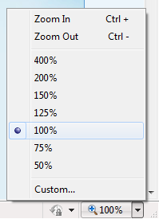
Figure 3.2. Zoom adjustment in Internet Explorer 9
Overview of accessibility features in Internet Explorer 9
Feature | Description
Zoom in on a webpage | Zoom lets you enlarge or reduce the view of a webpage. Unlike changing font size, zoom enlarges or reduces everything on the page, including text and images.
Select text and move around a webpage with the keyboard | Rather than using a mouse to select text and move around within a webpage, you can use standard navigation keys on your keyboard—HOME, END, PAGE UP, PAGE DOWN, and the ARROW KEYS. This feature is called Caret Browsing and is named after the caret—or cursor. This makes it easier to select, copy, and paste text to another document with a keyboard instead of a mouse.
Simplify common tasks with Accelerators | Make tasks like copying, navigating, and pasting easier by using accelerators to save time and keystrokes. Accelerators help you quickly perform tasks without navigating to other websites to get things done. Highlight text from any webpage, and then click on the blue Accelerator icon that appears above your selection to obtain driving directions, translate and define words, e-mail content, or search.
Choose colors used on webpages | Make webpages easier to see by changing the text, background, link and hover colors. Internet Explorer 9 supports the system link color, so High Contrast mode and color preferences you have chosen in Windows will work in Internet Explorer too.
Customize Internet Explorer 9 to work with a screen reader or voice recognition software | Some Internet Explorer 9 features can cause screen readers to give confusing or incorrect information, but you can customize to make them work more smoothly.

Accessibility in Microsoft Office 2010
Microsoft Office 2010 makes it easier for everyone to create documents, spreadsheets and presentations with rich content. Finding commands you need is easier with the redesigned user interface. Find more information at www.microsoft.com/enable/products/office2010/.
Overview of accessibility features in Office 2010
Feature | Description
Accessibility Checker | Word 2010, Excel 2010, and PowerPoint 2010 include an Accessibility Checker that helps users create more accessible content. By identifying areas that might be challenging for users with disabilities to view or use, and providing a task pane to review those areas, users can fix potential problems with their content.
Sub-Titling Add-in for Microsoft PowerPoint (STAMP) | Add closed captions to video and audio files you include in your PowerPoint presentations. If you work with captioned video and audio files that already have Timed Text Markup (TTML) files associated with them, this add-in lets you import them directly into your presentation.
Use the Save as DAISY add-in for Word to convert files to an accessible format | Use Microsoft Word to convert Open XML files to the Digital Accessible Information System (DAISY) format so files are accessible for people with print disabilities using talking books and compatible software.
Backstage view | Actions previously found on the File menu or Microsoft Office button, such as Print and Save, can now be found in the Microsoft Office Backstage view. By presenting commands more logically and providing more detail, users will have more context and information about the commands they use.
Hear text read aloud with Mini Translator | At times you may receive email messages or documents that contain words in unfamiliar languages. With the Microsoft Office 2010 Mini Translator, you can point to a word or selected phrase with your mouse and the translation displays in a small window. The Mini Translator also includes a Play button so you can hear an audio pronunciation of the word or phrase, and a Copy button so you can paste the translation into another document.
Add alternative text descriptions to shapes, pictures, tables, and graphics | You can now add a description to tables, PivotTables, images, shapes, and other objects, similar to a second level of alternative (ALT) text. This helps authors describe complex content to readers who cannot see those objects.
Use the keyboard to work with  ribbon programs | The menus and toolbars in all Office 2010 programs have been replaced with the ribbon. To move through the ribbon with a keyboard instead of a mouse, you can press CTRL+RIGHT ARROW or CTRL+LEFT ARROW on a ribbon tab to move to the next or previous ribbon group tab.
Create accessible Web portals | SharePoint Designer 2010 includes a built-in compatibility checker for common accessibility standards to help make sure websites are easy to use for everyone. "More Accessible Mode" in SharePoint Services provides greater accessibility for custom controls.
Use the Speak text-to-speech feature | Text-to-speech (TTS) is the ability of your computer to play back written text as spoken words. Depending upon your configuration and installed TTS engines, you can hear most text that appears on your screen in Word 2010, Outlook 2010, PowerPoint 2010 and OneNote 2010.
Use Full Screen Reading view | Word 2010 includes a Full Screen Reading view that improves the resolution and display of text for reading on the screen.
Create accessible PDFs | Tagged PDF files make it easier for screen readers and other assistive technologies to determine a logical reading order and navigation for the file, as well as allowing for content reflow when using large type displays, personal digital assistants (PDA) and mobile phones.
Assistive Technology Product Starter Guide
The following tables provide lists of assistive technology hardware and software products by category. Specific examples of the assistive technology products are provided. The table is by no means exhaustive or an endorsement of these products but is provided as a sampling of what is available today. These types of assistive technology products are also referenced in the assistive technology decision tree which follows.
Assistive Technology – Hardware Products
 | Vision | Mobility | Hearing | Language | Learning | Example
Amplified phone |  |  | ● |  |  | Ameriphone Dialogue XL
Augmentative Communication Device |  |  |  | ● |  | GoTalk 4+
Alternative input |  | ● |  |  |  | HeadMouse Extreme and Tracker Pro
Alternate keyboard | ● | ● |  | ● |  | ZoomText Large-Print Keyboard and Orbitouch Keyless Keyboard
Alternative mouse or pointing device |  |  |  |  |  | BigTrack
Braille display | ● |  |  |  |  | Eurobraille Esys 12  Braille Display
Braille printer | ● |  |  |  |  | Emprint™ SpotDot
DAISY Reader | ● |  |  |  |  | Victor Reader Wave
Ergonomic keyboard |  | ● |  |  |  | Microsoft Wireless Laser Desktop 4000
Foot mouse |  | ● |  |  |  | Footime™ Foot Mouse
Hands-free telephone |  | ● |  |  |  | QualiPHONE*
High-resolution monitor | ● |  |  |  |  | HP w1858 18.5" Diagonal Monitor
Large-button phone | ● | ● |  |  |  | Ameriphone Dialogue XL
Listening aid |  |  | ● |  |  | Motiva™ Personal FM System
Monitor glare guard | ● |  |  |  |  | Fellowes Anti-glare Screen
Movable numeric keypads |  | ● |  |  |  | Maxim Low-Force Keypad (USB)
Notetaker | ● |  |  |  | ● | Livescribe Pulse Smartpen and GW Sense Navigation
One-handed keyboard |  | ● |  |  |  | Maltron One-Handed Keyboard
Optical character recognition system | ● |  |  |  | ● | Scan and Read Pro**
Oversized or undersized keyboard |  | ● |  |  |  | BigKeys LX and WinMini
Oversized monitor | ● |  |  |  |  | HP w2338h 23" Diagonal
Scanner | ● |  |  |  | ● | Scan N Talk Ultra
Screen magnifier/Magnifier | ● |  |  |  |  | Desktop SenseView DSV, SmartView Graduate and ColorMouse
Switch |  | ● |  | ● |  | Big Red Twist Switch
Talking calculators | ● |  |  |  | ● | Sci-Plus 300 Large Display Talking Calculator
Touch screens |  | ● |  | ● | ● | Magic Touch Add-On Touch Screens
TTY |  |  | ● |  |  | Compact/C
Voice synthesizer/  Speech to text | ● |  | ● | ● | ● | TextSpeak TS Wireless AAC Speech Generator and iCommunicator***
* Requires PC to phone line connection, ** Requires flatbed scanner (e.g. Scan N Talk Ultra), ***Requires installation on a PC
Assistive Technology – Software Products
 | Vision | Mobility | Hearing | Language | Learning | Example
Braille translator | ● |  |  |  |  | Duxbury Braille Translator
Communication aid |  |  |  | ● |  | Overboard
Graphical idea trees |  |  |  |  | ● | Read & Write GOLD
Macro writing software |  |  |  |  | ● | ClaroRead Standard
On-screen keyboard |  | ● |  |  |  | ScreenDoors and SofType
Reading aid | ● |  |  |  |  | gh Player 2.2
Scanner software | ● |  |  |  | ● | Scan N Talk Ultra
Screen magnifier | ● |  |  |  |  | ZoomText v9.1
Screen readers | ● |  |  |  |  | Window-Eyes v7.0
Speech recognition/  Voice dictation |  |  |  |  | ● | Dragon Naturally  Speaking Preferred
Talking calculators | ● |  |  |  | ● | Sci-Plus 300 Large Display Talking Calculator*
Task organizer software | ● | ● | ● | ● | ● | MyLifeOrganized
Voice synthesizer/  Speech to text | ● |  | ● | ● | ● | TextSpeak TS Wireless AAC Speech Generator and iCommunicator
Word prediction software |  |  |  |  | ● | Read & Write GOLD and ClaroRead Standard
* Includes a large-display calculator
Purchasing Assistive Technology
The Enablemart website (www.enablemart.com) is one source where you can purchase assistive technology products for schools. Education and government customers may be eligible for volume pricing.
Assistive Technology Decision Tree
UnumProvident’s Assistive Technology Decision Tree, shown in Figure 3-3, leads you through questions based on the type of impairment to identify assistive technology products that you might consider. By asking questions regarding the extent and type of impairment (including range of motion, quadriplegia, back impairment, vision impairment, hearing/auditory impairment, speech impairment, and psychological impairment), the decision tree narrows down technology that might be helpful for an individual.
Assistive Technology Decision Tree by UnumProvident
Figure 3-3a. Assistive Technology Decision Tree
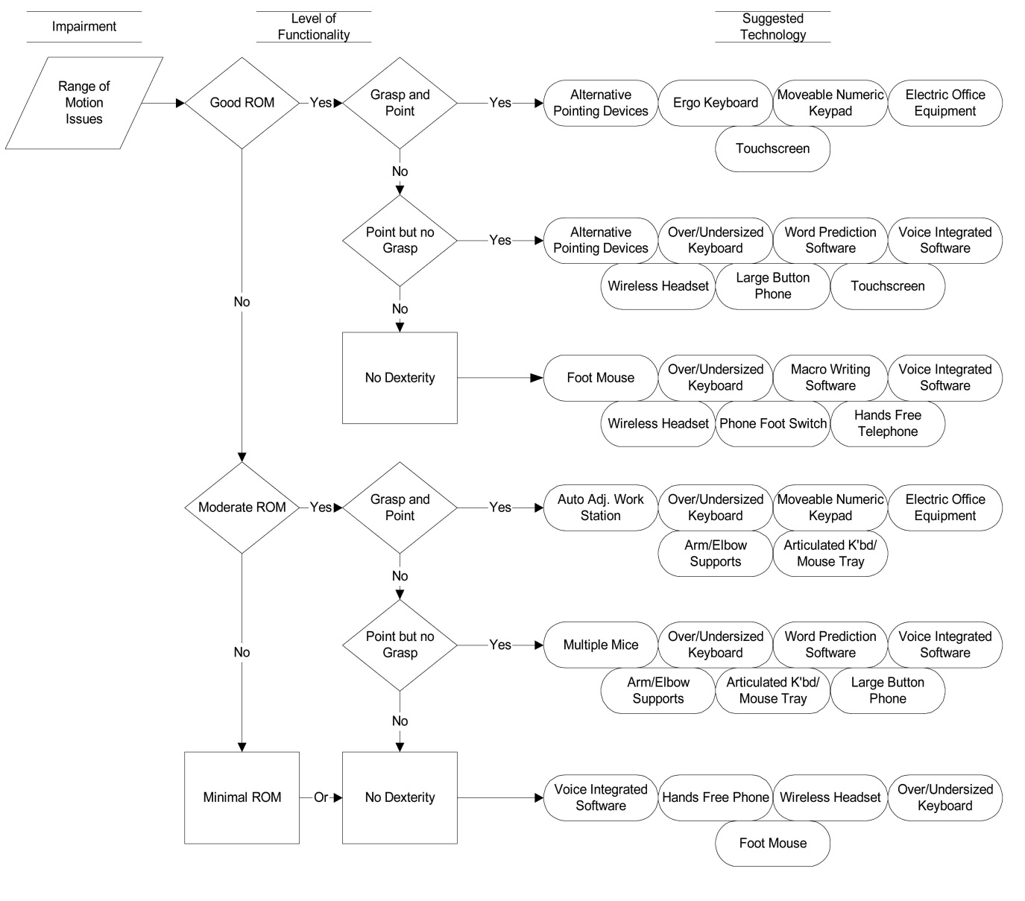
Figure 3-3b. Assistive Technology Decision Tree
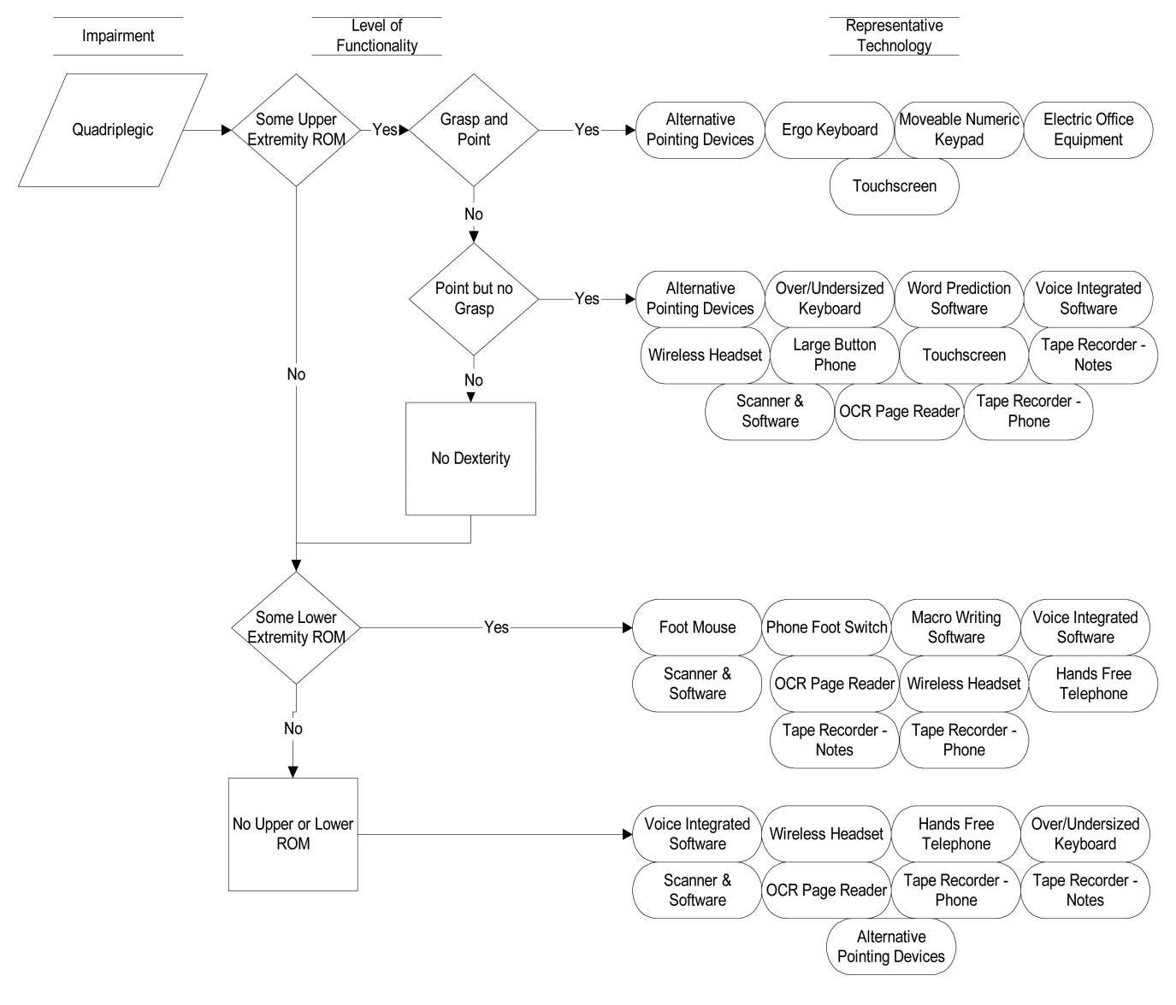
Figure 3-3c. Assistive Technology Decision Tree
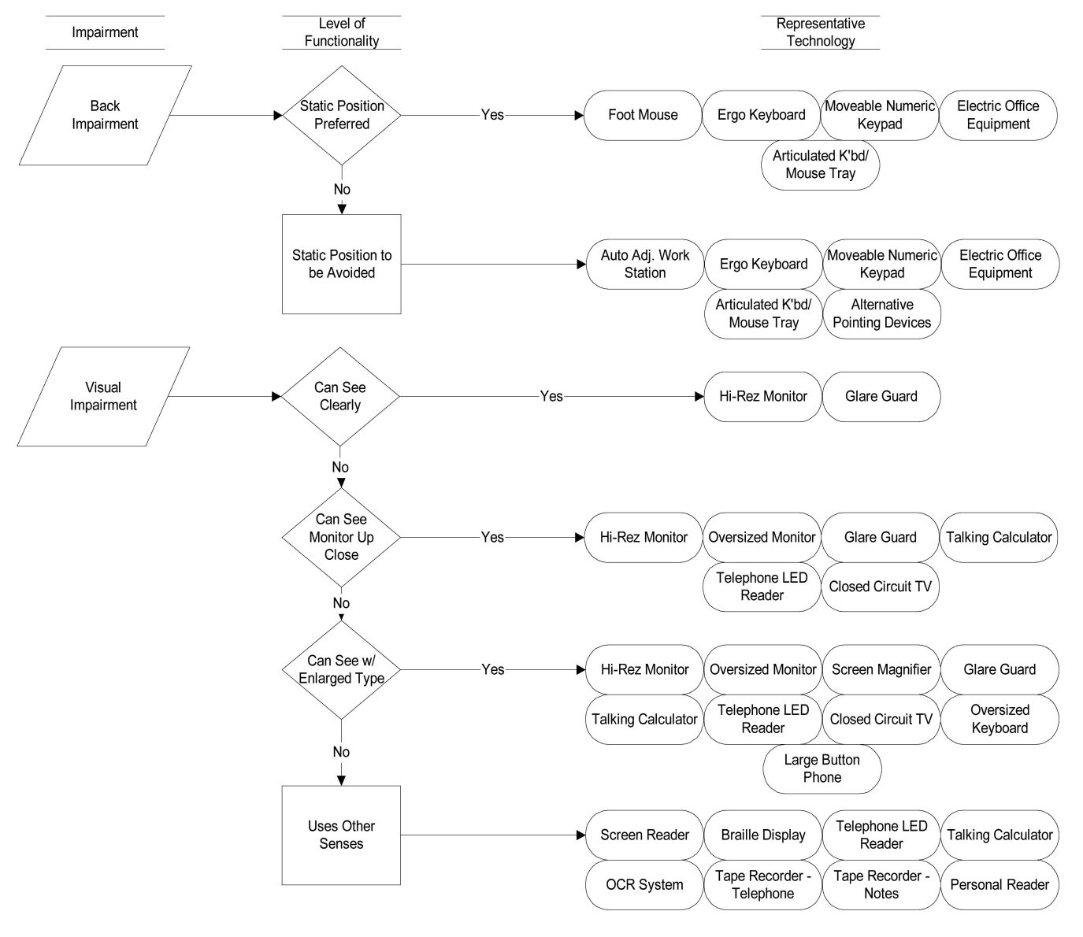
Figure 3-3d. Assistive Technology Decision Tree
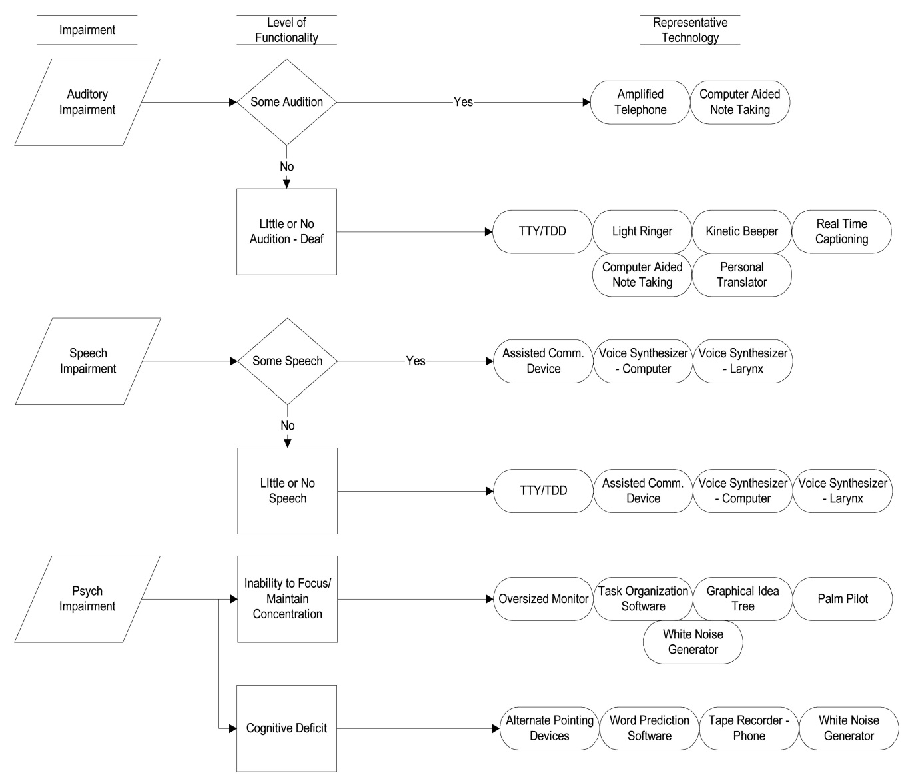

Resources
Resources from Microsoft
Microsoft’s mission is to enable people and businesses throughout the world to realize their full potential. Computer technology is an important and powerful tool that enables and empowers individuals of all abilities. At Microsoft, we strive to develop technology that is accessible and usable by everyone, including individuals who experience the world in different ways because of impairments or disabilities.
For two decades, we have been exploring and evolving accessibility solutions that are integrated with our products. Microsoft’s accessibility work is a part of Microsoft Trustworthy Computing (www.microsoft.com/mscorp/twc/) business practices which focus on integrity and responsibility.
Microsoft Accessibility Website www.microsoft.com/enable/
- Accessibility Update newsletter www.microsoft.com/enable/news/subscribe/
- Accessibility in Microsoft Products www.microsoft.com/enable/products/
- Accessibility Tutorials www.microsoft.com/enable/training/
- Accessibility Demos www.microsoft.com/enable/demos/
- Assistive Technology Products www.microsoft.com/enable/at/
- Microsoft Accessibility Resource Centers www.microsoft.com/enable/centers/
Additional Resources and Annual Conferences
Teaching Children with Disabilities in Inclusive Settings
www2.unescobkk.org/elib/publications/032revised/index.htm
This toolkit published by UNESCO provides activities for embracing diversity in the classroom.
Annual Conferences about Accessible Technology
The following organizations host annual accessible technology conferences.
- Assistive Technology Industry Association
www.atia.org
- Technology and Persons with Disabilities Conference at CSUN
www.csun.edu/cod/conf/
- Rehabilitation Engineering and Assistive Technology Society of North America www.resna.org

