Resources for teachers who are supporting children with deaf-blindness at a distance

The staff at the ND Dual Sensory Project have compiled the following resources for teachers and related services staff who teach and support children and youth who are deaf-blind. Some of these materials will be useful “as is” for distance learning, while others may need some adaptations for distance instruction or for passing on to families. Enjoy!

Audible Stories
Audible has launched Audible Stories, a free service that offers educational and entertaining audiobook content for kids, teens, and families. There are titles for beginning readers and for older readers. There’s also fun educational content like children’s song collections. These and hundreds of other titles are available free of charge—no catch, nothing to buy. There are titles across six different languages, and it’s set up for kids through teens with easy-to-navigate categories, plus a section of literary classics.
https://stories.audible.com/start-listen

FREE MEMBERSHIP in CEC!!
If you have ever thought about joining (or rejoining) the CEC, this is the time!!! The Council for Exceptional Children (CEC) is opening its doors to the special education community in need of resources. Nonmembers of CEC can receive a free basic membership from now through May 31 by using the promotional code "CECED60." This will give you access to all of CEC's journal articles, member discounts on events, and access to CEC's online membership community where you can ask questions and receive support from special educators, administrators and support personnel.

ASL Storytelling QR Codes: 180+ Signed Stories for Independent and Share Viewing
https://drive.google.com/file/d/1VBJkmttmj5AJsm73Cs1wstV-uN9qM06H/view?fbclid=IwAR2BTcF8Sm99BrPR3BTg15xu_jVaciUU5_H_lfXXFVDM-dY1vqASy-XLCLo
You may need to do some adaptations for using this at home or online, but good resources to pass on to families also!

Helpful Apps
The National Family Association for Deaf-Blind has compiled a list of apps that might be helpful in instruction.
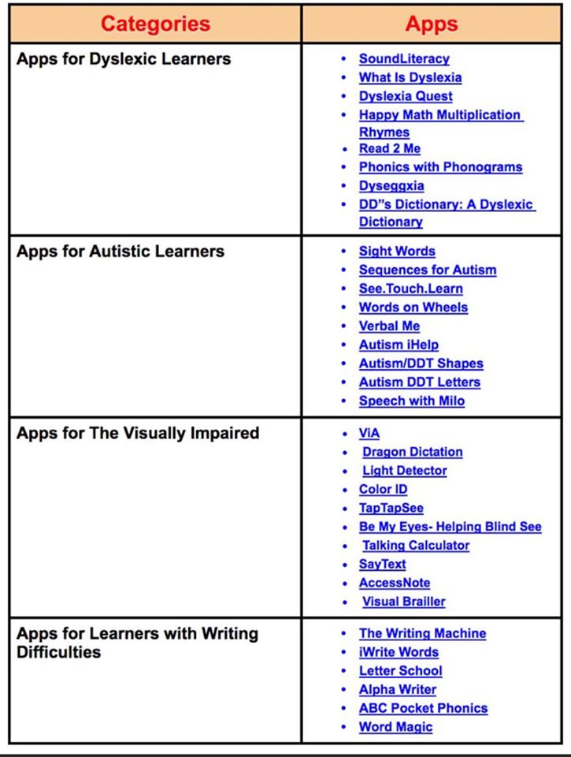

The Center for Literacy and Disability studies at University of North Carolina has compiled a list of resources and materials for teaching students who are deaf blind. Again, these will need to be adapted for distance learning.
Tools for Literacy
https://www.med.unc.edu/ahs/clds/files/2018/09/TopClassroomTools.pdf

In addition, the staff have produced PowerPoint book templates.
https://www.med.unc.edu/ahs/clds/resources/deaf-blind-model-classroom-resources/switch-accessible-powerpoint-book-templates-for-students-with-significant-disabilities-including-deaf-blindness/

