Letters from the Bark Side

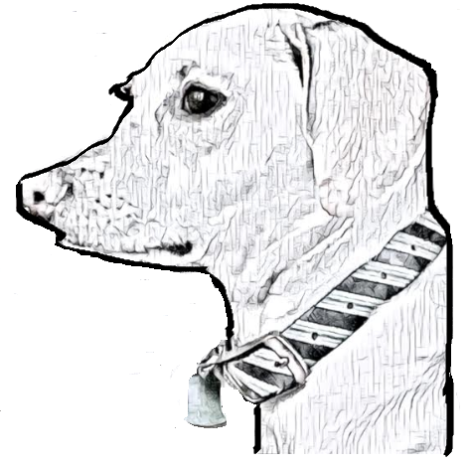

Dear Coby,

My name is Gabriel. Me and Ms. D work together. She is my speech therapist.

Have you ever written letters before?

Talk to you soon,
Gabriel

Hello Gabriel!
Wow I am so so so excited that you wrote me a letter WOOF! No one EVER writes me letters! I have never written a letter before WOOF so this is my first letter WOW.
Is Ms. D my mom? I call her mom at home and did not know she has another name!
What is school like? I go to a school sometimes with mom. My teacher’s name is K9 Kenny, and he teaches me how to be a good boy.

Talk to you soon WOOF!
Coby

Hello, Coby!

I’m so excited you wrote me back! I’ve never written a dog before! This is so cool!

Yes, Ms. D is your mom! Your mom is nice and fun! I like working with her at school!

School is fun!

At school we do math, science and social studies! I get to play with friends at recess. I like to write crazy stories.

What is your school like? What do you learn at school? Do you have any classes?

What is it like to be a dog? What do you do for fun? What is your favorite thing to do.

Talk to you soon!
Gabriel

Howdy Gabriel!

WOOF I cannot believe you know my mom! Wowzer!

My school is pretty small WOOF. Usually it’s just me, my mom and K9 Kenny (he’s my teacher). We work on things I need to do at home. Things like: listening to mom, walking on a leash without pulling, and sitting in one spot until mom says “Free”. It makes my brain hurt WOOF. But mom says it’s important for me to learn how to be a good boy, since I am getting older.

What is human school like? And what is recess? I haven’t heard of that before.

Being a dog is pretty neat- I get to run around and sniff other dogs. Did you know that dogs sniff each other’s behinds to say “Hello!”, but humans don’t do that. How come? How do humans greet each other?

My favorite activity is walking around Lady Bird Lake with my mom on a sunny day. I get to see lots of humans and dogs, and there are SO MANY GREAT SMELLS!

Talk to you soon WOOF!
Coby

Coby,

What are you up to?

A human school looks like it is fun to me. I like to wright funny stories. I do math, science, social studies and reading at school. I am learning about food and food chains. Recess is when you play with friends and check things out on the playground. I like to swing because it is relaxing.

Humans greet each other by walking to the person and saying hello. When they say hello they have a conversation. They look at the person who is talking to them. Humans don’t smell each other because it is very nasty.

On a sunny day my favorite thing to do is to swim in the lakes and rivers. My parents can take me there.

Talk to you soon!
Gabriel

Gabriel,

I have been hanging out at home this week. I had a friend visit with me this week, and it was nice to have company! I also go to doggy daycare sometimes.

What's a food chain? Sounds like a bunch of hot dogs, bacon and chicken on a string. YUM! Recess sounds fun! I don't have recess but I do like to go to dog parks and play with other dogs.

Huh. Human "hellos" sound very polite. Dogs are much less formal, I guess WOOF. When dogs have conversations, we usually bark at each other... loudly. My mom doesn't like it when I bark, she says it hurts her ears.

You like to swim in lakes and rivers?! I do NOT like water. Puddles are even scary to me. I can handle a bath when my mom is there but I REFUSE to swim in a lake. The thought of it makes me shudder. Instead, I like to go on long walks with my mom at Zilker Park in Austin. Have you ever been there?

WOOF!
Coby

Hello Coby,
I have been at home. I am home because of a virus that makes people. I have been listening to audiobooks and playing games. I have not done my school work yet. Food chains is like when an animal eats another one. Like a lion eats a deer. My dogs growl when I step on their leg by accident. I step on them because I don’t see them. Sometimes when my dogs bark it hurts my ears. I have never been to Zilker Park in Austin.

What are you doing at home? Are you having fun at home? I am happy to be at home because I like to do a lot of things like jumping around. Are you afraid you’ll get sick with the virus?

See ya later!
Gabriel

