It’s Not Silly to Me

Plugging “Non-Communicative” acts into Literacy and Communication Activities for Students with Visual Impairment and Autism Spectrum Disorder

By: Megan Mogan, MS, CCC-SLP

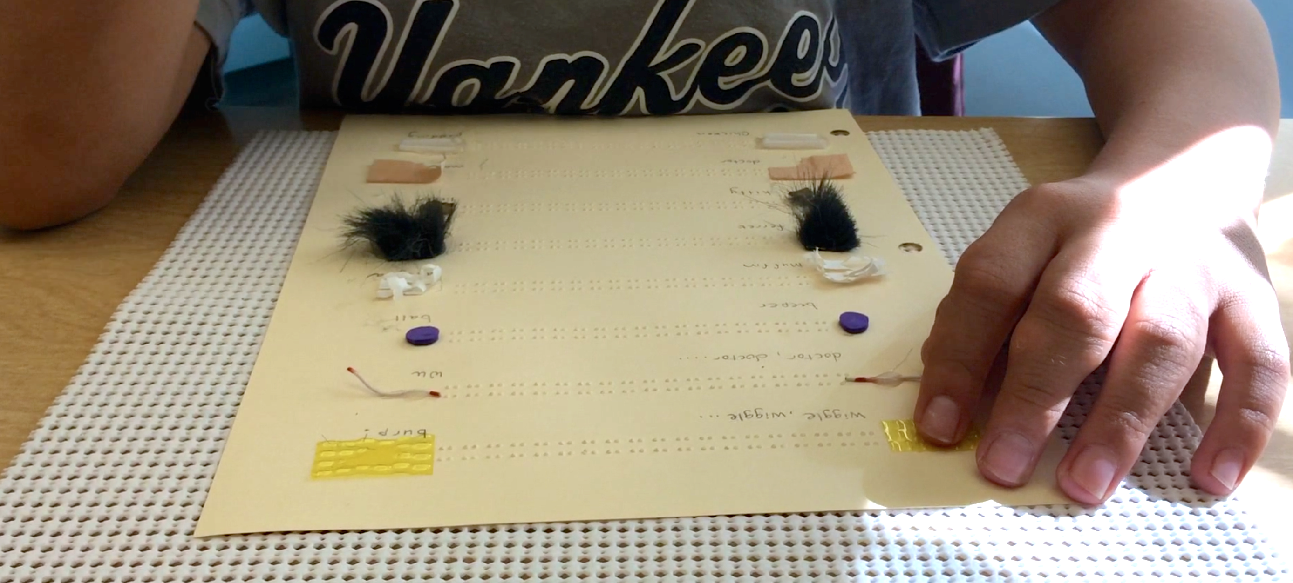

I used to be that therapist. The one who threw around the words “self-stimulatory behaviors” and “idiosyncratic language” all of the time. The one who described her students as engaging in silly sounds, strange vocalizations, repetitive body movements, and non-communicative language. The one who had discussions about replacing those behaviors with socially appropriate behaviors unless of course we could ignore those behaviors or extinguish those behaviors altogether! I used to be that therapist.

Without even realizing it, I had referred to those non-communicative acts as something negative. I probably thought anything short of conventional discourse was a poor reflection on me as a therapist! In reality I was missing all of the potential positive that could emerge from those non-communicative gestures, sound effects, nonsense words, and phrases. To my students on the autism spectrum, those non-communicative acts were efficient, accessible, and meaningful. Efficient. Accessible. Meaningful. Not strange. Not repetitive. Not nonsense.

At some point in my practice, I stopped thinking about the acts as non-communicative and started thinking about them as original thoughts and ideas.

What if you started multiple conversations each day with “Good Morning!” and someone always responded with, “It’s not time for your silly words right now.” The same applies to my student who is on the autism spectrum and exclaims “Wiggle wiggle burp!” To him, greeting with “Good Morning” is equally as silly as exclaiming “Wiggle wiggle burp.” If the people around you kept referring to your original thoughts and ideas as silly and nonsense, it wouldn’t take very long to retreat into those thoughts without expressing them out loud at all. That is surely not the direction we want to go. Original thoughts and ideas deserve attention and topicality attached to purpose and intention. They deserve their own spot at the forefront of daily communication and literacy instruction.

If this concept had a sequential progression from the perspective of the student, it may look something like this:

I say a Silly/Non-Communicative Phrase > Someone else considers it as my own, original idea and confirms to me they heard it> I laugh> That person shows me how to use it with a purpose using my preferred sensory channel(s) > Now I can use my own idea to communicate with another person > That person shows me how to use it for a multiple purposes, with different partners, at different times, and in different places > People start to refer to me as the “kid who has a great sense of humor!”

I flipped the nonsense paradigm one morning this year when a particularly boisterous “Wiggle wiggle burp” warranted its own spot at the top of a homemade re-usable tracking worksheet. My student and I documented a list of 11 original ideas including:

Wiggle wiggle burp
Dr. Wu
Beeper ball
Muffin lasagna
Ferret water
Kitty litter
Dr. Moa
Chicken pudding
Carmel apples
Banana goldfish
Coconut cookies

This totally blind student was working on a variety of emerging literacy and communication targets including early tactile discrimination, tracking, refining his finger skills, and searching for information (also known as reading). Conventional lessons targeting emergent literacy and communication skills were not very successful in the past. In fact, they often ended abruptly in some things that some one used to refer to as self-stimulatory behaviors and non-communicative phrases!

Using our list of 11 original ideas, we chose corresponding tactile symbols. Muffin lasagna had muffin cup paper. Dr. Wu had wire that felt sharp, like a shot. You get the idea. I cut the tactile symbols down into more of a “micro” symbol (2-3 times the size of a braille cell) to challenge those tactile skills. Then I cut the symbols into two equal pieces, one representing the first part of the phrase and the other representing the second part of the phrase. We separated the tactile symbols by a long string of braille x’s. An Occupational Therapist friend had once told me it was a good way to support fluent tracking since the pads on the fingertips naturally fit into the grooves of a line of x’s.

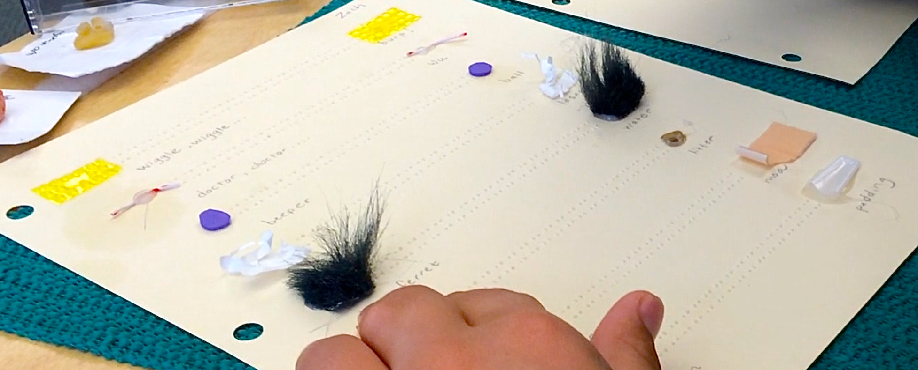

We started the process of learning how to access this new form of media. It took a lot of hand-under-hand modeling. I cannot film and provide hand-under-hand modeling at the same time (I promise I’m saving my pennies for a headband-mounted therapy cam), so when you watch one of the videos please know that my student is reading independently after he listened and felt me read his tracking lines multiple times.

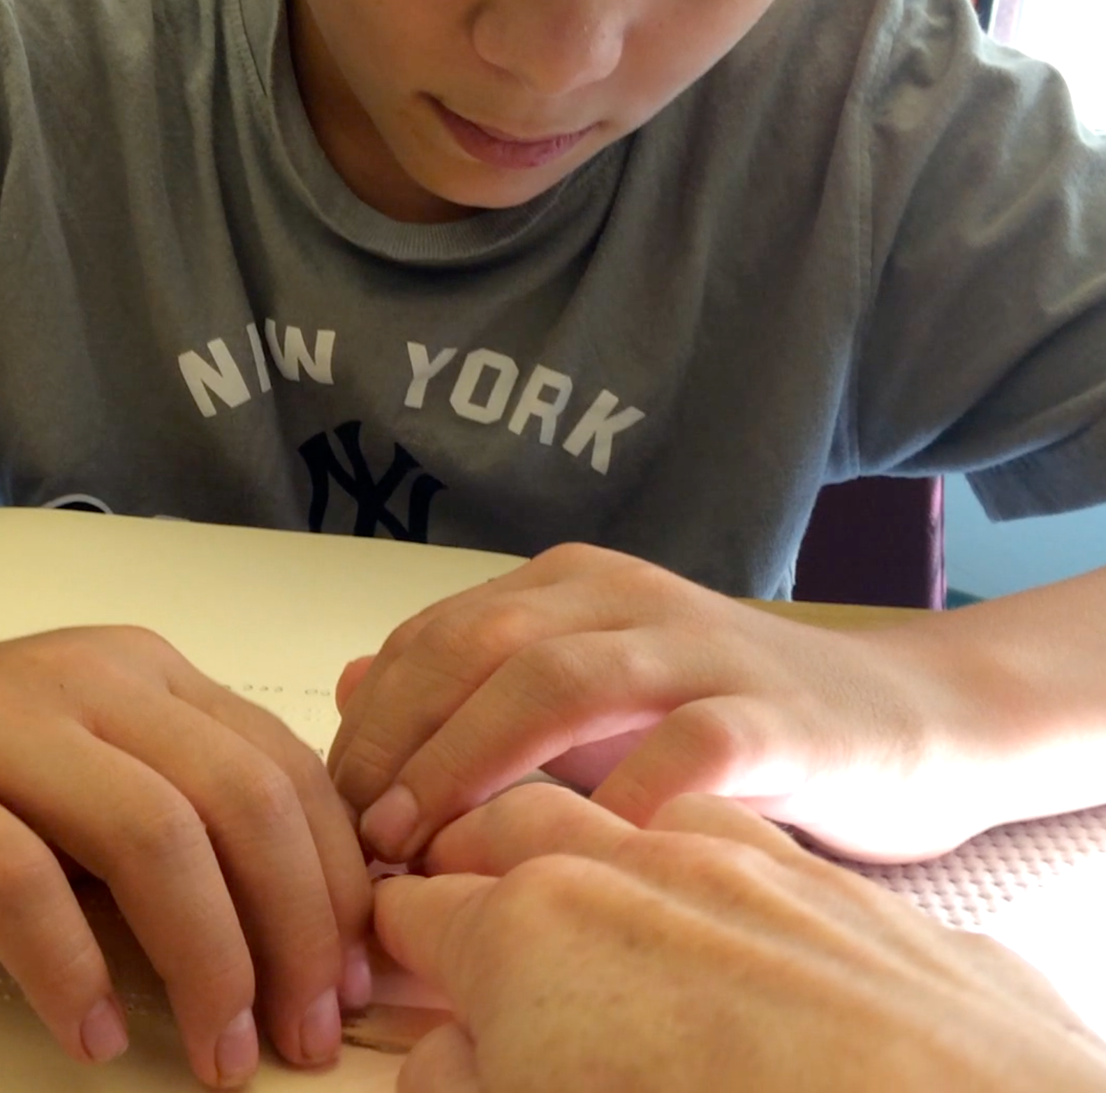

Why do you think he even listened to me for that many repetitions? Why do you think he kept his fingers on top of mine for every phrase over and over? He initially engaged because he was listening to and reading his own thoughts. He remembered because he could both feel and hear the information. And then he learned to do it all by himself!

[Insert video clip: The Yawning Beeper Ball]

Once we learned the tracking worksheet, we started to mix it up a little and target other skills that didn’t have to do with tracking. We even combined the symbols on the worksheet with the symbols on his daily schedule (mounted on his desk). We played fun little word-finding games using mixed up phrases like “PE lasagna” and “wiggle wiggle music class.” We played interactive games with classroom peers where my student would start the original phrase, pause, and wait for his peers to shout out the second half. His friends wanted their own tracking worksheets with phrases like pepperoni ……………..pizza and Lady………………..Gaga.

[Insert Video Clip: Wiggle litter PE!]

Even though he mastered independent reading and lots of other skills using the tracking worksheet, sometimes my student still wanted to just sit back and listen to me read his words to him over and over, just like when we first started out with this seemingly crazy idea. I have this theory it is the same reason I like reading it out loud to him over and over. Maybe it reminds us of that first time we connected on this topic of silly words – that time he said, “It’s not silly to me,” and the time I responded, “It’s not silly to me either.” We didn’t use words to say those things to one another by the way.

To hear someone else acknowledge and read aloud your own original ideas is a wonderful feeling. I didn’t do this enough in my practice with students on the autism spectrum or my students who are deafblind. I did a lot of brushing things off as “non-communicative” or “self-stimulatory.” I did a lot of hearing, not listening.

When you hear your student’s ideas (in whatever form they are presented), confirm it for him/her. Acknowledge the idea and see where it goes. Listen. Attach a purpose to that idea, a reason to use it. You will most likely find yourself on a path to finding the joy in communication, not the silly. A Path to Literacy.

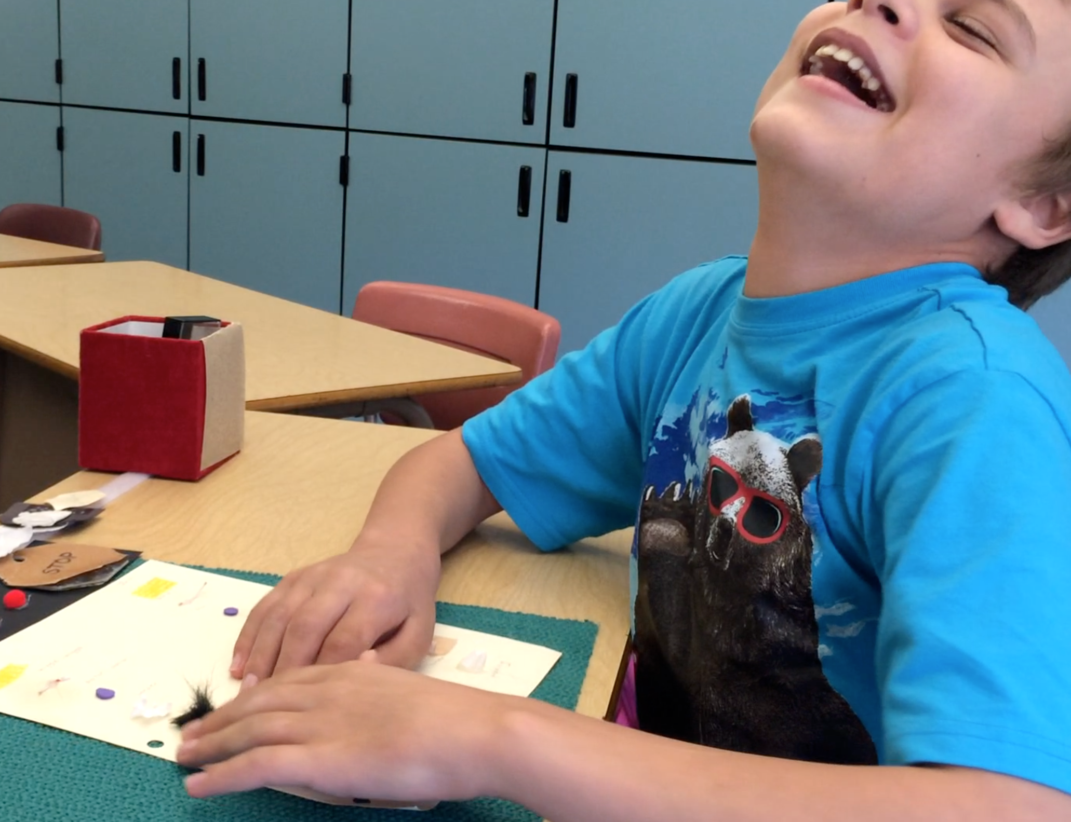
Help me caption this photograph of my student smiling while reading his tracking worksheet filled with original phrases: Silly and Non-Communicative, or Joyful and Independent?

If you want to learn about more of a structure to building a literacy approach that includes your student’s original thoughts and ideas, consider looking into:
Braille Literacy: A Functional Approach by Diane P. Wormsley, AFB Press.

**Charlotte please guide me in adding any other resource to the end of this post**

