Grilled Chicken Braille Game

Contractions: upon, word, these, those, whose, cannot, had, many, spirit, world and their

Created By: Samantha Zauner

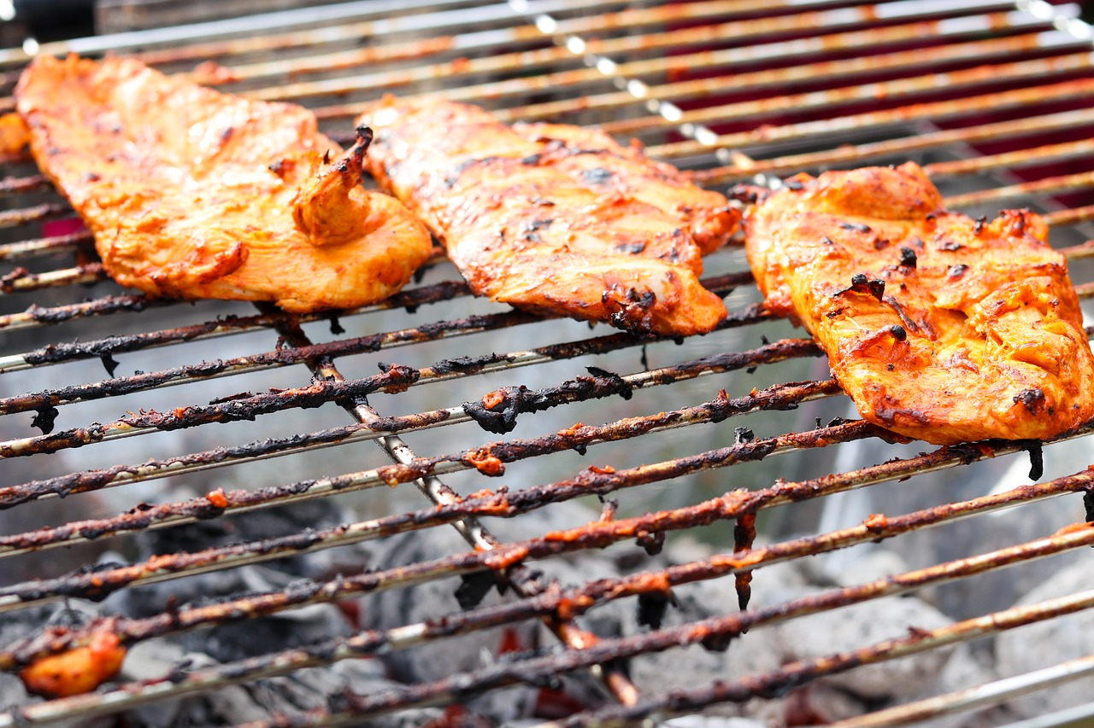

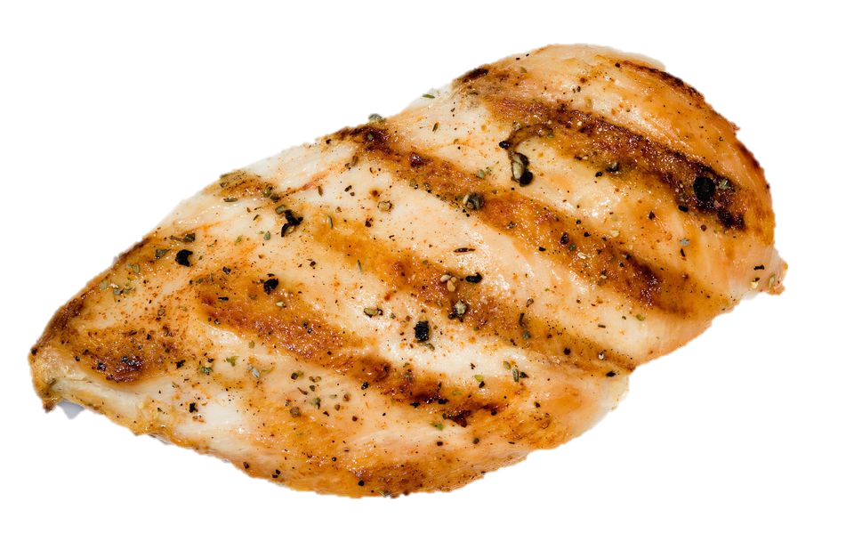
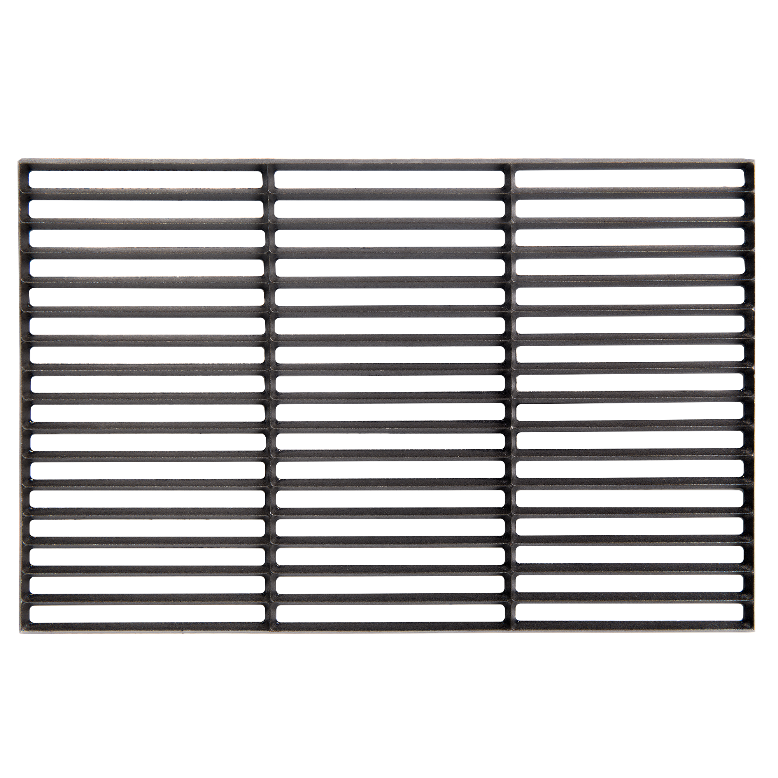
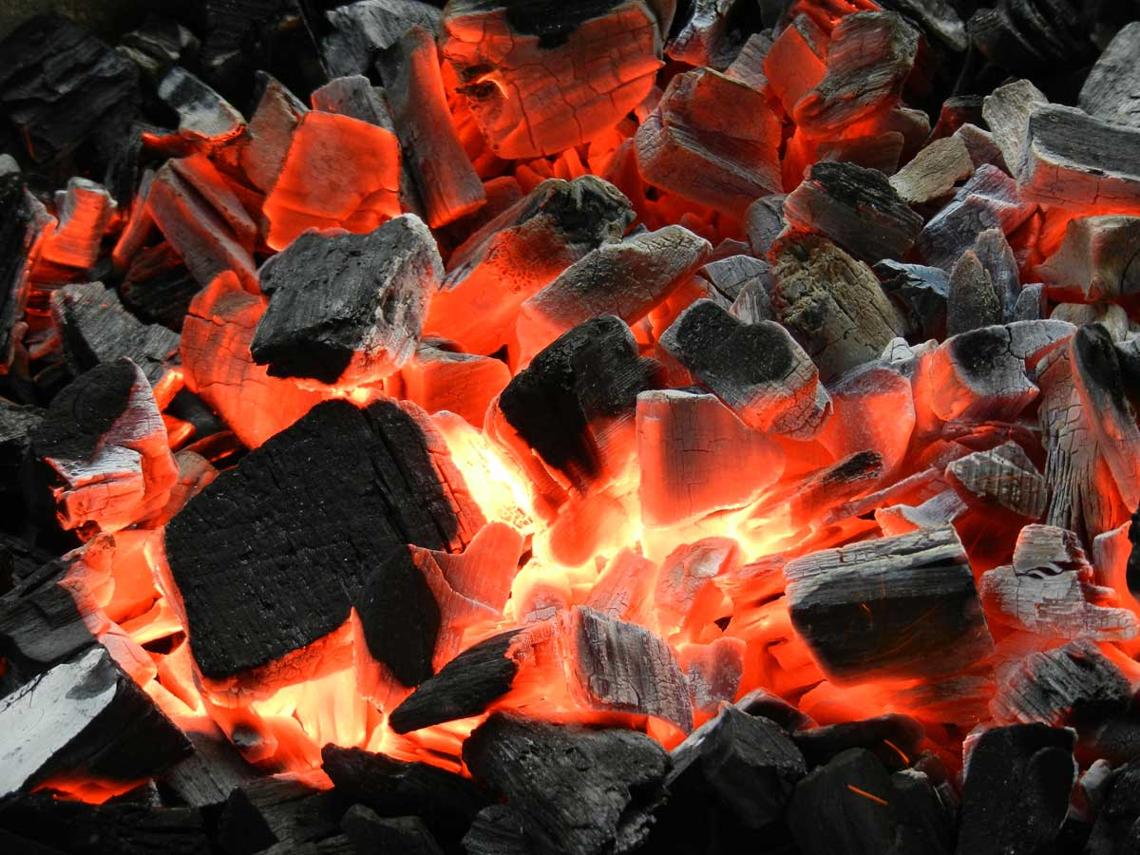
ow
ow
ow
ow
in
Dots 4, 5 and 6
Dots 2, 3 and 4

Dots 4, 5 and 6
Dots 1, 3 and 4

Dots 4 and 5
Dots 1, 3 and 6

Dots 4, 5 and 6
Dots 1 and 4

Dots 4 and 5
Dots 1, 5 and 6

Dots 4 and 5
Dots 2, 4, 5 and 6

Dots 4, 5 and 6
Dots 2, 4, 5 and 6

Dots 4 and 5
Dots 2, 3, 4 and 6

Dots 4, 5 and 6
Dots 1, 2 and 5

Dots 4 and 5
Dots 1, 4, 5 and 6

Dots 4, 5 and 6
Dots 2, 3, 4 and 6

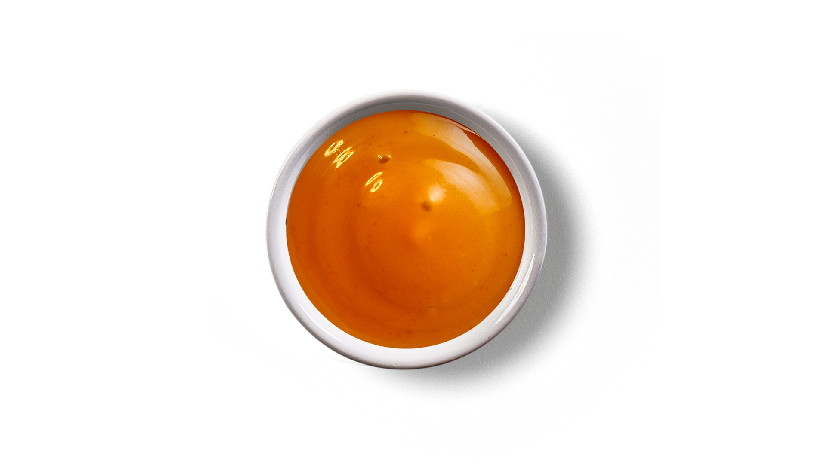
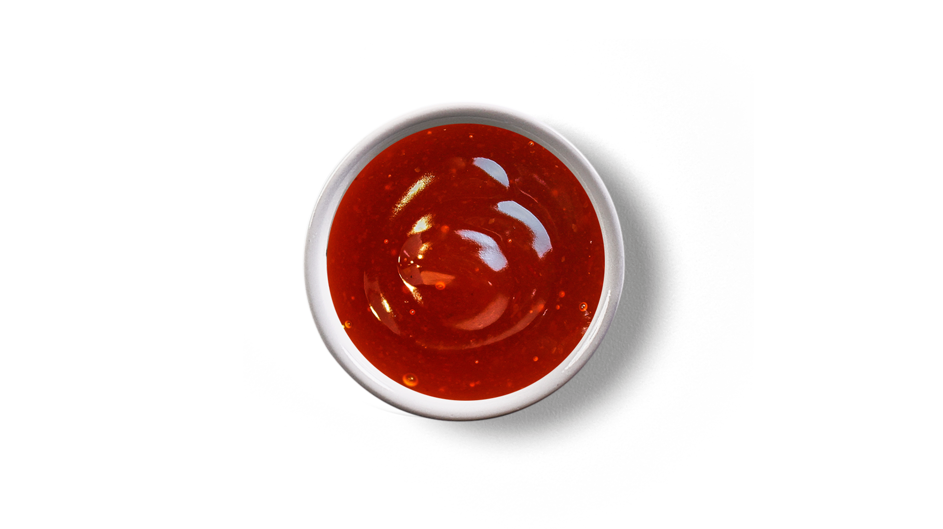
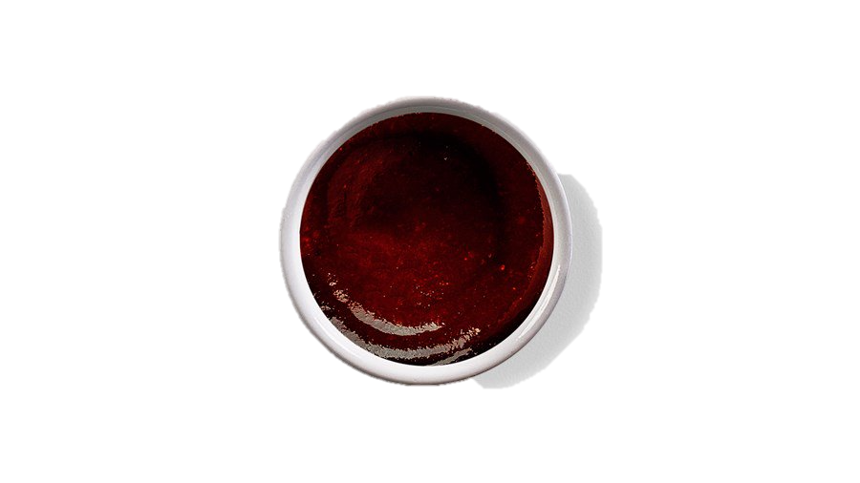
upon
word
these

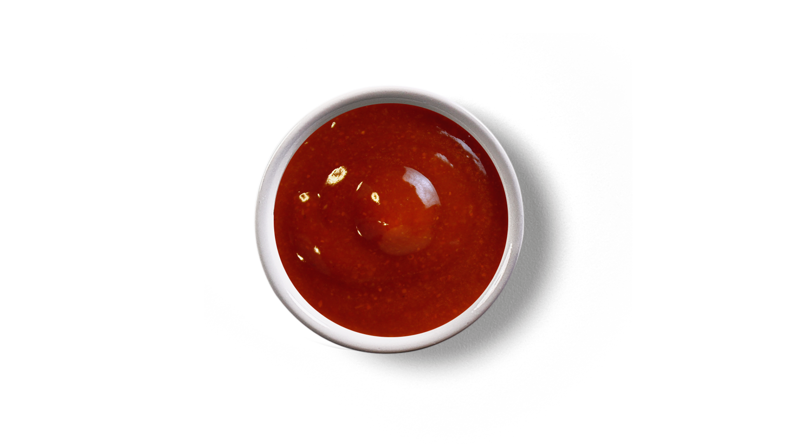
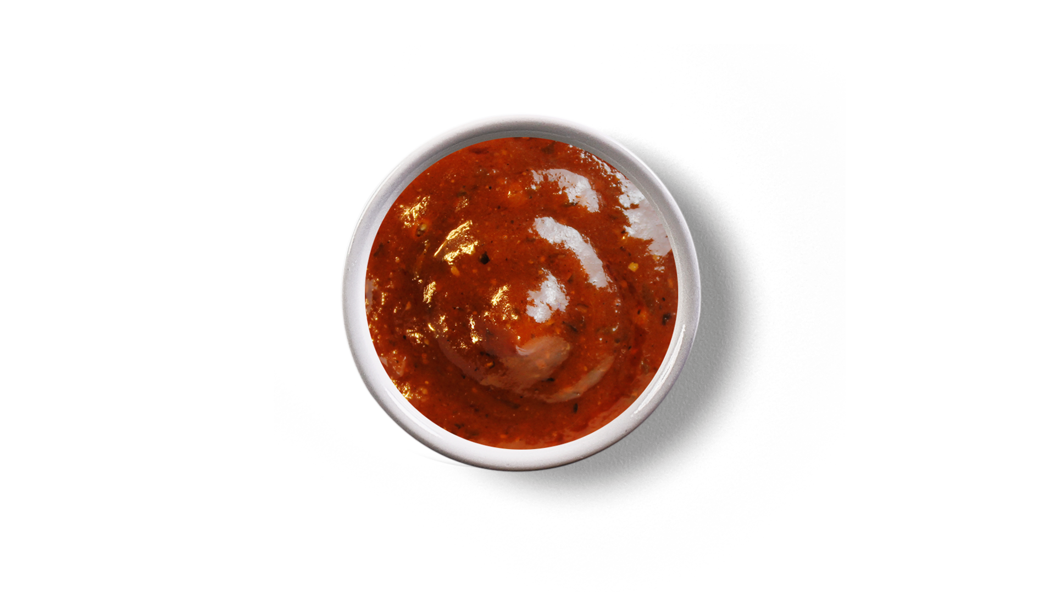

those
cannot
whose
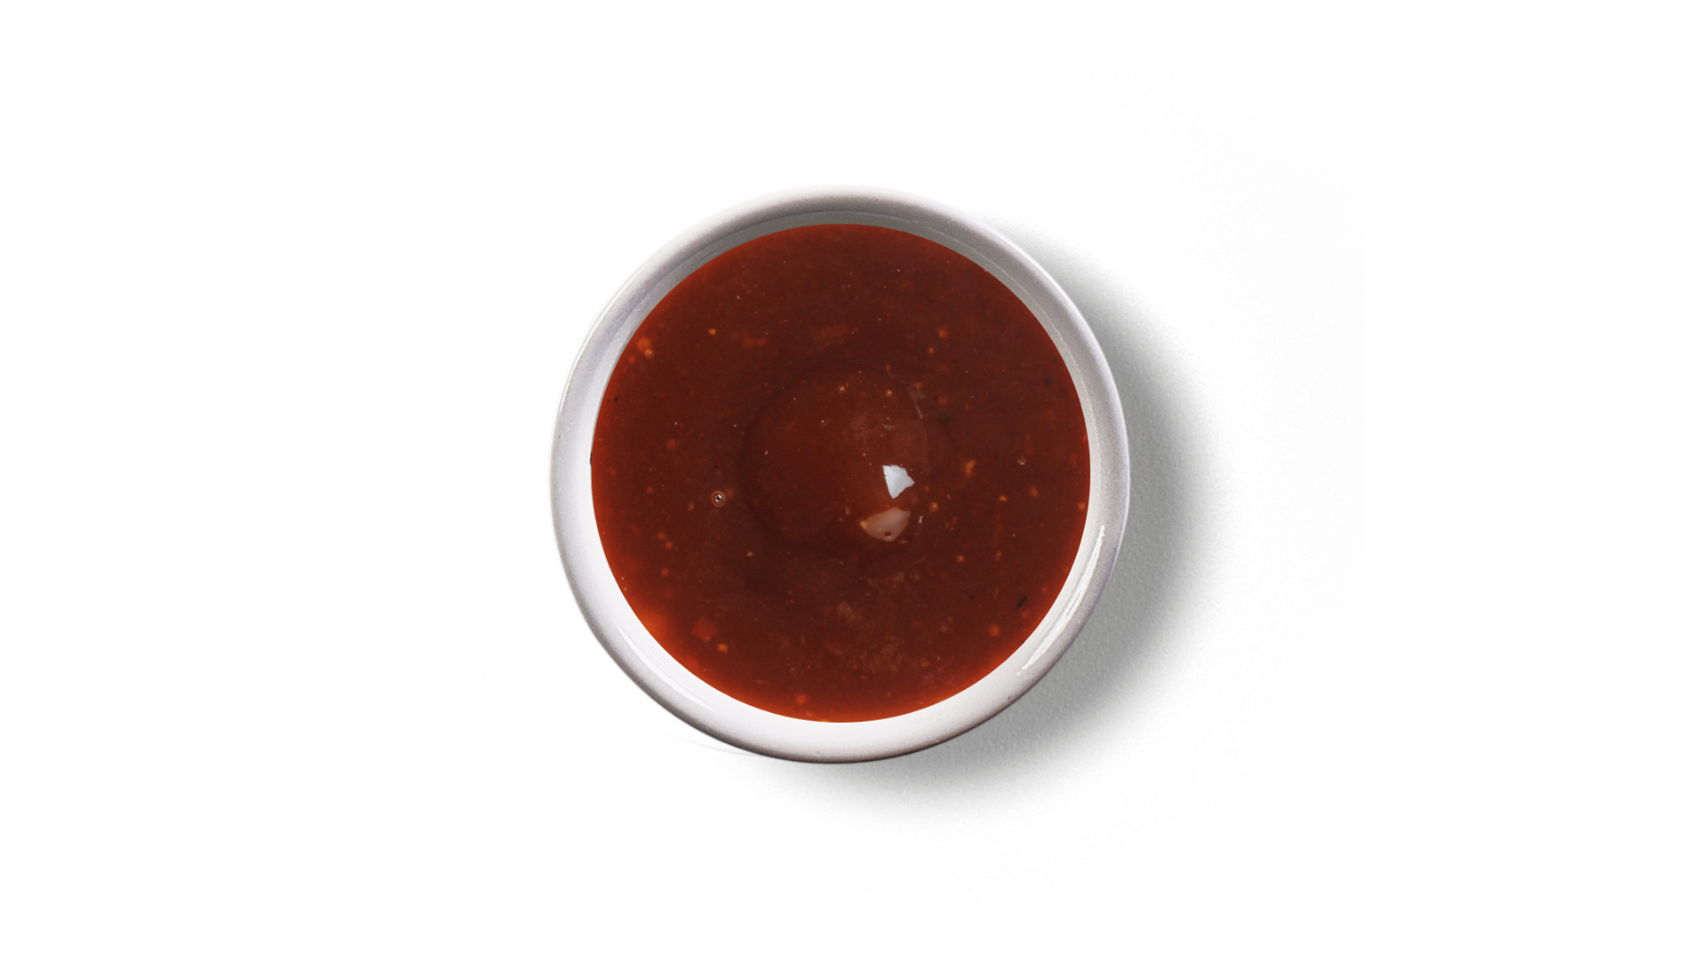

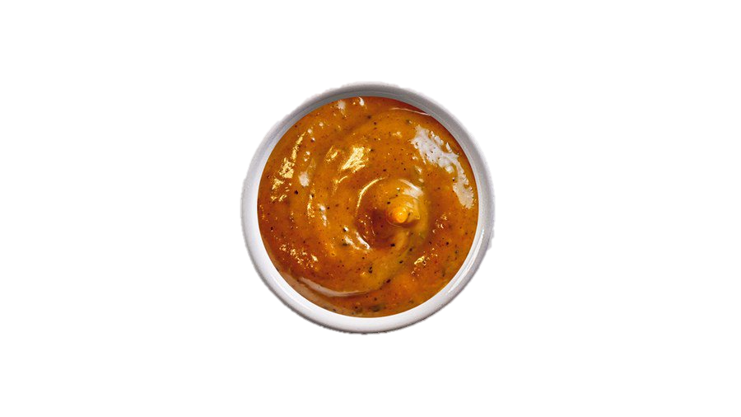

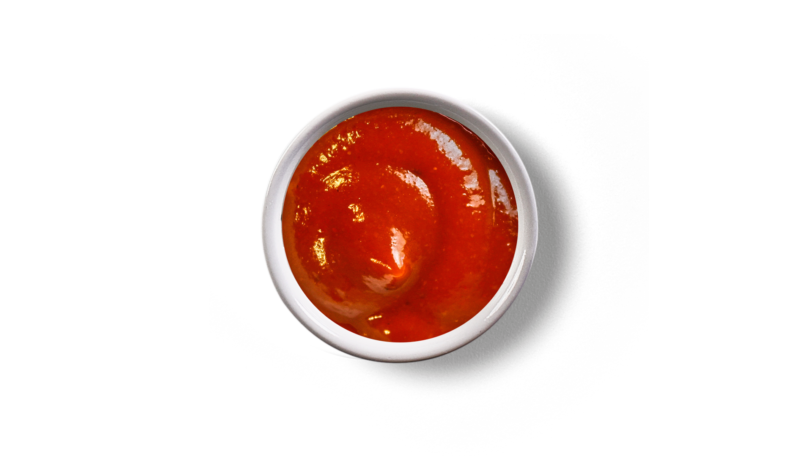

had
many
spirit

world
their

Visual | Dot Formation | Contraction
^u | Dots 4 and 5  Dots 1, 3 and 6 | upon
^w | Dots 4 and 5  Dots 2, 4, 5 and 6 | word
^! | Dots 4 and 5  Dots 2, 3, 4 and 6 | these
^? | Dots 4 and 5  Dots 1, 4, 5 and 6 | those
^: | Dots 4 and 5  Dots 1, 5 and 6 | whose
_c | Dots 4, 5 and 6  Dots 1 and 4 | cannot
_h | Dots 4, 5 and 6  Dots 1, 2 and 5 | had
_m | Dots 4, 5 and 6  Dots 1, 3 and 4 | many
_s | Dots 4, 5 and 6  Dots 2, 3 and 4 | spirit
_w | Dots 4, 5 and 6  Dots 2, 4, 5 and 6 | world
_! | Dots 4, 5 and 6  Dots 2, 3, 4 and 6 | their
Answer Key

Name: ________________________

Circle the correct braille contraction that represents the print word on the left.

upon | _u ^u _+ ^+ _n
word | _w ^w _D ^d _r
these | _T _! ^! ^? _?
those | _! ^? _T _? ^!
whose | ^w ^: _< ^w _:
cannot | _t _c ^c ^t _N
had | _h _D _f _j ^h
many | ^% ^m _m _% _Y
spirit | _s _: _t ^S ^:
world | ^w _w ^r _r _d
their | _! ^? _? ^! _T
Name: ________________________

Draw a line to connect the print letters to the correct braille contraction.

upon |  | _c
word |  | _s
these |  | ^?
those |  | _m
whose |  | ^!
cannot |  | _w
had |  | ^w
many |  | ^:
spirit |  | _h
world |  | ^u
their |  | _!

Name: ________________________

Circle the correct dot numbers that are needed to create each contraction to represent the printed word on the left.

Contraction | Dots
upon | Dots 4, 5 and 6 or Dots 4 and 5  1 2 3 4 5 6
word | Dots 4, 5 and 6 or Dots 4 and 5  1 2 3 4 5 6
these | Dots 4, 5 and 6 or Dots 4 and 5  1 2 3 4 5 6
those | Dots 4, 5 and 6 or Dots 4 and 5  1 2 3 4 5 6
whose | Dots 4, 5 and 6 or Dots 4 and 5  1 2 3 4 5 6
cannot | Dots 4, 5 and 6 or Dots 4 and 5 1 2 3 4 5 6
had | Dots 4, 5 and 6 or Dots 4 and 5  1 2 3 4 5 6
many | Dots 4, 5 and 6 or Dots 4 and 5  1 2 3 4 5 6
spirit | Dots 4, 5 and 6 or Dots 4 and 5 1 2 3 4 5 6
world | Dots 4, 5 and 6 or Dots 4 and 5 1 2 3 4 5 6
their | Dots 4, 5 and 6 or Dots 4 and 5 1 2 3 4 5 6

