Braille Production Decision Guide for Physical Science Class
What is in the document? | What is the format? | What do I do with it?
Print only | Digital/Electronic-------------------------------------  Paper ----------------------------------------------------- | Give to student on flash drive  Give to braille clerk to type up or scan at least ONE school day before it is needed to access on flash drive
Simple Charts or Graphic Organizers  Examples: Table charts with print only; Venn diagrams or tree diagrams with print only | Digital/Electronic/Paper ---------------------------- | Give all to braille clerk to produce in a readable format at least ONE school day before it is needed to access on flash drive
All Other Graphics: Diagrams, Complex Charts, etc.  Examples:  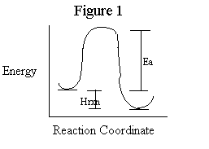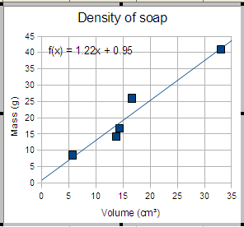 | Digital/Electronic ------------------------------------  Paper ---------------------------------------------------- | Email or put in shared folder to braille clerk at least FIVE school days before it is needed  Give to TVI, hand deliver to braille clerk, place in box or scan in and either put in shared folder or email to braille clerk at least FIVE school days before it is needed
Mathematical or Scientific Notation  Examples:  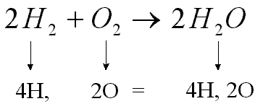 | Digital/Electronic -----------------------------------  Paper --------------------------------------------------- | Email or put in shared folder for braille clerk at least THREE school days before it is needed  Give to TVI, hand deliver to braille clerk, place in box or scan in and either put in shared folder or email to braille clerk at least THREE school days before it is needed
Things you are unsure about | All Formats -------------------------------------------- | Consult with TVI at least FIVE school days before you will be doing the assignment

